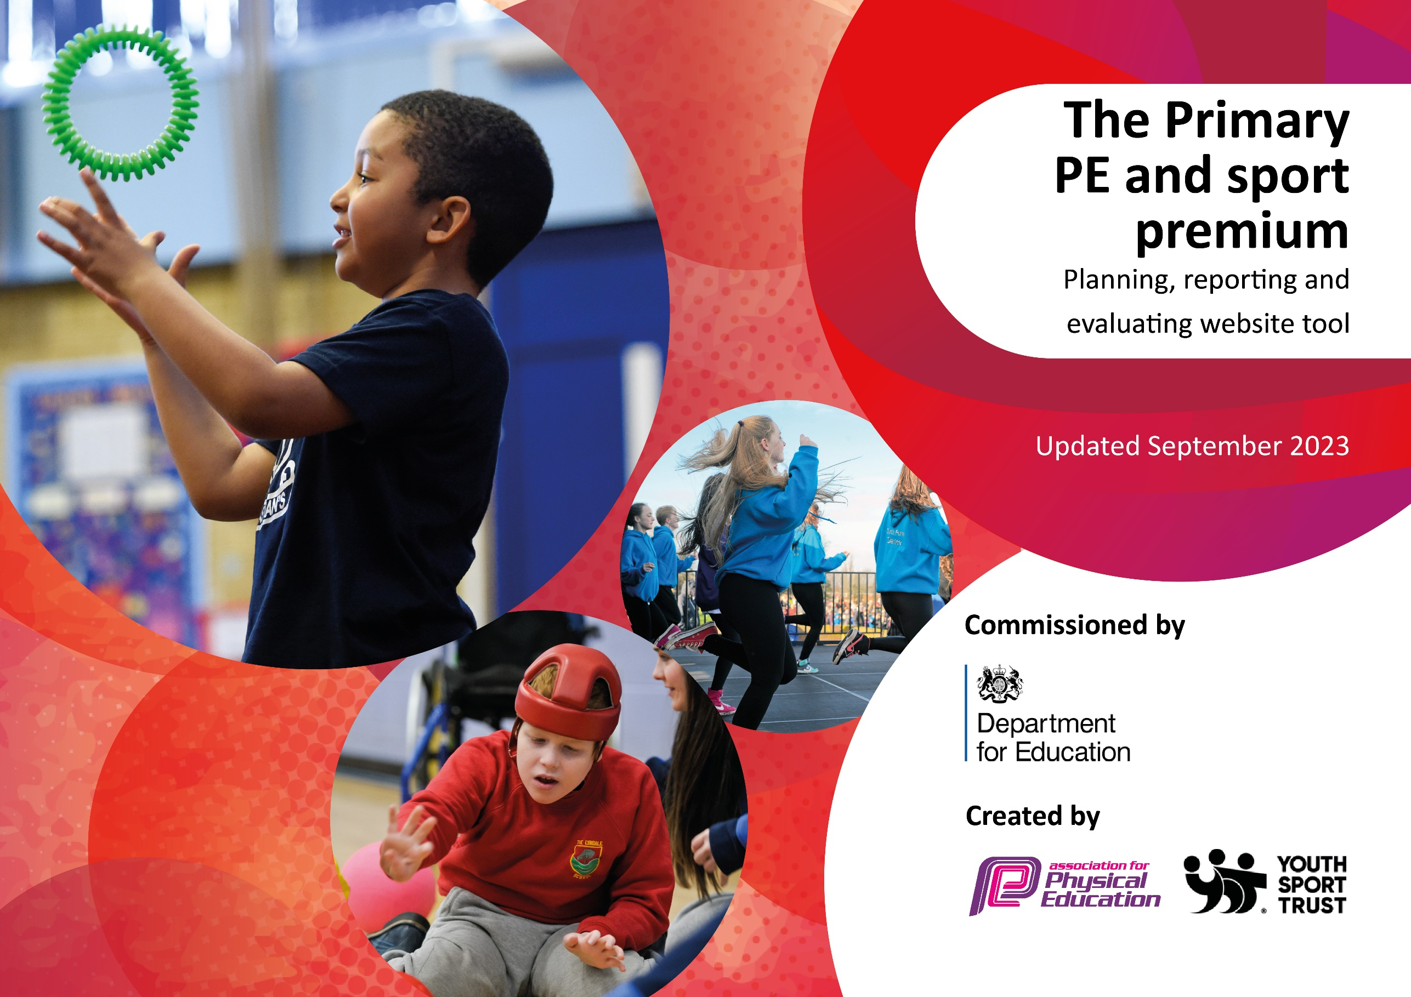

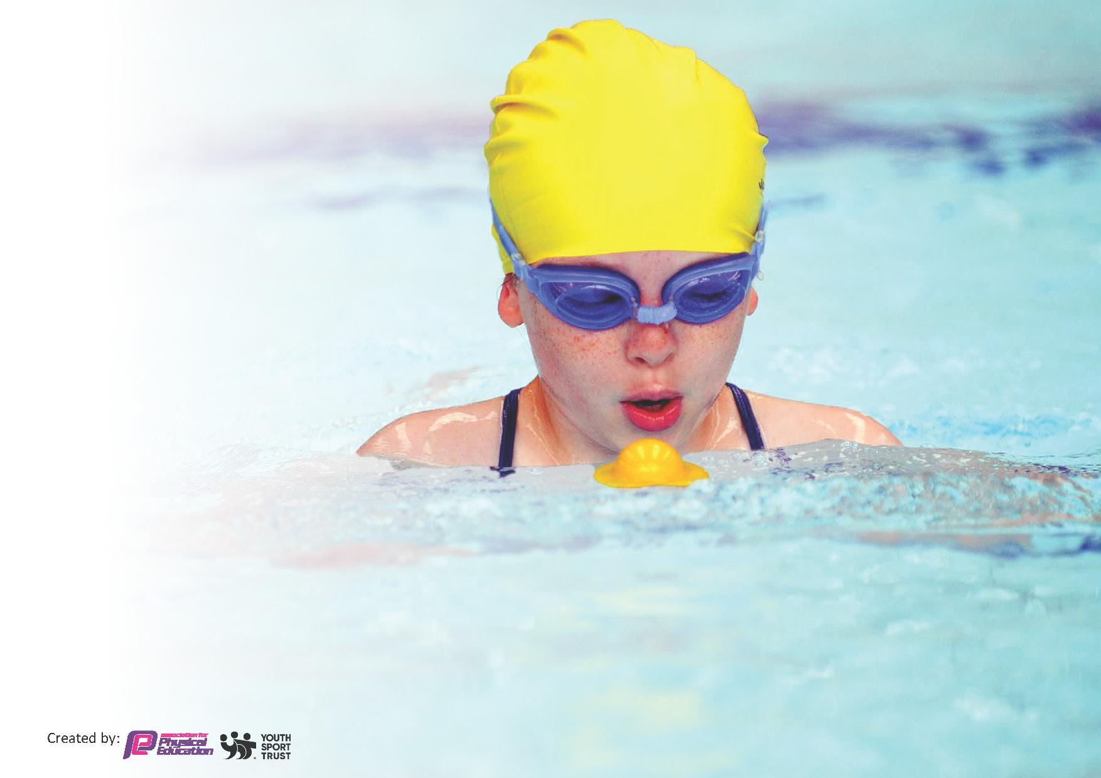
This template can be used for multiple purposes:
by:
- It enables schools to effectively plan their use of the Primary PE and sport premium
- It helps schools to meet the requirements (as set out in guidance) to publish information on their Primary PE and sport premium
- It will be an effective document to support Ofsted inspections enabling schools to evidence progress in Physical Education (PE) and evidence swimming attainment, which forms part of the PE National Curriculum. We would recommend schools consider
the Intent, Implementation and Impact of any spend, as examined within the Education Inspection Framework.

It is important that your grant is used effectively and based on school need.

Schools must use the funding to make additional and sustainable
improvements to the quality of the PE, School Sport and Physical Activity (PESSPA)
they offer. This means that you should use the Primary PE and sport premium to:

- Build capacity and capability within the school to ensure that improvements made now will benefit pupils joining the school in future years
- Develop or add to the PESSPA activities that your school already offers.

The Primary PE and sport premium should not be used to fund capital spend projects; the school’s core budget should fund these. Further detail on capital expenditure can be found in the updated Primary PE and sport premium guidance.

The Primary PE and sport premium guidance, outlines 5 key priorities that funding should be used towards. It is not

necessary that spending has to meet all the key priorities, you should select the priorities that you aim to use any funding towards.

Although completing this template is not a requirement for schools, schools are required to publish details of how they spend this funding. Schools must also outline what the impact this funding has had on pupils’ PE and sport participation and attainment and how any spending will be sustainable in the future. All funding must be spent by 31st July 2025.

The Department for Education has worked closely with the Association for Physical Education (afPE) and the Youth Sport Trust (YST) to develop this template and encourages schools to use it. This template is an effective way of meeting the reporting requirements of the Primary PE and sport premium.
Review of last year’s spend and key achievements (2024/2025)

We recommend you start by reflecting on the impact of current provision and reviewing your previous spend.

Activity/Action | Impact | Comments
Outdoor area has continued to be enhanced and the.  Wider range of extra-curricular clubs  Increased swimming offer to Year 4 in addition to Year 5. Paid for an additional qualified swim instructor to go into the water with the less confident swimmers.  Additional sporting opportunities has increased within school | Majority of pupils are engaging in physical activity for at least 30 minutes in the school day  Ball skills, mega skills, big Comp club, cricket, Football, Forest School, gymnastics, hand and ball skills, mini rugby, multi sports, Ninja warrior, archery, tiny tennis Clubs offered 31  339 Pupils participated in the clubs this academic year  33% swimming 25m  Tennis, taster judo, tag rugby, roller bikes, blaze pods, golf. | Plans to enhance the outdoor space further to include greater teamwork challenges.  Pupil voice has been sought regarding clubs for next year. Cricket has been swapped  This is to continue next year to measure impact on % that can swim by Year 6  Part of these were within fitness fortnight. To run a fitness week again next year.

Key priorities and Planning 2025-2026

Action – what are you planning to do | Who does this action impact? | Key indicator to meet | Impacts and how sustainability will be achieved? | Cost linked to the action
Provision for all children to access Forest Schools to build confidence and knowledge in regards to the outdoor curriculum | Forest School company employed for a full day each week for 38 weeks | Key indicator 2 -The engagement of all pupils in regular physical activity – the Chief Medical Officer guidelines recommend that all children and young people aged 5 to 18 engage in at least 60 minutes of physical activity per day, of which 30 minutes should be in school | All children to receive outdoor learning.  Future proof with own trained member of staff 26-27 | Forest School Coach  £6650
To increase team building outdoor activities promoting physical activity.  To improve provision for pupils with SEND through addition of sensory play. | Add in additional construction area using crates, planks, tarpaulin clips etc.  Sand pit to be added.  Water tray that can be used for other sensory play – slime etc.  Equipment – | Key indicator 2 -The engagement of all pupils in regular physical activity – the Chief Medical Officer guidelines recommend that all children and young people aged 5 to 18 engage in at least 60 minutes of physical activity per day, of which 30 minutes should be in school.  Key indicator 4: Broader experience of a range of sports and activities offered to all pupils | More pupils meeting their daily physical activity goal, more pupils encouraged to take part in PE and Sport Activities.  Adaptations that ensure all pupils are able to engage in physical activities | Sports Leader in place to coordinate the outdoor activities. £4,607
To continue to provide a major contribution to the strategic leadership of school improvement, by ensuring effective subject leadership of PE, within the context of the wider school curriculum. | West Yorkshire PE conference | Key Indicator 3 Increased confidence, knowledge and skills of all staff in teaching PE and sport. | Knowledge of subject leader is current and this can be cascaded down to all staff who are teaching PE.  In future years to include costing within CPD budget
Afterschool clubs subsidised to provide a wide range of sporting opportunities | External provider sourced to run the additional clubs | Key indicator 4: Broader experience of a range of sports and activities offered to all pupils | Clubs to be supported by a parent donation to enable the clubs to continue | Club costs£3544 (less £2,773 income)
Residential trip for outdoor activities Kingswood. Subsidised places | Identified families supported with trip costs to enable underprivileged pupils to go | Key indicator 4: Broader experience of a range of sports and activities offered to all pupils | Look for competitive providers to make the trip as affordable as possible
Fitness week to expose children to different forms of physical exercise and healthy eating | Pupils physical fitness. | Key indicator 4: Broader experience of a range of sports and activities offered to all pupils  Key Indicator 3 Increased confidence, knowledge and skills of all staff in teaching PE and sport.  Key indicator 2 -The engagement of all pupils in regular physical activity – the Chief Medical Officer guidelines recommend that all children and young people aged 5 to 18 engage in at least 60 minutes of physical activity per day, of which 30 minutes should be in school | To become a regular event in the Pinders Calendar
Wakefield Trinity to teach Tag rugby Year 3, ¾ and 4 ( 90 Children) for a 6 week block | Staff CPD for teaching rugby  Specialist sports teaching for the pupils. | Key indicator 4: Broader experience of a range of sports and activities offered to all pupils  Key Indicator 3 Increased confidence, knowledge and skills of all staff in teaching PE and sport.  Key indicator 2 -The engagement of all pupils in regular physical activity – the Chief Medical Officer guidelines recommend that all children and young people aged 5 to 18 engage in at least 60 minutes of physical activity per day, of which 30 minutes should be in school | Staff CPD enable improved teaching of Rugby next year.
Increase outcomes in swimming proficiency with extra year of lessons so that all pupils receive two years of lessons.  Employ additional swimming teacher for both swimming years to go in the water with the lowest ability / least confident. | Pupil outcomes to improve | Key indicator 2 -The engagement of all pupils in regular physical activity – the Chief Medical Officer guidelines recommend that all children and young people aged 5 to 18 engage in at least 60 minutes of physical activity per day, of which 30 minutes should be in school | If impact is seen will look at budget to support the extra sessions | Additional pool session £3990  Additional swimming teacher cost. £2,662

Key achievements 2025-2026
This template will be completed at the end of the academic year and will showcase the key achievements schools have made with their Primary PE and sport premium spending.

Activity/Action | Impact | Comments

Swimming Data
Meeting National Curriculum requirements for swimming and water safety.
Priority should always be given to ensuring that pupils can perform safe self-rescue even if they do not fully meet the first two requirements of the National Curriculum program of study

Question | Stats: | Further context  Relative to local challenges
What percentage of your current Year 6 cohort can swim competently, confidently and proficiently over a distance of at least 25 metres? | 24% | Number of lessons have been increased as our starting points each year are so low.
What percentage of your current Year 6 cohort can use a range of strokes effectively [for example, front crawl, backstroke, and breaststroke]? | 28% | Good progress was made. Additional swimming has been put into the curriculum for the next cohort coming through

What percentage of your current Year 6 cohort are able to perform safe self-rescue in different water-based situations? | 28% | None of the cohort were able to swim when they started in Year 5.
If your schools swimming data is below national expectation, you can choose to use the Primary PE and sport premium to provide additional top-up sessions for those pupils that did not meet National Curriculum  requirements after the completion of core lessons. Have you done this? | No | Extra swimming is being out in at Year 4 so that they will then have a top up for those not meeting the national expectation in Year 5
Have you provided CPD to improve the knowledge and confidence of staff to be able to teach swimming and water safety? | Yes | We have employed a swimming teacher as a LSA and he takes a group at swimming.

Signed off by:

Head Teacher: | Lorna Kemplay
Subject Leader or the individual responsible for the Primary PE and sport premium: | Katie Hargreaves
Governor: | Stuart Heptinstall
Date: | 14/06/2025

