**Book List – Design & Technology**

**EYFS**

**Autumn – Autumn - Vegetable Soup**

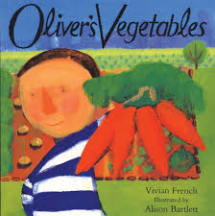

**Oliver’s Vegetable – Vivian French**

**Christmas – Christmas Decorations**

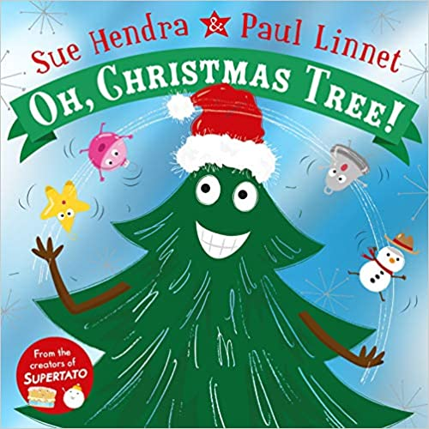

**Oh Christmas Tree - Sue Hendra and Paul Linnet**

**Spring – Easter – Easter Bonnet**

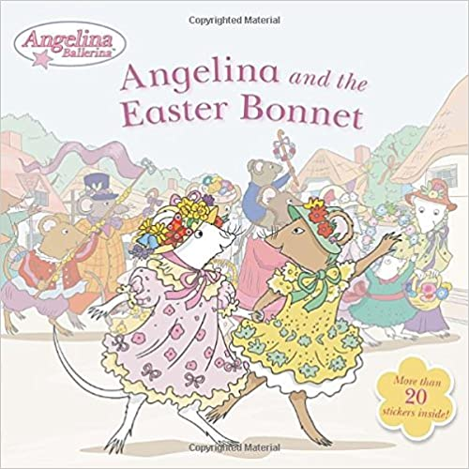

**Angelina & The Easter Bonnet -**

**Summer - Superheroes**

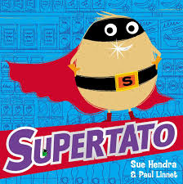

**Supertato - Sue Hendra and Paul Linnet**