**Book List – Design & Technology**

**KS1**

**Cycle A**

**(Explorers) – Christmas Decorations**

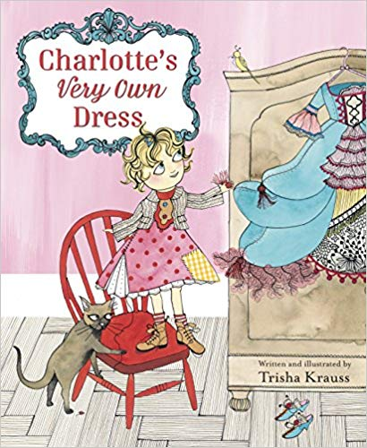

**Charlotte’s Very Own Dress - Trisha Krauss**

**London’s Burning – Fire Engine**

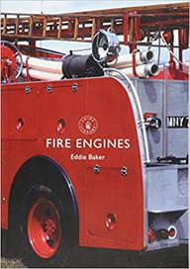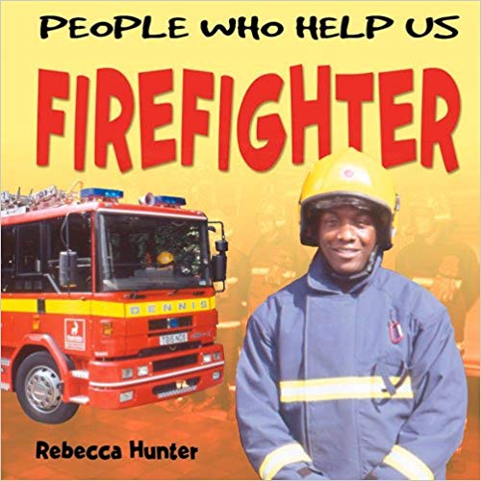

**People who help us Firefighter - Rebecca Hunter**

**Fire engines - Eddie Baker**

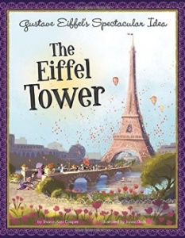**Paddingtons Travels - Towers**

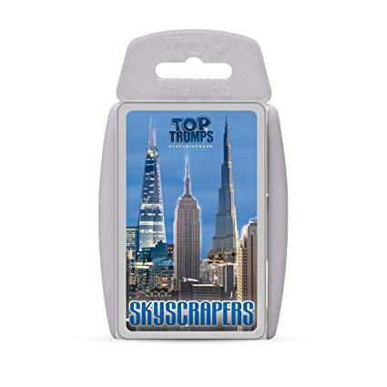

**ORT - Paris Adventure**

**Gustav Eiffels spectacular intro The Eiffel Tower**

**Top Trumps Skycraper**

**Book List – Design & Technology**

**KS1**

**Cycle B**

**(Traditional Tales) – Christmas Decorations**



**Charlotte’s Very Own Dress - Trisha Krauss**

**Wonderful World – Moving Pictures**

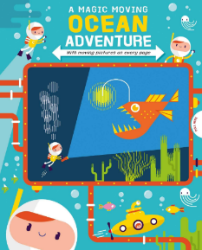

**A Magic Moving Ocean Adventure – Igloo Books**

**How does your garden grow? - Cooking**

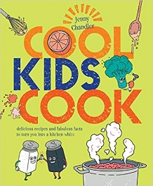[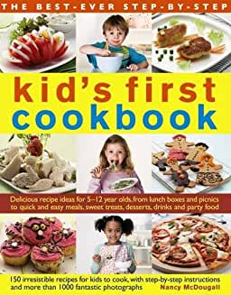](https://www.amazon.co.uk/Best-Ever-Step-Step-First-Cookbook/dp/0857231979/ref=sr_1_5?crid=JDIUJSF4UE94&keywords=childrens+cook+books+age+5-7&qid=1575470007&s=books&sprefix=childrens+cook+book%2Cstripbooks%2C322&sr=1-5)[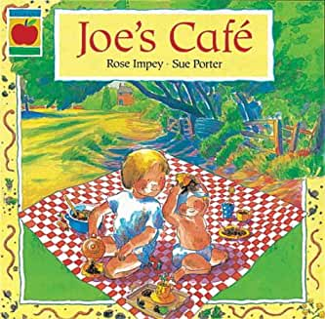](https://www.amazon.co.uk/Joes-Cafe-Orchard-Paperbacks-Impey/dp/1852135638/ref=sr_1_12?keywords=cafe+childrens+book&qid=1575469888&s=books&sr=1-12)

**Joes Café - Rose Impey**

**Kids First Cook book - Nancy McDougall**

**Cool Kids Cook - Jenny Chandler**