Pinders Primary School – Mathematics Mental Strategies – Year 1
Rapid Recall Skills | Key Knowledge and Vocabulary
- Y1 facts on grid tested and recorded termly – including associated subtraction facts | Know how to count in ones and in steps of two  - Know that a number line can be used to count on and back  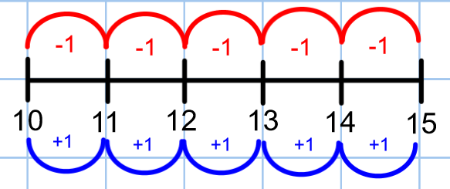  Know number bonds to 10  - Know that tens frames can be used to create the “magic 10”  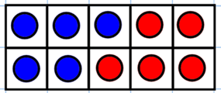  5 + 5 = 10  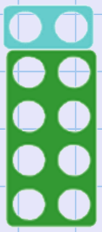  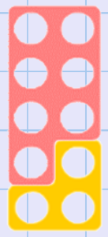  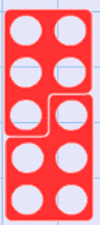  - Know that numicon can be used to combine plates to make connections and recognise patterns  - Know that tens frames can be used to order number bonds systematically  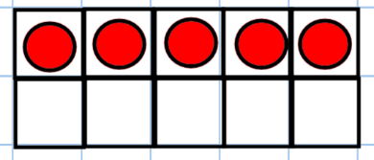  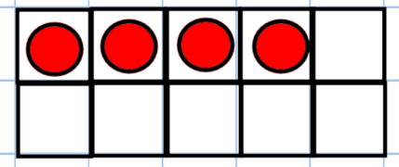  - + _ = 10 5 + _ = 10  Know double and halving facts to 20  - Know that doubling is twice as many  - Know that repeated addition is adding equal groups together  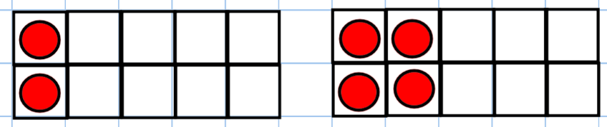  1 + 1 =2 Double 1 is 2 2 + 2 = 4 Double 2 is 4  Near number bonds  - Know how to use near number bonds to add two one digit numbers  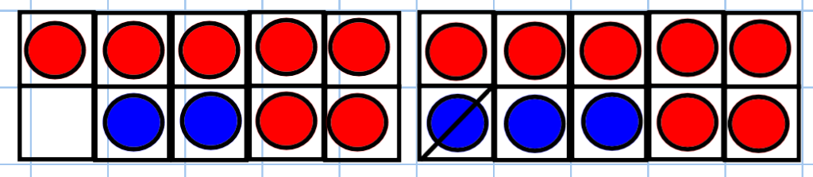  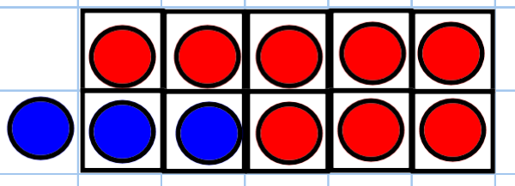  E.g. 7 + 2 = 9 because 7 + 3 = 10 (one less) 8 + 3 = 11 because 8 + 2 = 10 (one more)  Know near double facts  - Know how to use near double facts to numbers to 10  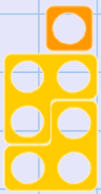  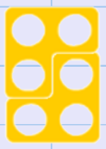  E.g. 3 + 4 = 7 double 3 is 6 one more)  Partitioning  - Know how to partition using number facts  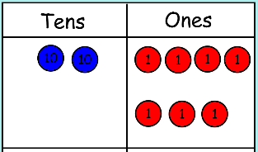  E.g. 24 + 3 = ? first add the one’s 3 + 4 = 7 then add the ones with the ten’s 20 + 7 = 27  - Know how to partition in different ways  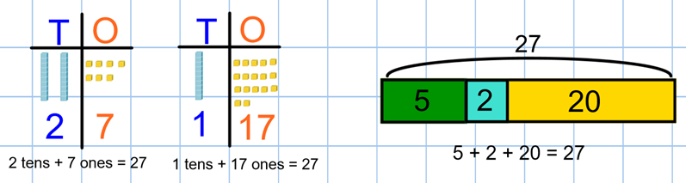  Adjusting  - Know how to adjust numbers to make 10  e.g. 8 + 6 becomes 8 + 2 + 4 e.g 6 + 7= becomes 10 + 3  