Pinders Primary School – Mathematics Mental Strategies – Year 2
Rapid Recall Skills | Key Knowledge and Vocabulary
- Y1 and 2 facts on grid tested and recorded termly –  including associated subtraction facts  - 2, 5 and 10 times table multiplication and division facts | Number bonds to 10 and near number bonds to add two or three single digit numbers  • Know that tens frames and numicon can be used  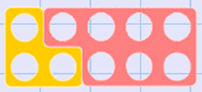  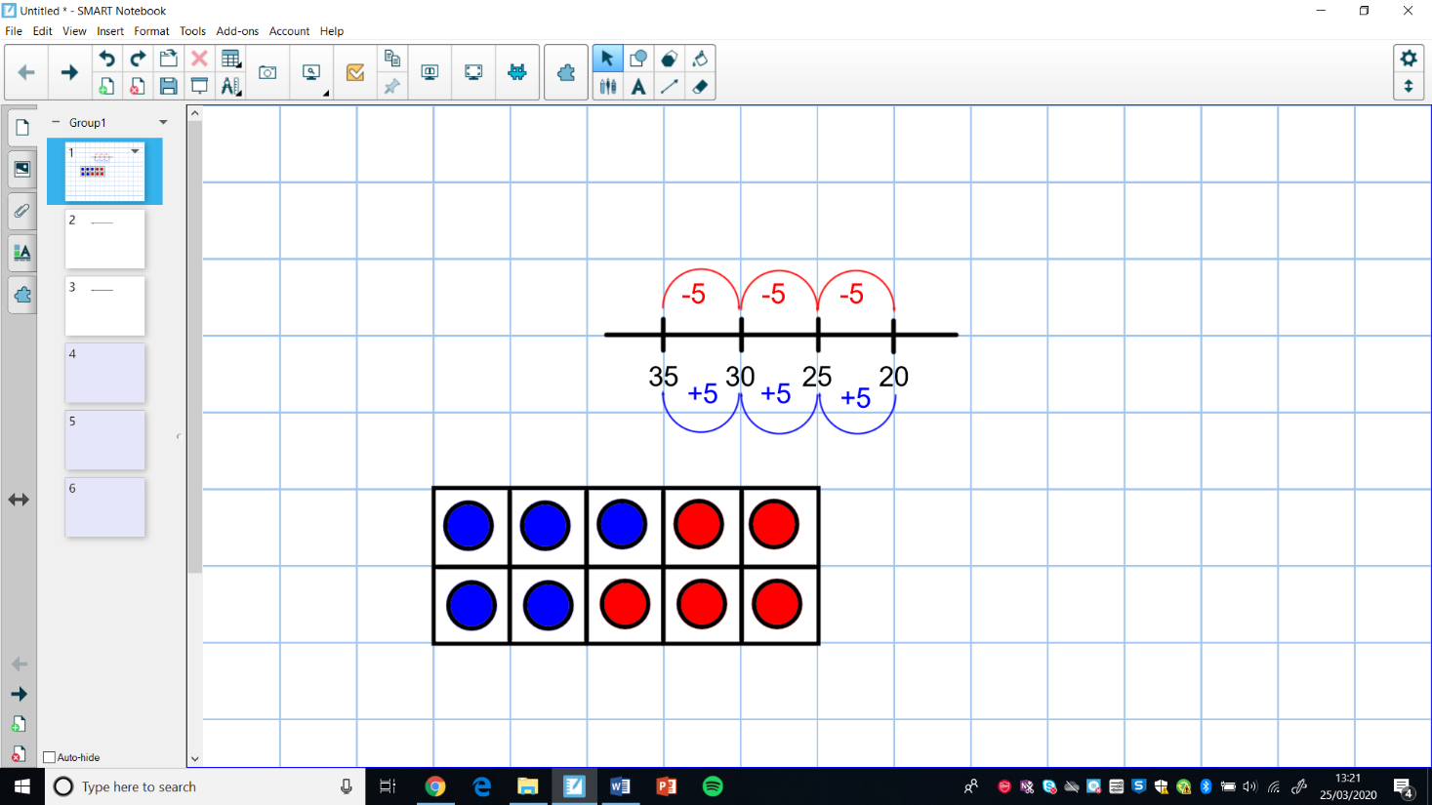  5 + 5 = 10 3 + 7 = 10  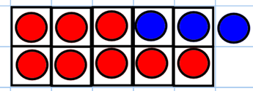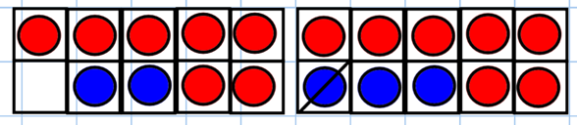  8 + 3 = 11 because 8 + 2 = 10 (one more) E.g. 7 + 2 = 9 because 7 + 3 = 10 (one less)  Spot doubles and near doubles to add two or three single digit numbers  - Know that a doubling is twice as many  - Know that a near double are numbers that are nearly the same as another  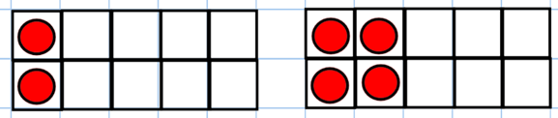  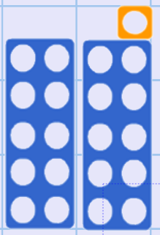  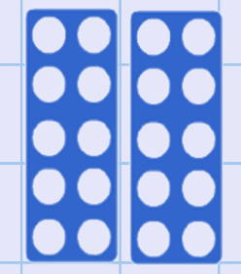  1 + 1 =2 Double 1 is 2 2 + 2 = 4 Double 2 is 4  - Know that 10 + 10 = 20 then this can help you work out 10 + 11.  10 + 11 is the same as 10 + 10 + 1 which makes 21.  Use number bonds to 20 and near number bonds to 20 to add 2 numbers  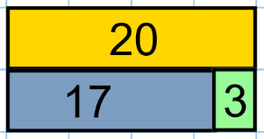  17 + 2 = 19 because 17 + 3 = 20 (one less)  Add 10 to any 2 digit number  - know how to use a hundred square  - know what happens to the numbers in each column – ten digit changes while the ones remains the same  Partitioning: Calculations with whole numbers which do not involve crossing place value boundaries- e.g. 23 + 45= ? by 40 + 5 +20 + 3 or 40 + 23 + 5  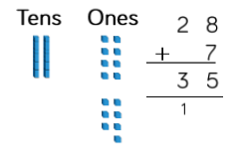  - Know that 10 ones are the same as 1 ten  - Know how to partition two digit numbers in order to partition them  Counting on or back in tens and ones to add or subtract – flexibility with number line  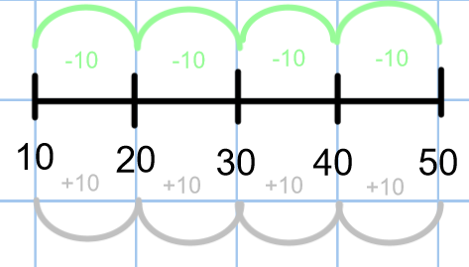  Adjusting - using the numbers 9 and 11  - Know how to adjust numbers by adding 10 then subtracting or adding 1  e.g. 45 – 29 becomes 45 – 30 (+1)  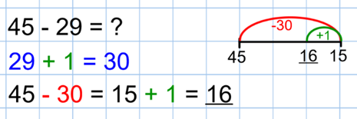  Adjusting - ‘make ten’  - Know how to adjust numbers to make 10 e.g 6 + 7= becomes 10 + 3  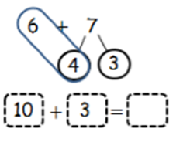  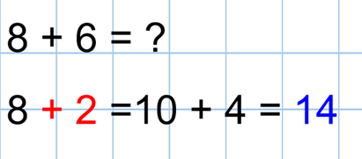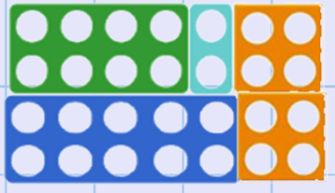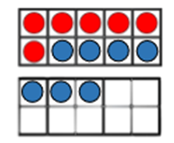  Adding and subtracting with multiples of 10 where the answer is between 0 and 100  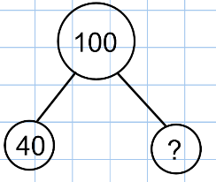  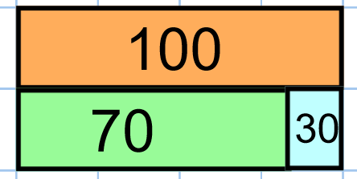  Doubling and halving: Derives doubles and halves of multiples of 10 up to 100  - Know to use number bond knowledge to make doubles up to 100  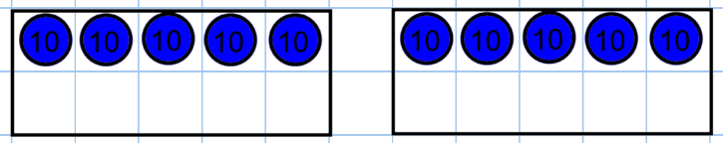  50 + 50 = 100  Doubling and halving: Find the doubles to 100 using partitioning and halves of any even number to 100  - Know that grouping and sharing will support dividing by 2  