Pinders Primary School – Mathematics Mental Strategies – Year 3
Rapid Recall Skills | Key Knowledge and Vocabulary
- 3, 4 and 8 times table and associated division facts  - Multiply 2 digit number by 10  - Add/subtract multiples of 10 where the answer is between 0 and 100 (e.g. 70 + 30 = 100, 20 + 40 = 60)  - Doubles and halves of multiples of 10 up to 100 | Know how to count on or back in intervals of five from any multiple of five  - Know that a number line can be used.  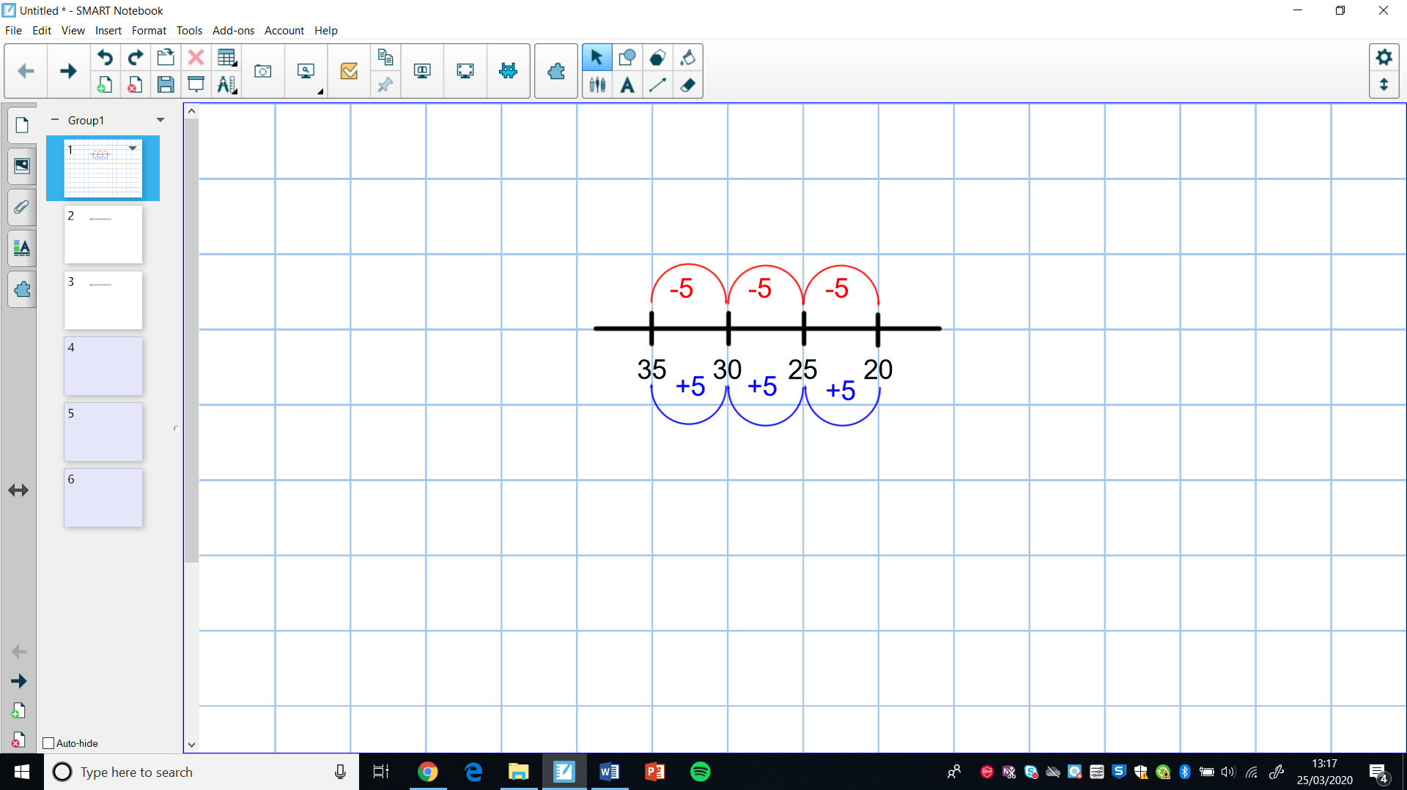  - Know that tens frames can be used.  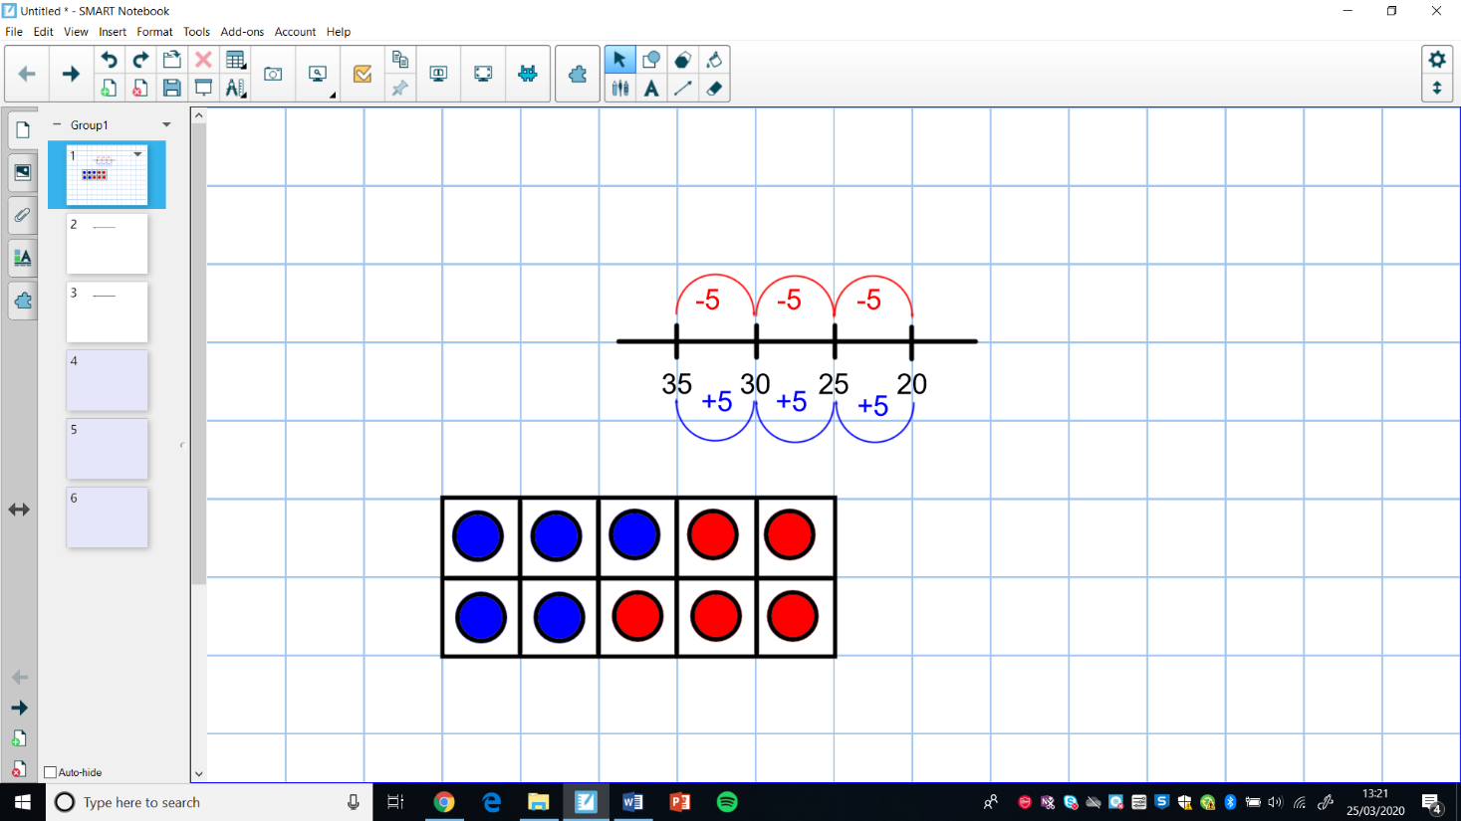  5 10 15 20  - Know that 35 + 15 can be solved by adding three lots of 5 to 35.  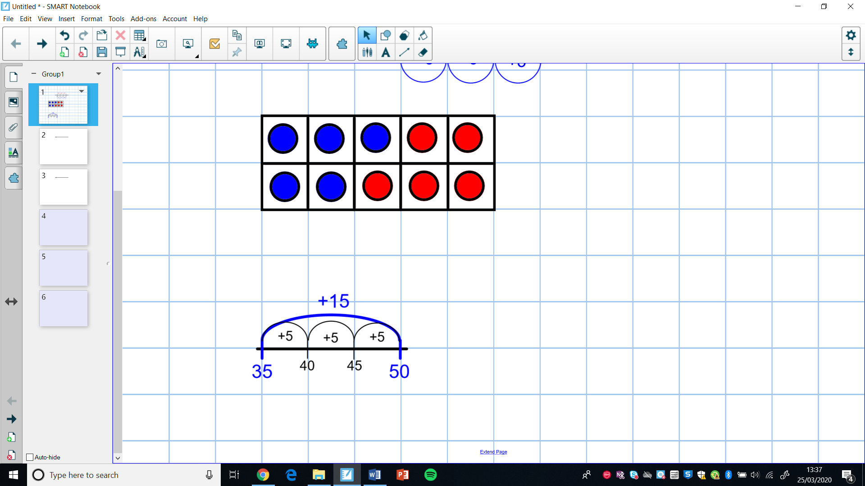  Know how to Count on or back in hundreds from any number  - Know that 570 + 300 can be solved by counting in multiples of 100.  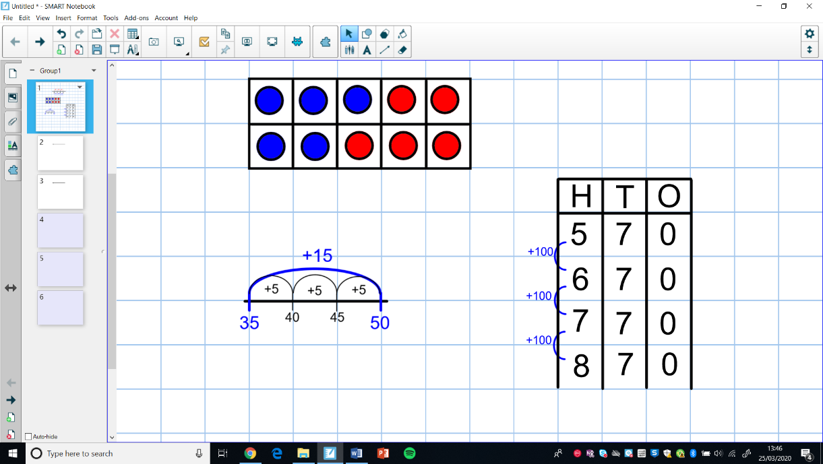  - Know that dienes or counters can be used to represent the total number and visualise removing the hundred plates.  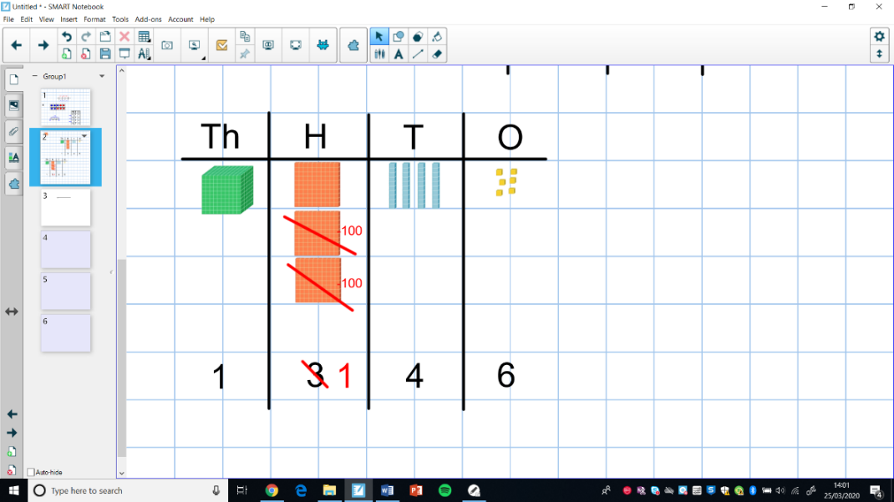  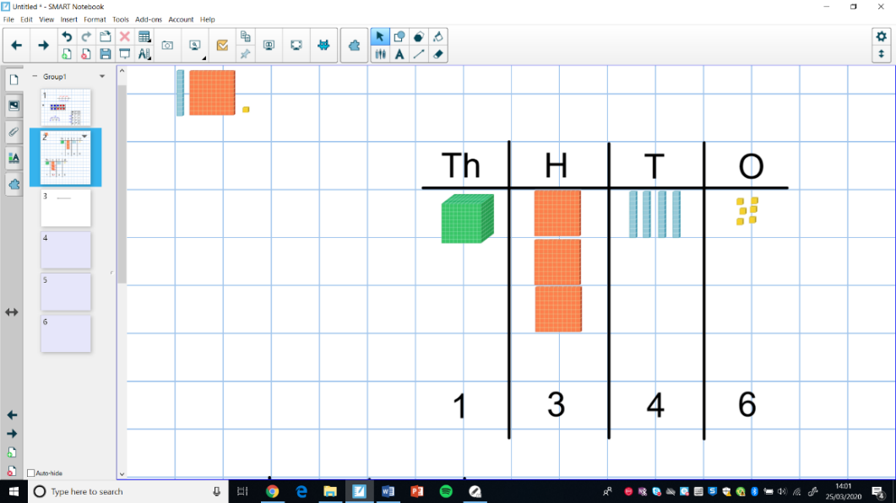  1, 3 4 6 – 3 0 0 = 1, 1 4 6  Partitioning  - Know how to solve calculations with whole numbers which involve crossing place value boundaries by partitioning.  e.g. 42 – 28 = ? partition 28 into 20 + 2 + 6 so 42 – 2 – 20 - 6.  42 – 28 = 14  40 – 2 = 40  40 – 20 = 20  20 – 6 = 14  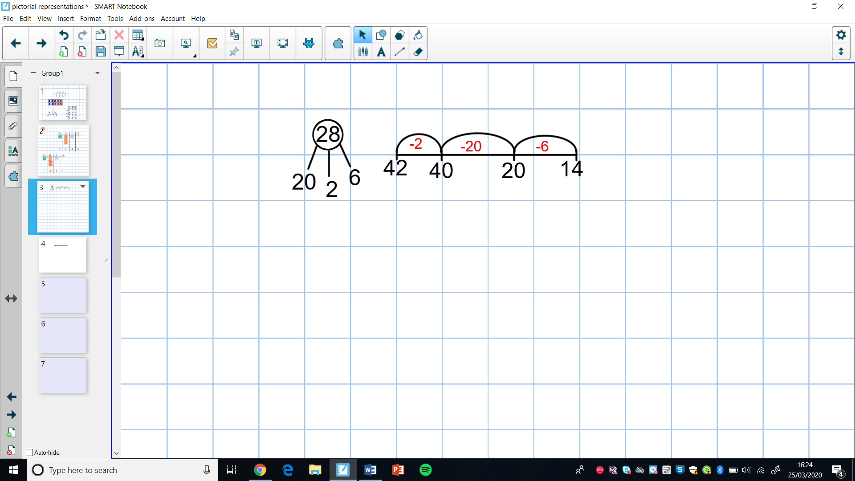  - Know how to partition numbers in different ways.  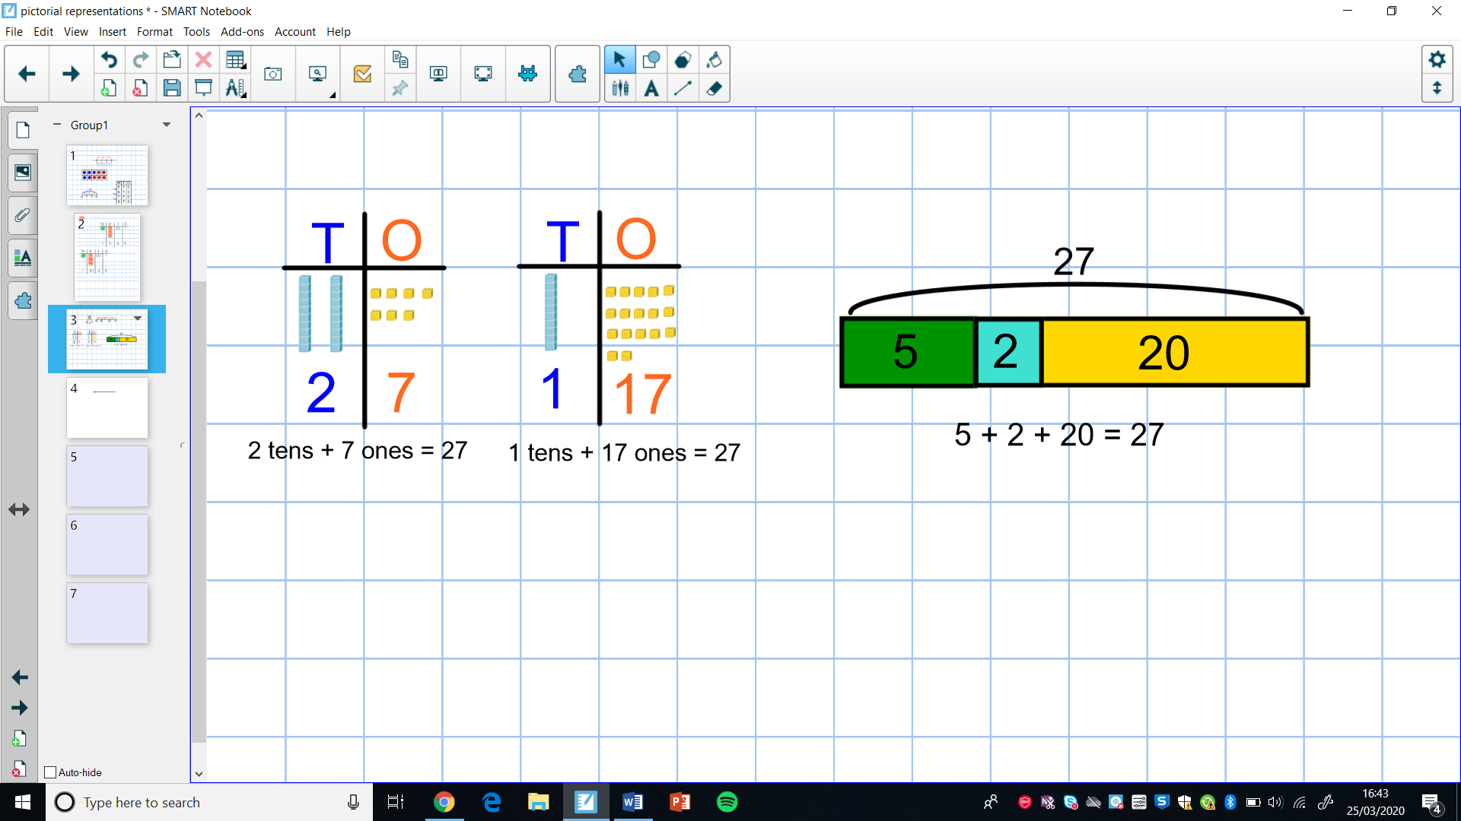
Adjusting – bridging or compensating numbers to round them to multiples of ten
- Know how to adjust numbers to use multiples of 10

e.g. 34 + 68 becomes 38 + 70 (-2) e.g. 45 – 29 becomes 45 – 30 (+1)
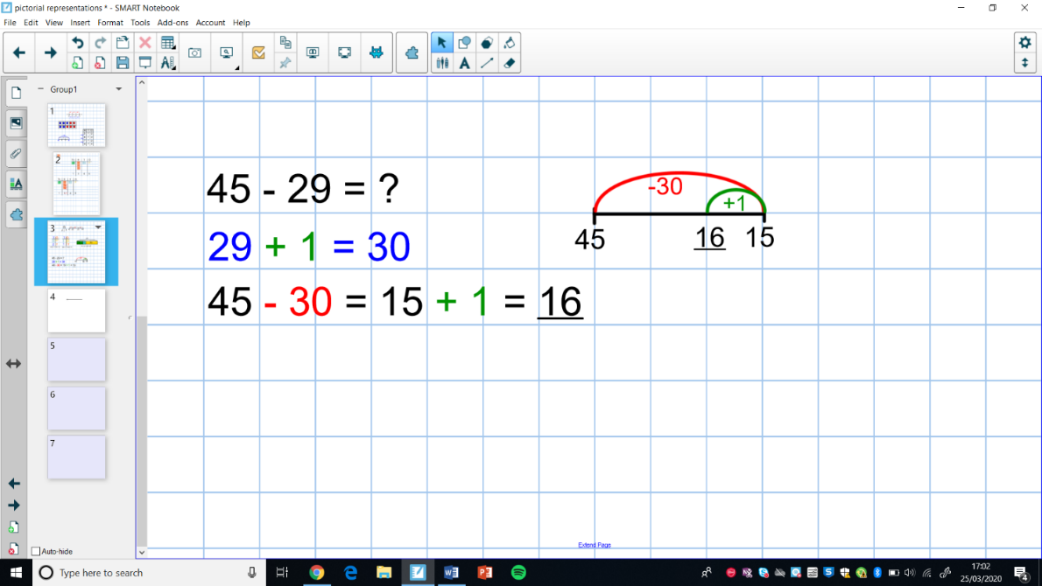
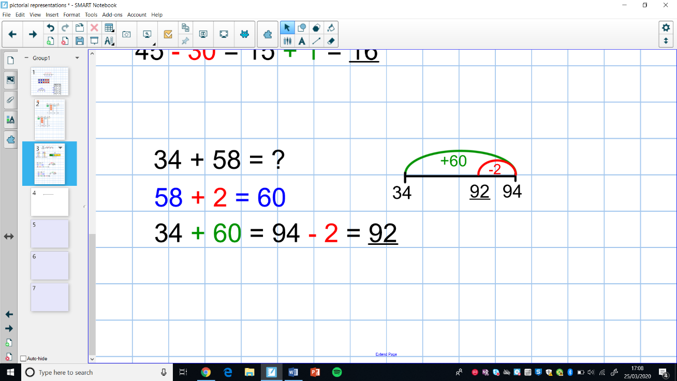

- Know how to adjust numbers to make multiples.
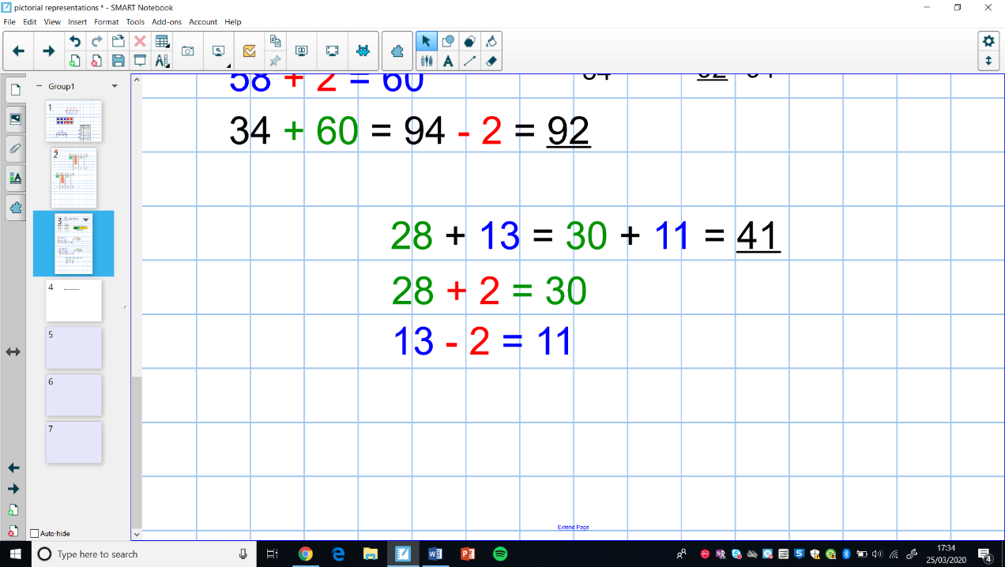

Near Doubles
- Know how to use near doubles to numbers up to 20 or to multiples of 10.

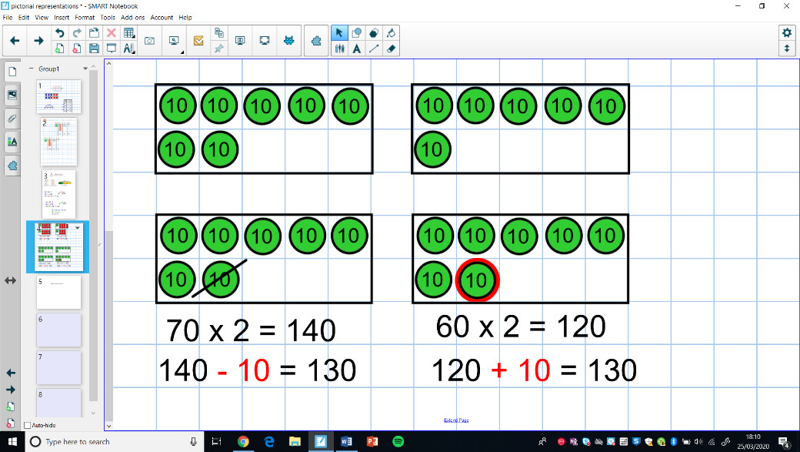
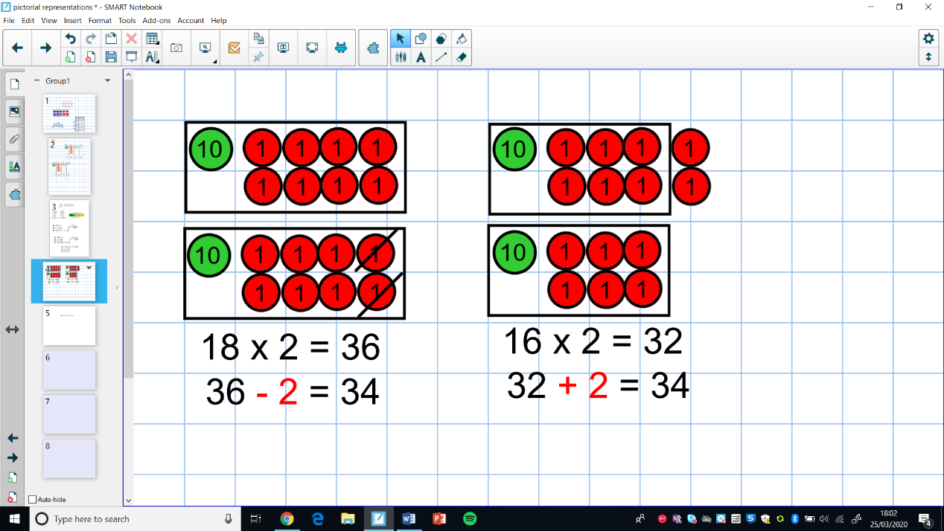

e.g. 18 + 16 is double 18 and -2 or double 16 and +2 e.g. 60 + 70 is double 60 +10 or double 70 -10.

Doubling and Halving
- Know how to find the double and half of any two-digit number and any multiple of 10 or 100.
e.g. half of 600 e.g. double 74
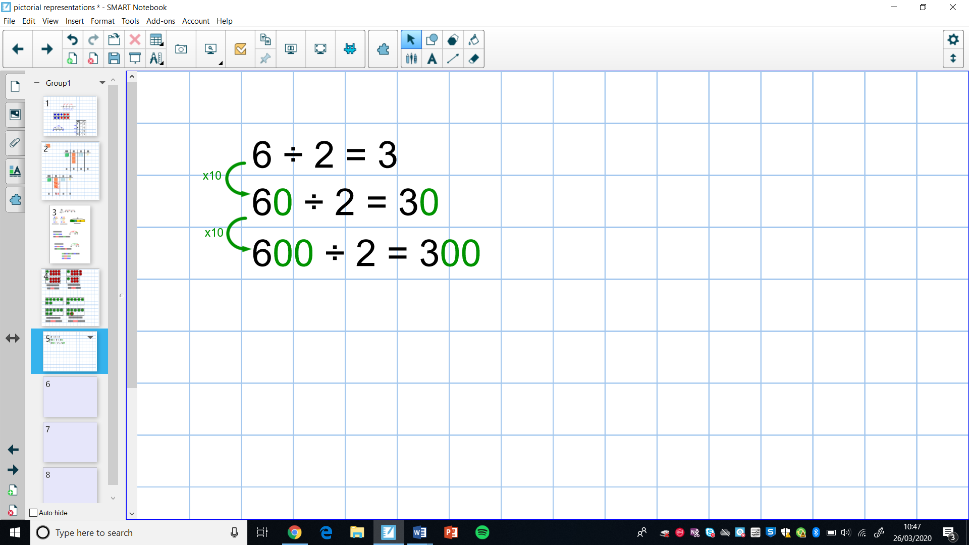
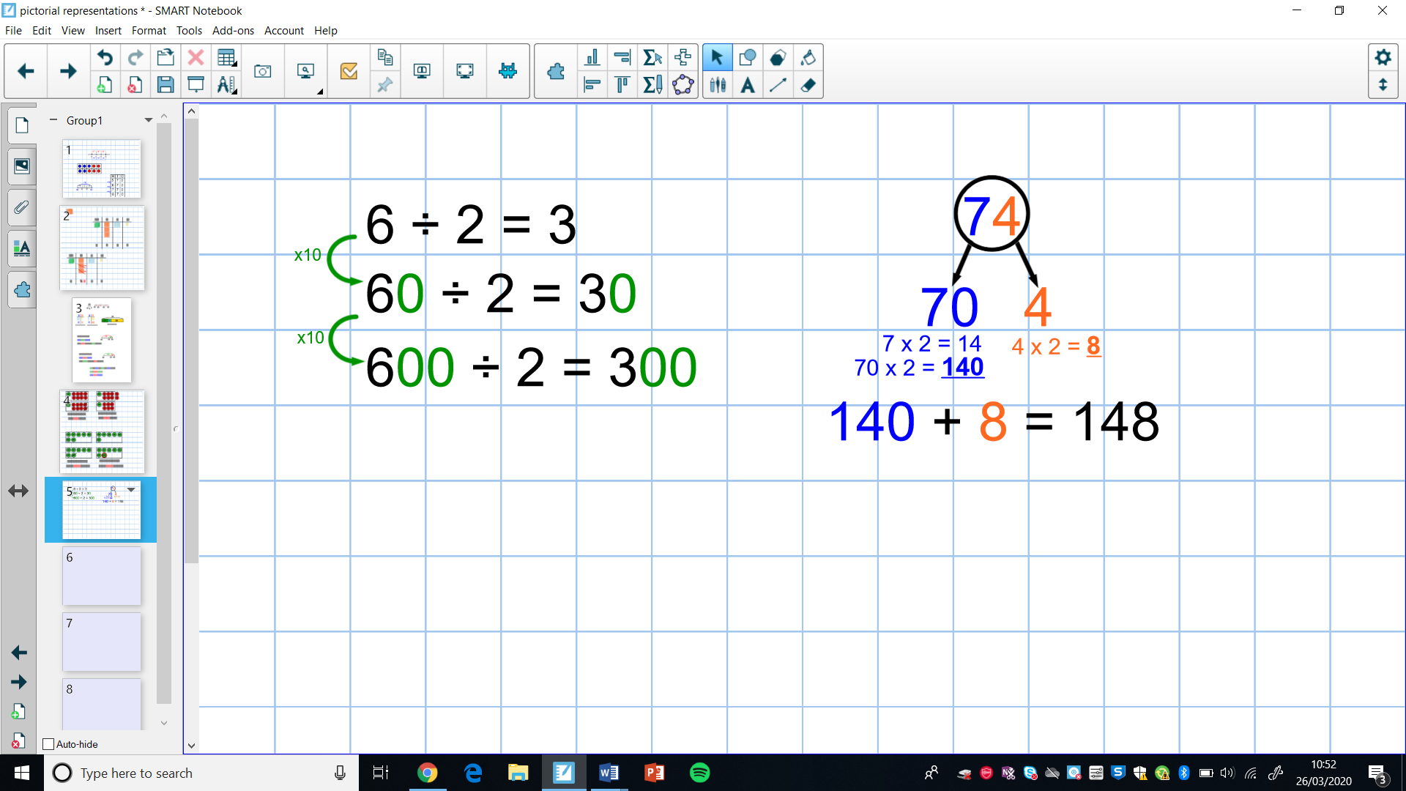

- Know how to multiply and divide by 4 and 8 by doubling and doubling again or halving and halving again.
e.g. 34 x 4 = 34 x 2 x 2 e.g. 112 ÷ 8 = 112 ÷ 2 ÷ 2 ÷ 2
