Pinders Primary School – Mathematics Mental Strategies – Year 4
Rapid Recall Skills | Key Knowledge and Vocabulary
- All multiplication and division facts up to 12 x 12  - Add/subtract multiples of 10 beyond 100 e.g. 50 + 60 = 110  - Add/subtract multiples of 100 up to 1000  - Half of any even number to 100  - Multiply and divide 2 or 3 digit numbers by ten | Know how to count on or back in tenths and/or hundredths  - Know how to adapt a number line to work with decimal numbers.  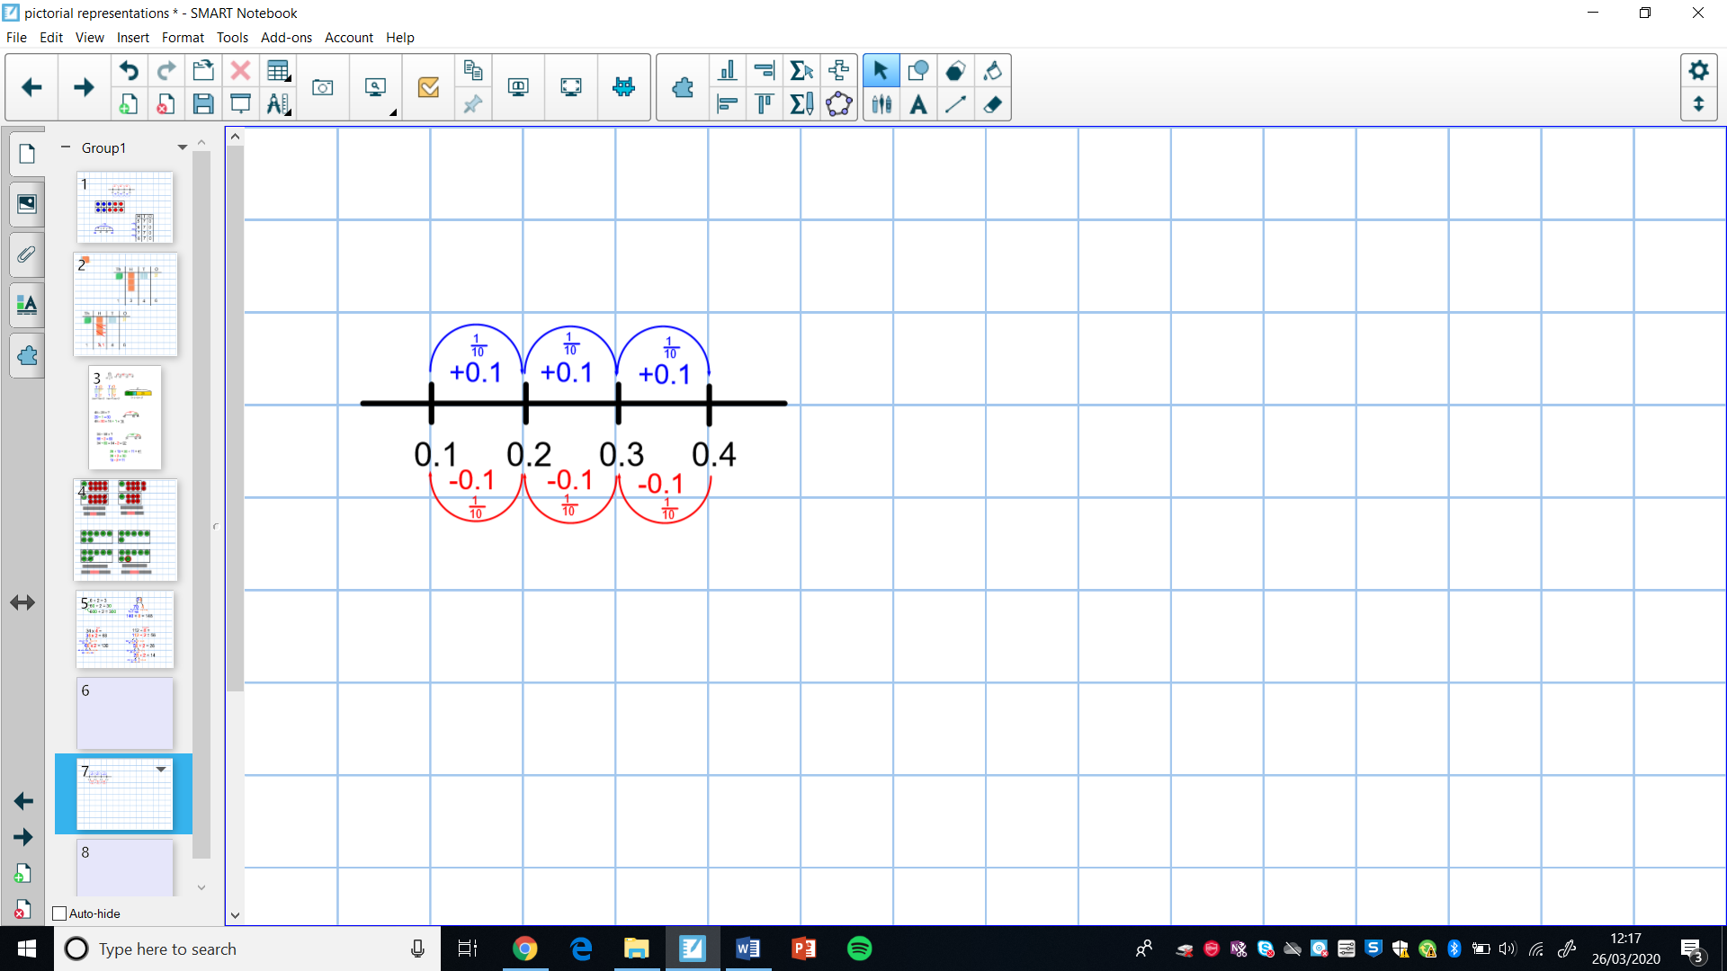  - Know how to solve calculations by counting on in tenths.  e.g. 3.2 + 0.6  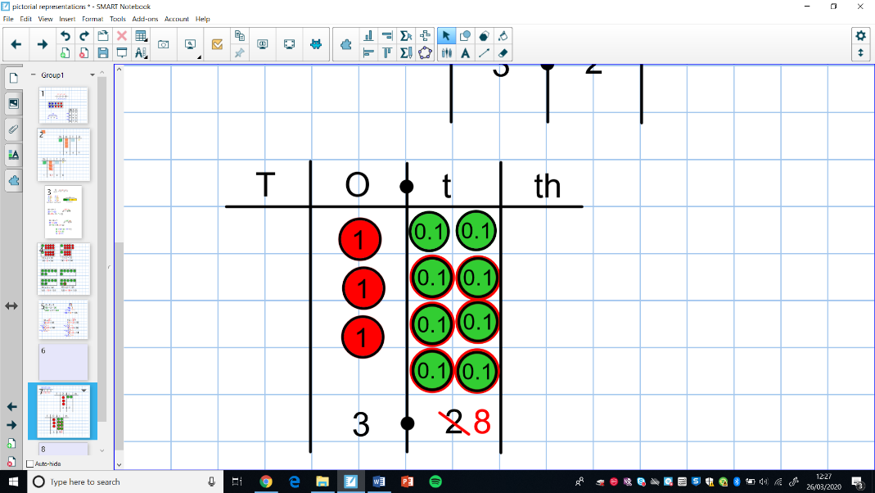  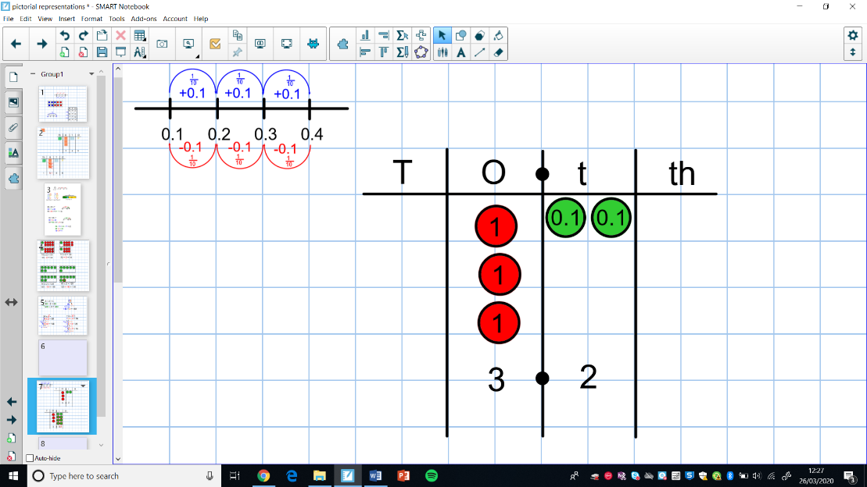  3.2 + 0.6 = 3.8  - Know how to solve calculations by counting on in tenths and hundredths.  e.g. 1.7 + 0.55  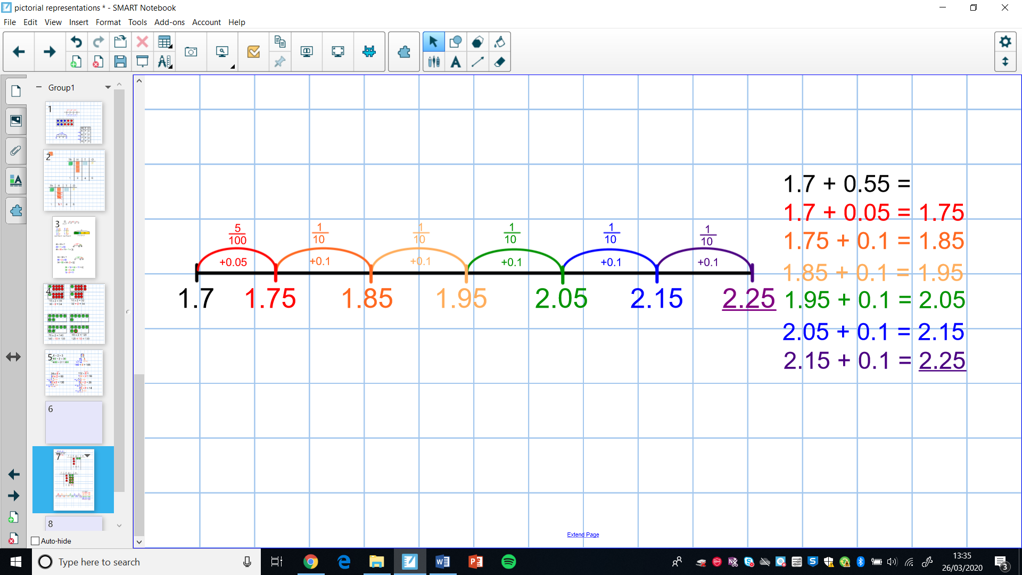  Adjusting multiples of 10 or 100 to solve calculations  - Know how to adjust numbers by rounding to multiples of 10 or 100.  e.g. 138 + 69= 138 + 70 – 1 e.g. 299 – 48 = 300 – 48 – 1  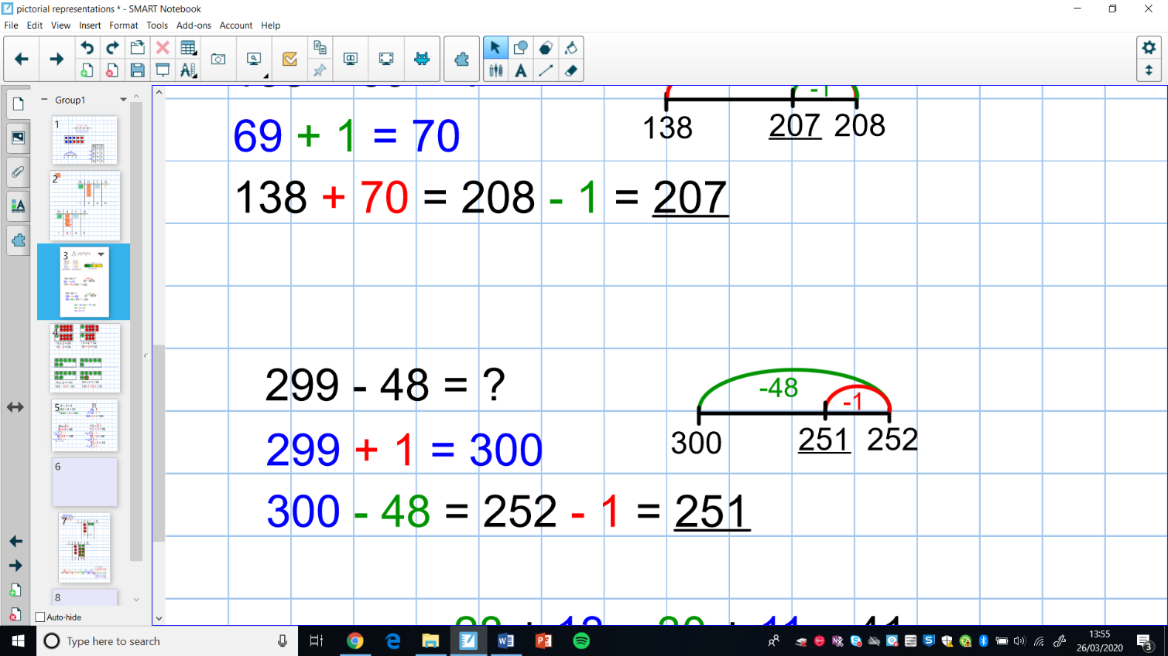  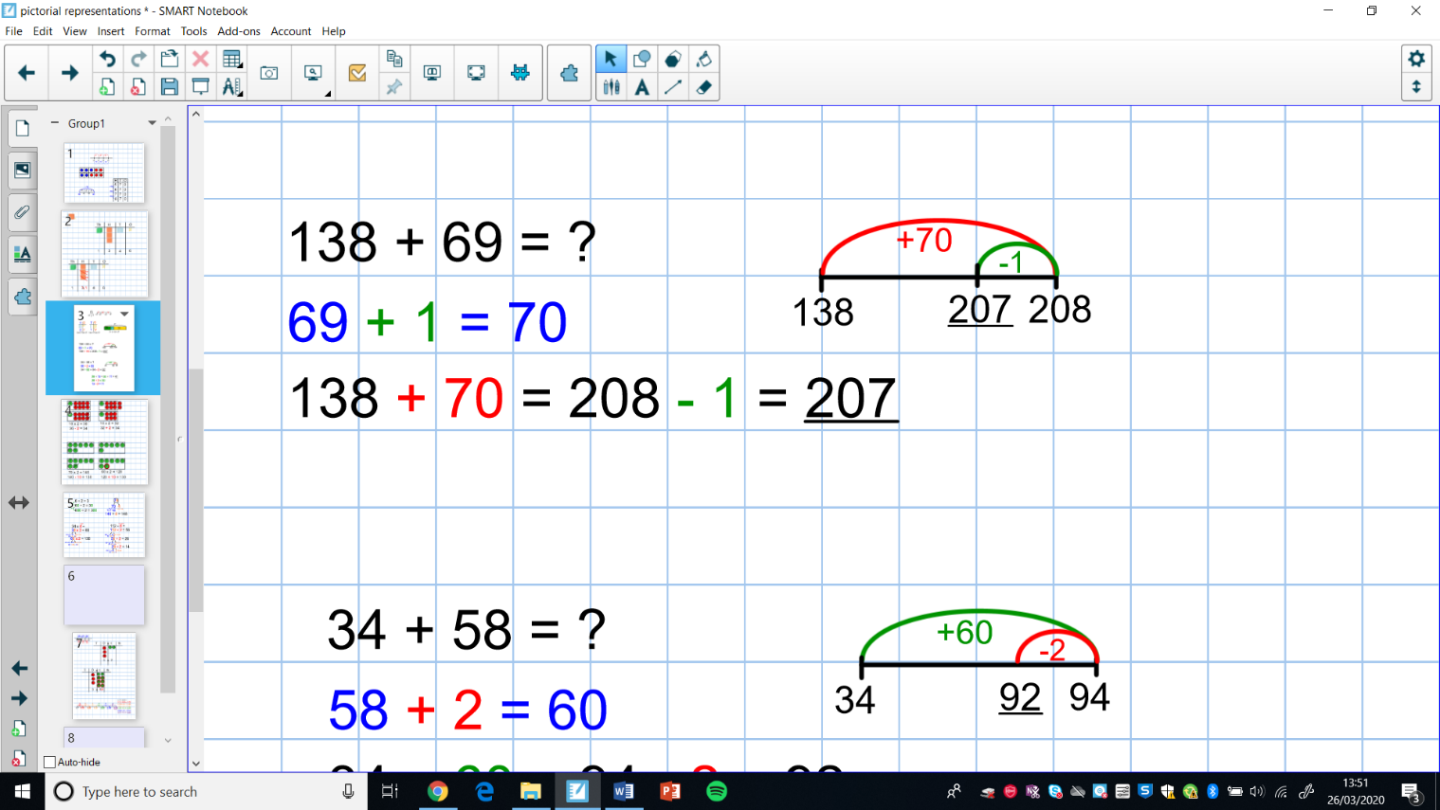  - Know how to adjust 3-digit numbers to make multiples of 10.  e.g. 128 + 32 = 130 + 30  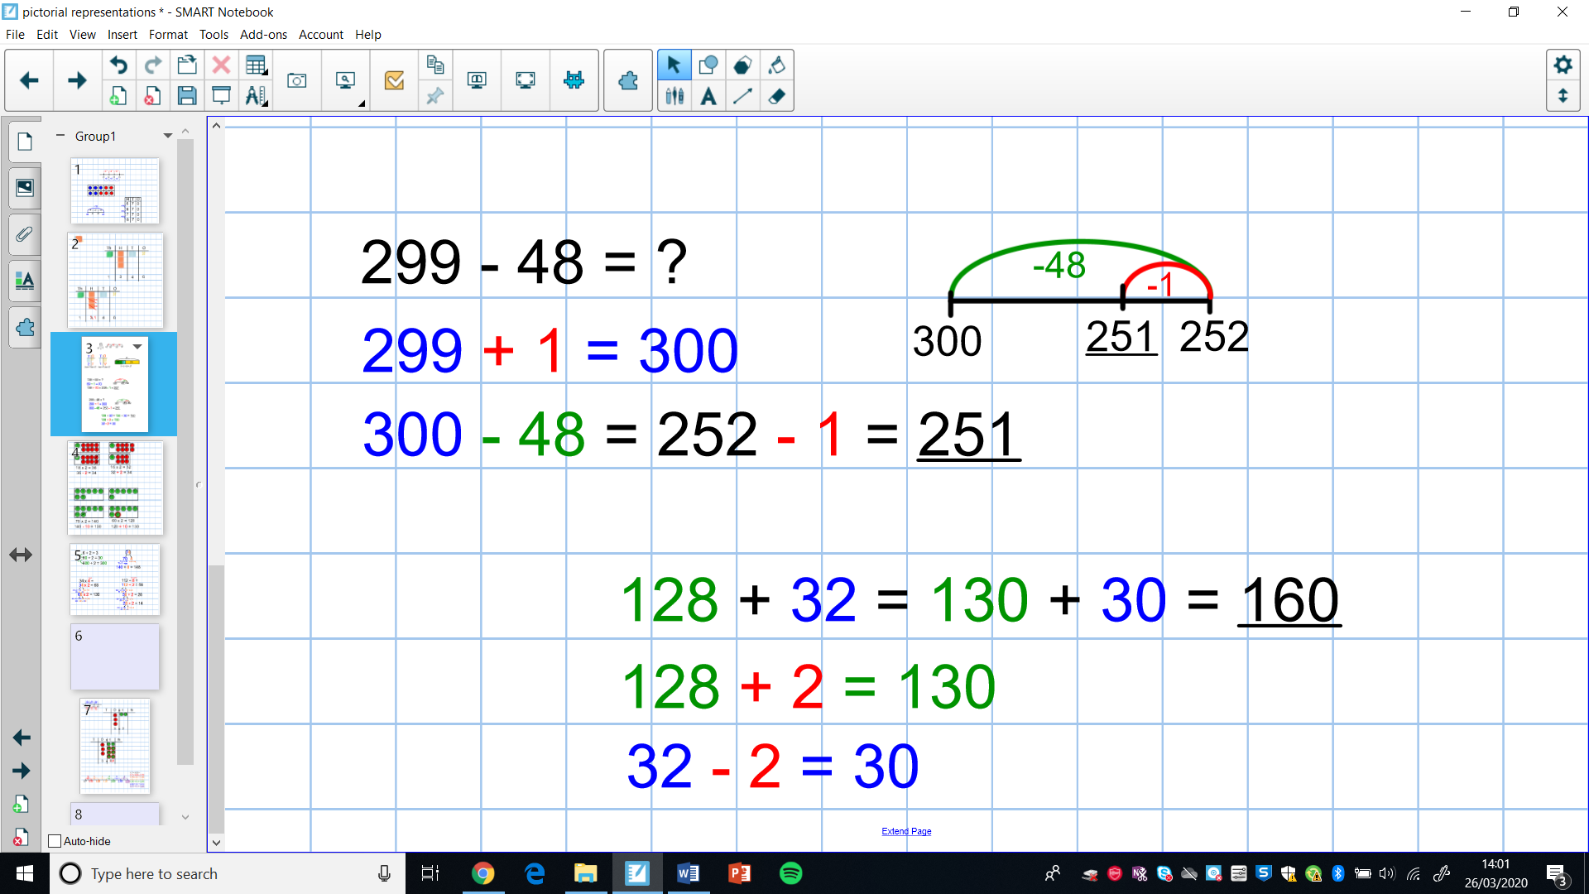  Partitioning – Calculations with decimal numbers  - Know how to partition numbers with decimal places with or without crossing place value boundaries  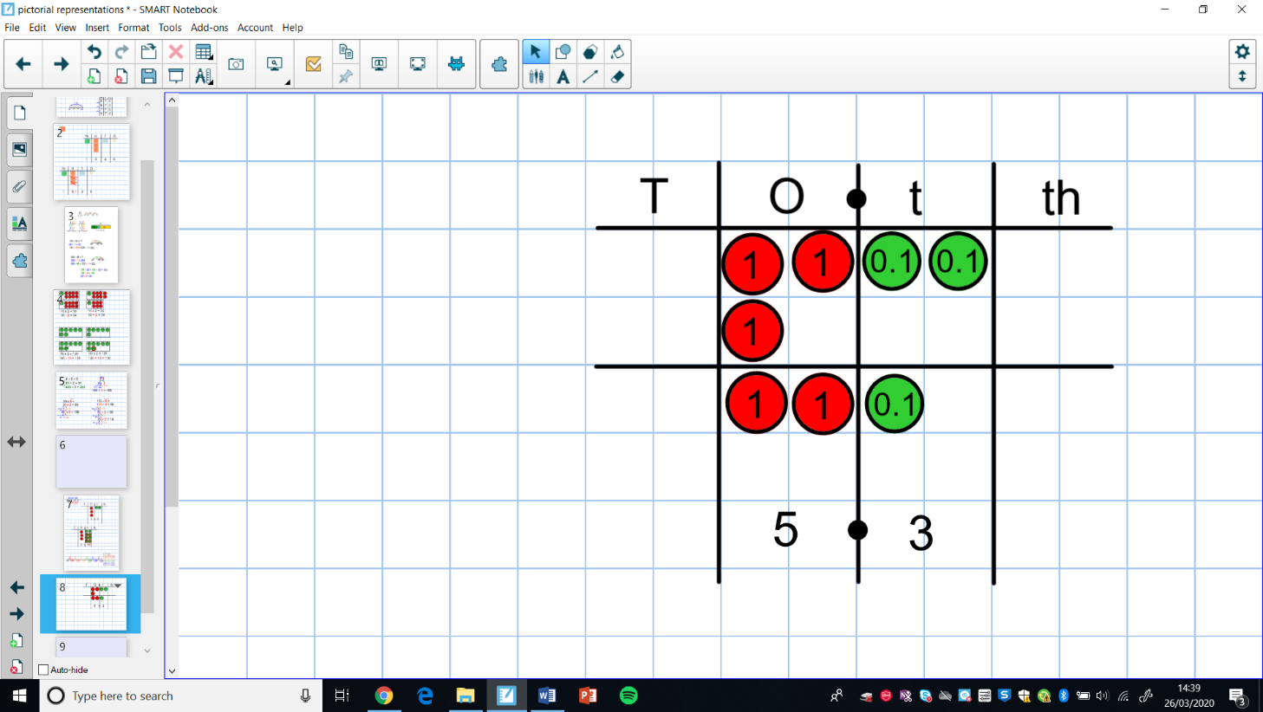  e.g. 3.2 + 2.1 = 5.3 e.g. 3.7 + 6.8  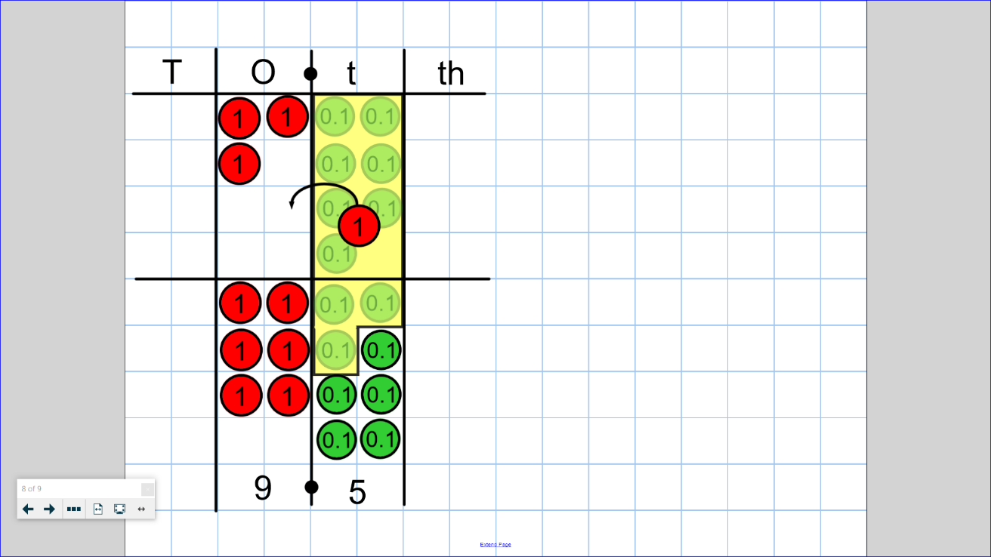
Near Doubles
- Know how to use near doubles to numbers up to 100.
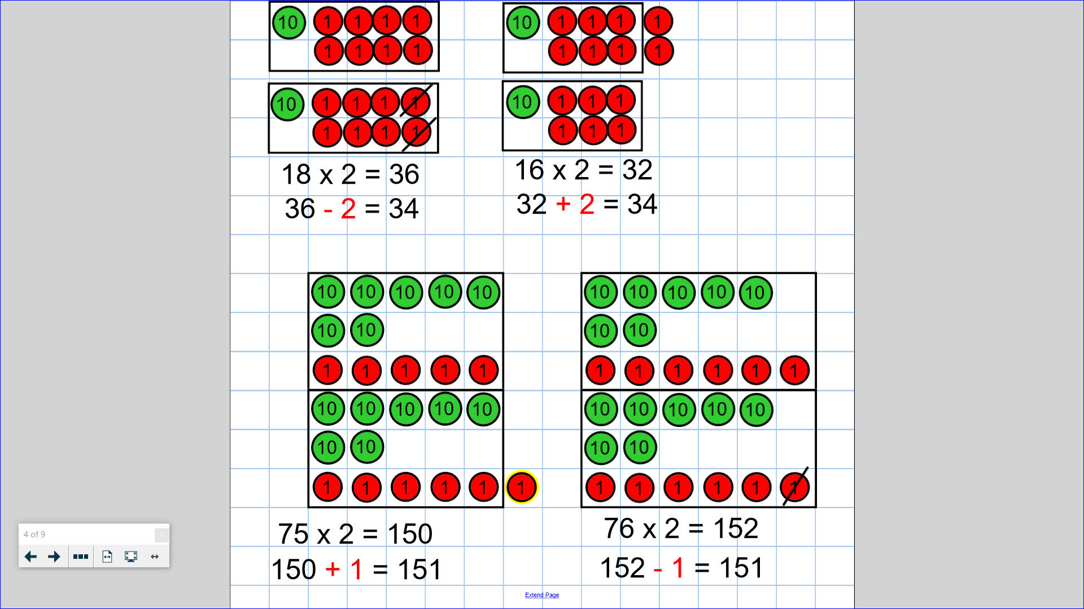

e.g. 75 + 76 is double 76 and subtract 1 or double 75 and add 1.

Doubling and Halving
- Know how to find the double and half of any number up to 1,000 by partitioning.
e.g. half of 3642 e.g. double 574
