Pinders Primary School – Mathematics Mental Strategies – Year 5
Rapid Recall Skills | Key Knowledge and Vocabulary
- Add/subtract multiples of 1000  - Multiply and divide any number by 10 and 100  - Halves of any number to 100 (e.g. half of 22 = 11, half of 51 = 25.5)  - Squares of all numbers up to 12  - Cubes of 2, 3, 4 and 5 | Adjusting multiples with decimals.  - Know how to adjust numbers with decimals or mixed fractions to solve calculations.  e.g. 2 $\frac{1}{2}$ + 1$\frac{3}{4}$ = 2 $\frac{1}{2}$ + 2 - $\frac{1}{4}$ e.g. 5.7 + 3.9 = 5.7 + 4.0 – 0.1  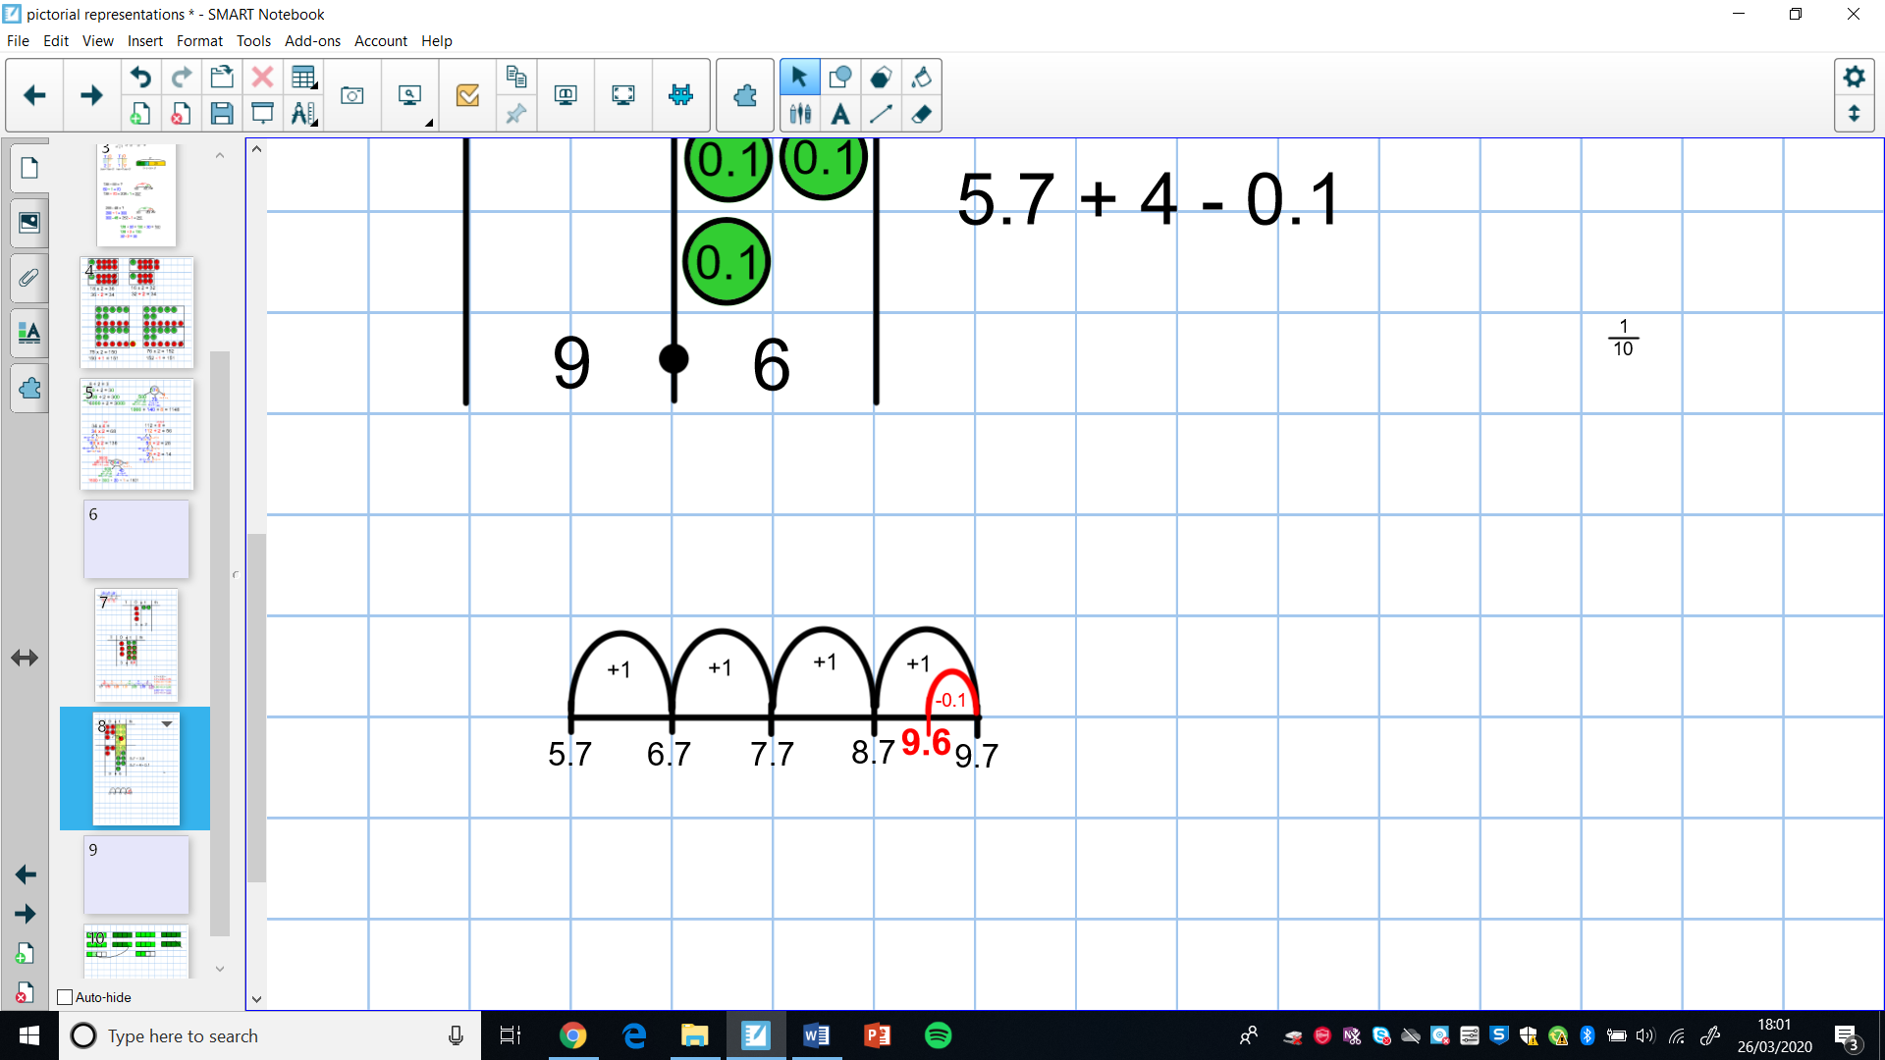  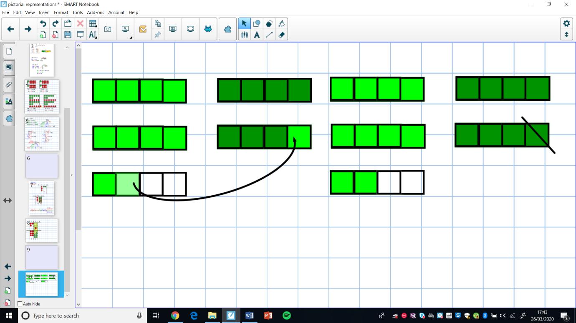  Near Doubles  - Know how to convert decimals to whole numbers to work out near doubles.  e.g. 2.5 + 2.6 is double 2.5 add 0.1 or double 2.6 subtract 0.1.  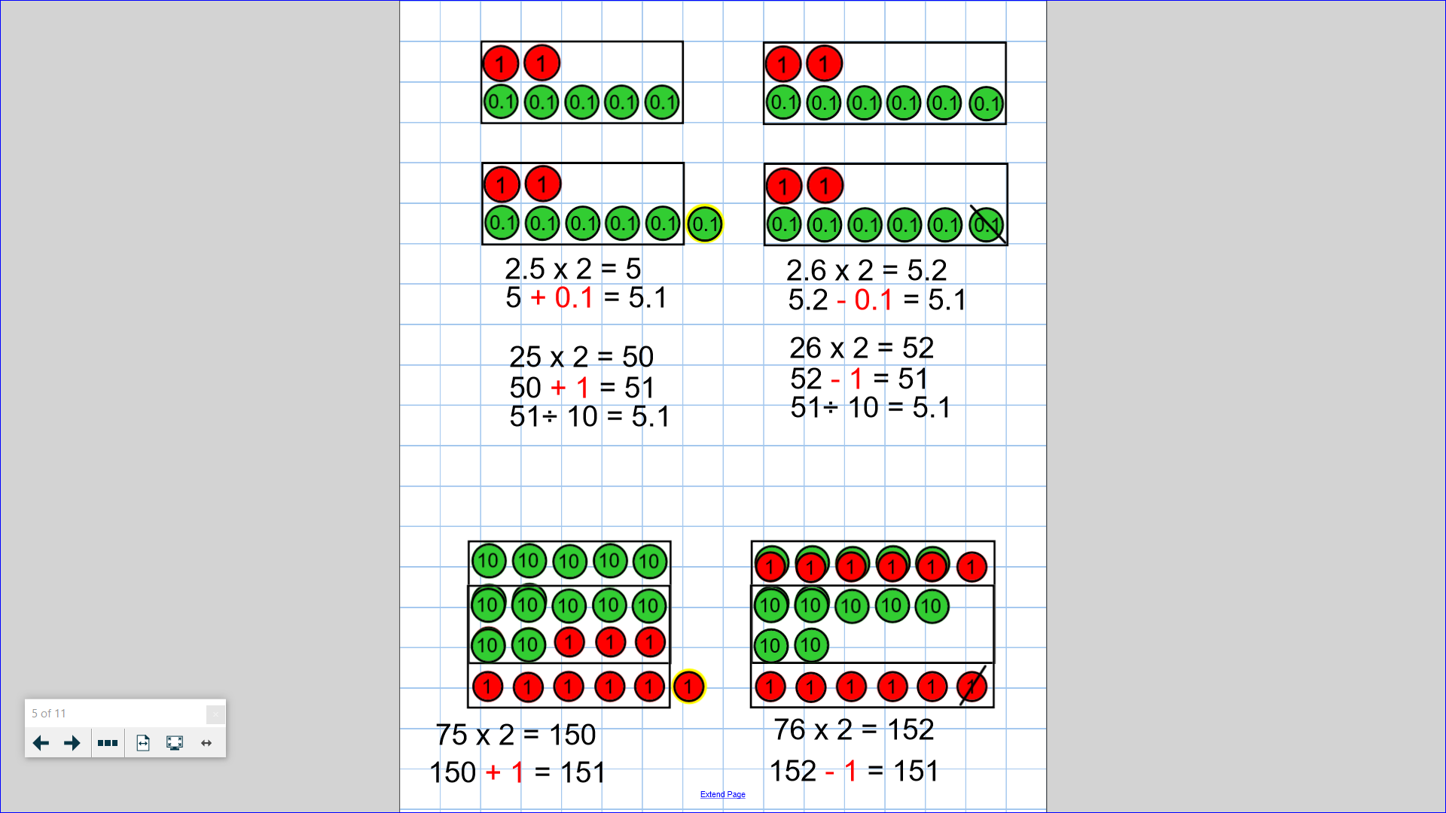  Doubling and Halving  - Know how to find the doubles and halves of any number up to 10, 000 by partitioning.  e.g. half of 83,642 by halving 80,000, 3,000, 600, 40 and 2  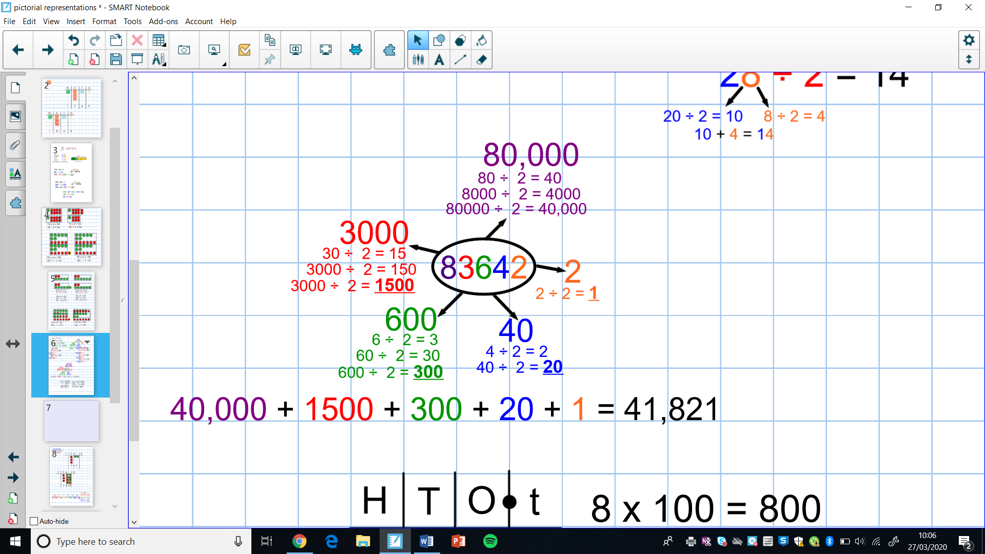  - Know how to multiply by 50 by multiplying by 100 and halving.  e.g. 8 x 50 = 8 x 100 ÷ 2  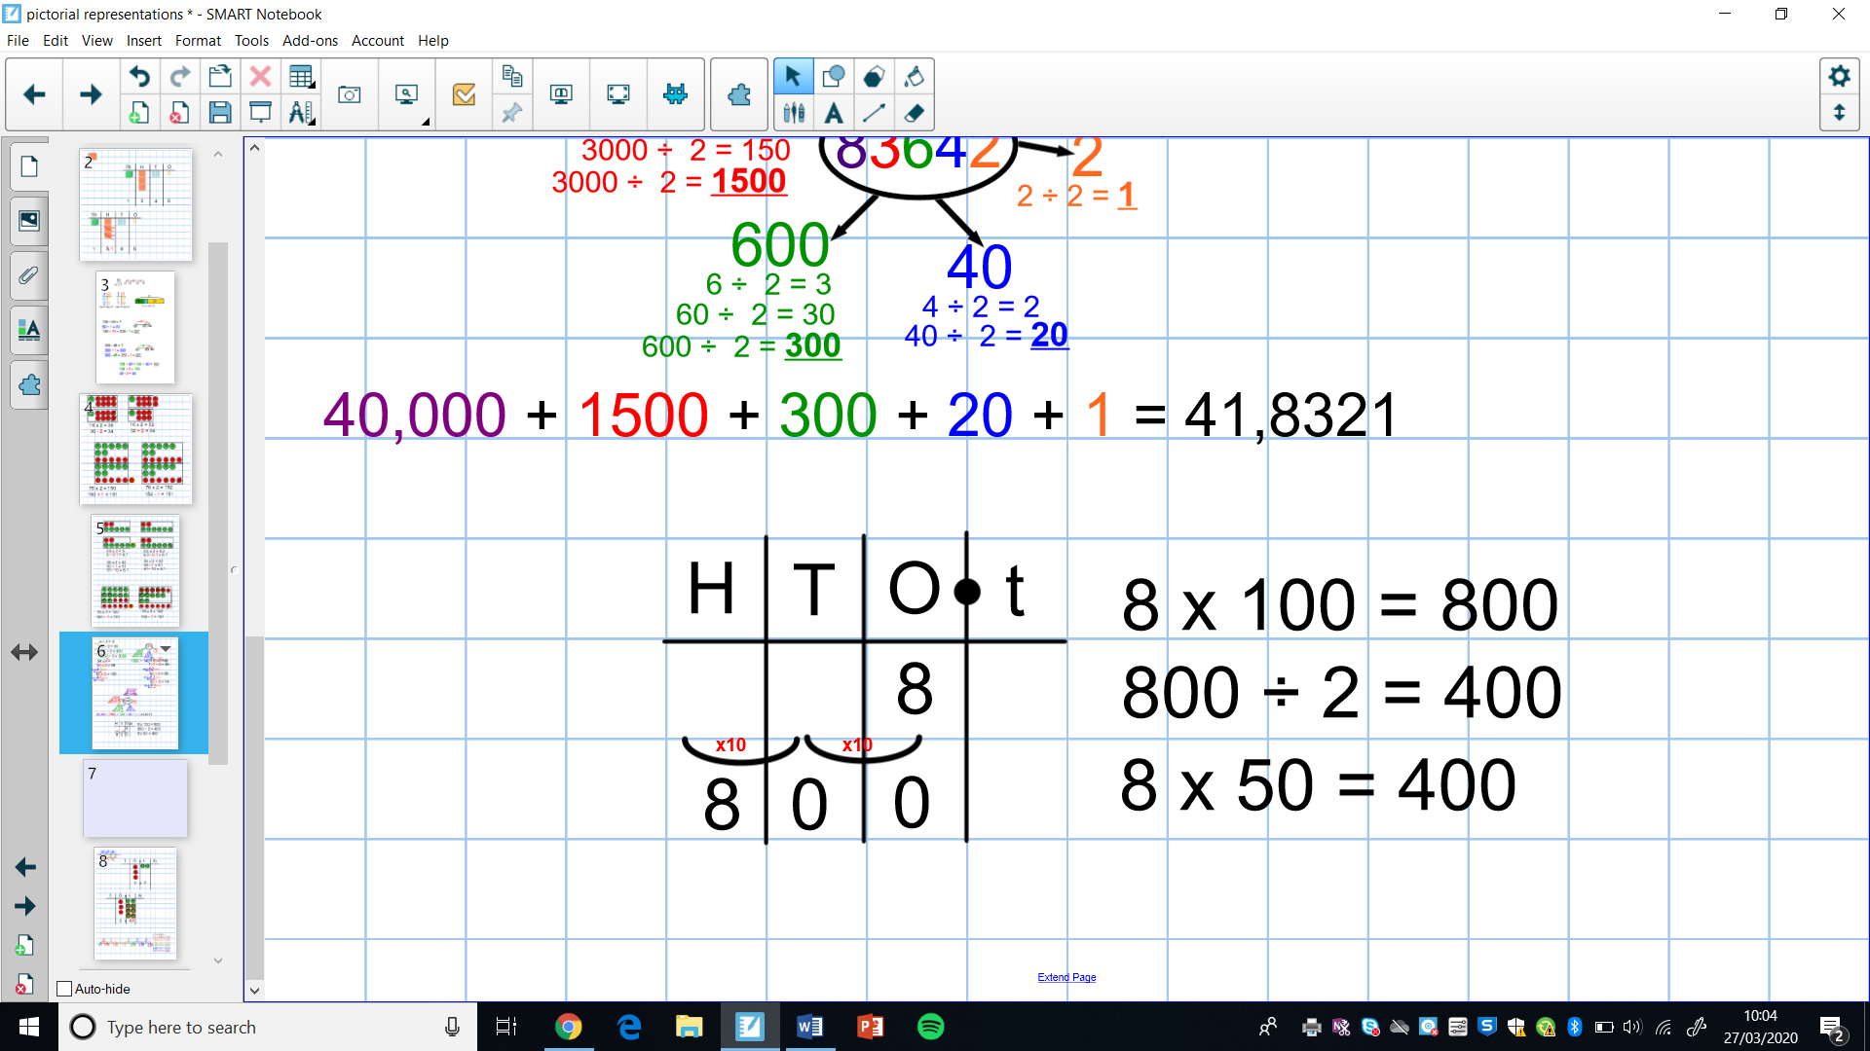  - Know how to double and half decimal numbers with up to one decimal place by partitioning  e.g. half of 8.4 by halving 8 and halving 0.4  