Pupil Premium Strategy

2019 – 2020



**Policy on the use of Pupil Premium Funding**



**Introduction**

Staff and Governors of Pinders Primary School are totally committed to ensuring that provision is made which secures the learning and teaching opportunities that meet the needs of all of the pupils so that all make maximum progress and reach their potential.

Our school welcomes and shares the government’s aim of tackling all forms of disadvantage and working tirelessly to ensure inclusion and equal access for all learners.

We recognise that the Pupil Premium funding is allocated to children in receipt of free school meals and is a means of addressing some of the issues associated with social disadvantage and in particular, in narrowing and hopefully eventually diminishing the difference where this exists. In making appropriate provision for this we also acknowledge that not all pupils in receipt of free school meals are socially disadvantaged.

**Provision**

Pinders is committed to excellence and the maintenance of high standards. We offer a wide range of provision aimed at enabling all learners to enjoy and thrive in learning and achieve their best.

**Rationale for decisions about provision**

The rationale for resource deployment is decided by the school, based on the principles stated in our provision map. These are:

* effectiveness and impact so that progress and achievement is maximised for every pupil
* fitness for purpose
* value for money acknowledging appropriate accountability
* equity
* inclusivity

Pupil Premium Funding will be used in the first instance to support the learning needs of children in receipt of free school meals who need extra support, however, this provision may well also include other children who have been identified as ‘vulnerable’.

The school’s leadership team, through class teachers will monitor the attainment and progress of all pupils and decide which pupils need additional provision and what this provision will be. We use on-going and fixed point assessment to identify children’s learning needs and plan next steps teaching. A range of additional support may be provided that is felt to best meet the child’s needs at the time. The SENCO is also involved in this process. We always seek to provide outstanding quality first teaching for all pupils. Timely, precision taught intervention is also used to maximise pupils’ progress and attainment.

When considering the deployment and funding of additional support through pupil premium and other school budget monies, we take into account carefully the following options in-order to maximise the impact for the pupil:

* facilitating pupils’ access to education
* facilitating pupils’ access to the school’s curriculum
* support in addition to the provision made in the classroom e.g. specific programmes or targeted interventions
* additional opportunities to enhance or complement the school offer e.g. after school clubs, holiday clubs etc.

Where it is considered that there is a need for alternative provision from external providers that complements the school’s offer, the Head Teacher will agree this following discussion and advice from colleagues and other relevant sources.

**Monitoring and Evaluating Provision**

Once decided, additional provision is monitored session by session by those staff providing support. Adaptations are then made as necessary. The overall effectiveness and impact is evaluated termly usually through year group attainment and progress meetings. Information on pupil progress is shared with parents and at consultation events.

In evaluating effectiveness, a range of evidence is used including:

* attainment and progress outcomes;
* feedback from staff, the child, parents and other professionals who may be involved;
* examples of learning through photographs, recorded learning or transcriptions
* anecdotal, impressionistic evidence relating to improved confidence, well-being, attitude, behaviour etc.

The Governors’ will have a monitoring oversight of the use of Pupil Premium Funding and the provision it supports.

**Reporting and Accountability**

It will be the responsibility of the Head Teacher, or a delegated member of staff, to produce a termly report for the Governors’ Curriculum sub- Committee on:

* the progress made towards diminishing the difference, by year group, for socially disadvantaged pupils
* the teacher assessment data we collect e.g. phonological assessment, spelling, reading, writing and maths that demonstrates this
* comparative data for all none socially disadvantaged pupils by year group

The Headteacher, with support from SLT, will provide an annual report to the governing body on the school’s progress towards ‘diminishing the difference for socially disadvantaged and other ‘vulnerable’ pupils. This will be presented at their first meeting each autumn term.

This report will follow DfE guidelines but will in essence:

* detail the average progress of those pupils receiving support funded from pupil premium;
* include financial details of how pupil premium was spent

This report will also be published on the school’s website and parents/carers will be informed when this has been done via the school’s Newsletter.

**Complaints**

It has been indicated by the DfE that it is intended that parents will be able to request access to their child’s share of the premium. As the intervention programme will be planned in advance and will account for all of the funding available to the school for these activities, funding will not, therefore, be available to parents to arrange their own chosen interventions. Our policy, therefore, is that this will not be allowed. The Head Teacher will meet with the parent and seek to come to an understanding and agreement about how funding will be best used for the individual if a parent so requests.

Any allegation, complaint, disagreement or appeal regarding the deployment of Pupil Premium Funding will be considered by a panel of Governors convened by the Chair of Governors, as necessary, for this purpose.

|  |  |  |  |  |  |
| --- | --- | --- | --- | --- | --- |
| **Summary Information** | | | | | |
| **School:** | Pinders Primary School | | | | |
| **Academic Year:** | 2019/2020 | **Total PP Budget:** | 64,713  (This is taken from 7/12 of the current financial year and 5/12 of the children in the academic year 19/20) | **Date of most recent PP review:** | Summer  (2018) - External |
| **Total number of pupils:** | 246 | **Number of pupil eligible for PP:** | 43 | **Date for next PP Strategy Review:** | Sumer 2020 |

|  |  |  |  |
| --- | --- | --- | --- |
| **Supporting the Whole Child** **Academic**    The pupil premium is additional monies given to schools to support pupils who are considered disadvantaged. The chosen measure for this is the entitlement of Free School Meals within the past 6 years. The current funding is £1320 per pupil and £2300 for any child who is Looked After Child. We have 60,688 in total. | | | |
| Activity | Outcomes | Expenditure | % of disadvantage impacting against (47 Pupil Premium) |
| **Focus Booster Groups (Years 2 and 6)**  Overview: Pupils in Year 2 and 6 to receive focus intervention within Maths, Reading and Writing after school by 1 teacher and two LSA’s | A greater number of children of pupils at or above age related expectations. Increased confidence and self-esteem | Cost: £942  Full Budget:  LSA - 25 hours x 2 = £3172  Teacher = £450  **Total Budget= £3622** | 11/43 = 26% |
| **Focus Maths Groups (Year 6) X Deputy Head Teacher**  5 hours a week of precision teaching session of a class of 8**.** | A greater number of children of pupils at or above age related expectations in Maths | £406  **Full Budget:**  **Wage (24 weeks – 5 days) - £5812** | 3/43 of the children are PP = 7% |
| **One to One Focus Sessions**  This will be completed by the Deputy Head teacher and Head teacher | Greater progress schools for children within Key Stage 2 | £984  **Full Budget:**  **Wage (14 weeks 5 hours a week - £7030** | 6/43 of the children are PP = 14% |
| **Maths resources + Revision Materials**  Pupils to use high quality resources to support their learning. | A greater number of children of pupils at or above age related expectations. Increased confidence and self-esteem | Cost: £1200 | 50/50 = 100% will be accessing and using the concrete resources |
| **Looked After Programme**  Looked after children gain an individualised programme with their funding directly impacting against education outcomes. | Greater progress scores within academic subjects. | £4600 |  |
| **Cross curricular reading resources** | To ensure a rich reading curriculum within the wider curriculum. | Cost: £500 |  |
| **Pixl – Precision materials to support diminishing the gap within Year 5 and 6** | A greater number of children of pupils at or above age related expectations or increased progress measures | Cost: £8000  Full cost: £9,003 | 43 (100%) disadvantage of the 43 cohort. |
| **Learning Support Assistants (LSA) through Same Day Intervention**  Pupils are identified if they need further support in maths. This is further support by the Maths Hub Intervention programme which involves the LSA’s.  **15 mins a day** | A greater number of children of pupils at or above age related expectations. Increased confidence and self-esteem | Cost: £1647  **Full budget spent on LSA: £348,017** | 50/50 = 100% will be accessing the SDI and the opportunity to be identified for intervention or challenge. |
| **Learning Support Assistants (LSA) One to One Daily Readers x 17**  **15 mins a day** | A greater number of children of pupils at or above age related expectations. Increased confidence and self-esteem | Cost: £1647  **Full budget spent on LSA: £348,017** | 50/50 = 100% will be accessing the SDI and the opportunity to be identified for intervention or challenge. |
| **Learning Support Assistant placed into Year 6 to support progress of disadvantage children** | Children will have greater confidence within their independent work in English and Maths | Cost: £5040  **Full budget spent on LSA: £18,000** | 12/43 = 28% |
| **Specific Learning Difficult Assistant to develop working memory** | Certain children with specific learning difficulties to have one to one intervention to develop working memory. | Cost: £525  **Full budget spent on LSA: £7500** | 3/43 = 7% of the Pupil premium cohort |
| **Wakefield Music Services** | Children have additional opportunities to learn a tuned instrument within their music curriculum. | Cost: £2107  **Full budget spent on £4200** | 22/43 = 51% of the Pupil Premium Cohort |
| **Hardware and Software to ensure precision and quality engagement from children**  -Classroom Secrets  -SMART  -LbQ  -Mobile Devices | Children have access to all be able to engage with the technology and learning software. | Cost: £8141  **Full budget spent £10,000** | 38/43 = 88% of the Pupil Premium Cohort |

|  |  |  |  |
| --- | --- | --- | --- |
| **Supporting the Whole Child** **Well Being**    The pupil premium is additional monies given to schools to support pupils who are considered disadvantaged. The chosen measure for this is the entitlement of Free School Meals within the past 6 years. The current funding is £1320 per pupil. We have 60,688 in total. | | | |
| Activity | Outcomes | Expenditure | % of disadvantage impacting against (50 Pupil Premium) |
| **Family Support Work**  Our family Support Worker works with families and children to provide pastoral care in school time and summer holidays | Pupils with additional needs supported through CAF. Increased confidence and self-esteem. Pupils happier at school and at home, more able to access learning. | Cost: £3000  **Full Salary: £7901.33** | On average 8/50.  This changes throughout the year |
| **Learning mentor—Emotional and Behavioural Support + Attendance Officer**  To work with a range of children’s personal, social and emotional behaviours. | Increased confidence and self-esteem. Pupils happier at school and at home, more able to access learning. Learning mentor supports at lunchtime with social skills and interaction. | Cost: £14,654  **Full Salary: £22,545** | 28/43 – 65% |
| **Attendance Initiatives.**  To encourage attendance to school with termly rewards and events. | More access to learning, consistent teaching and progress. | Cost: £1500 | 43/43 – 100% |
| **Attendance Support**  Works with families and EWO to ensure disadvantage children are regularly attending school. | Disadvantage children attendance is higher than non-disadvantage and PA is lower. | Cost £2683  (1 hour a day)  **Full Salary: £22,545** | 43/43 – 100% |
| **Behavioural Awards**  Rewards for behavioural events throughout the year | Children making positive choices towards all their behaviours throughout the day. | Cost: £1000 | 50/50 -100% |
| **Breakfast Club**  Breakfast club provision is free to all children and free bagels are delivered to class so all children have opportunity for food. | All children have access to free food. | £2112.24  **Full Budget:**  **£4062** | 23/43 – 57% |

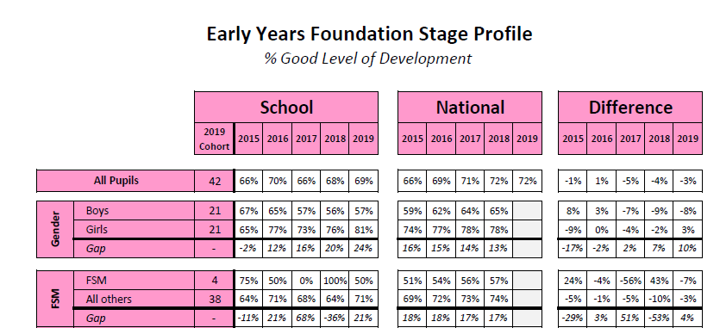

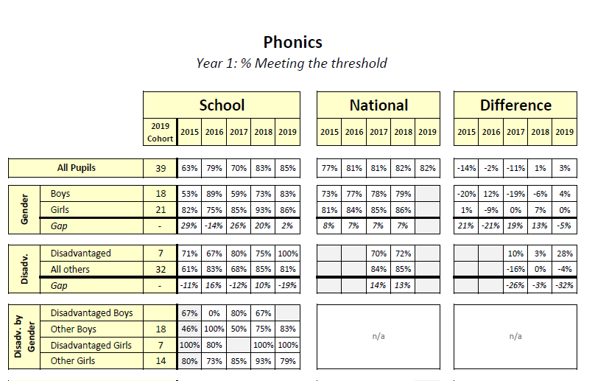

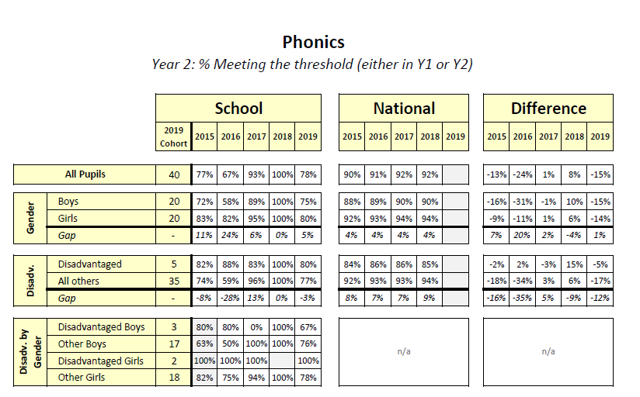

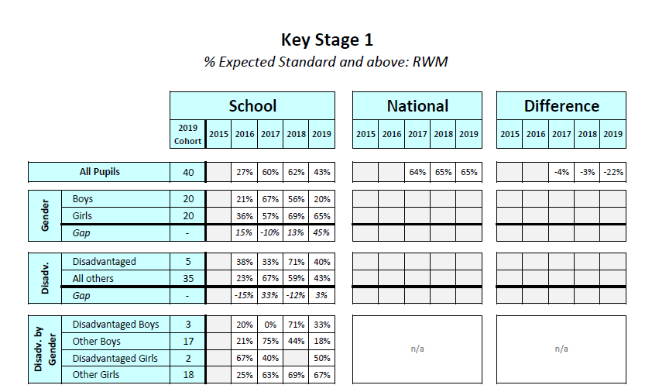

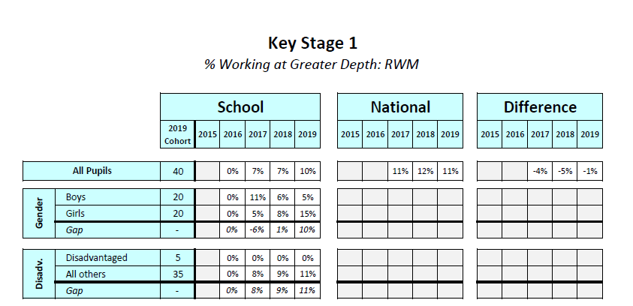

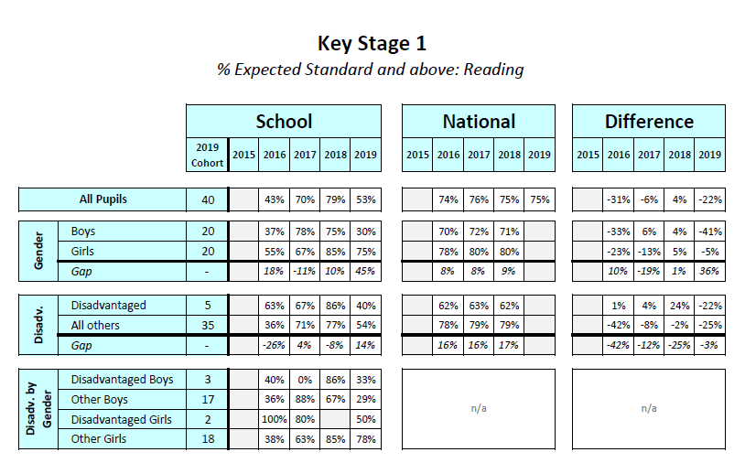

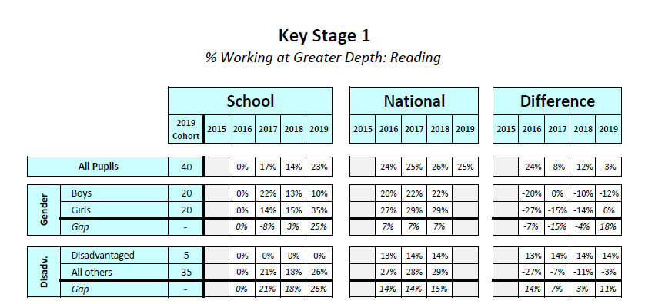

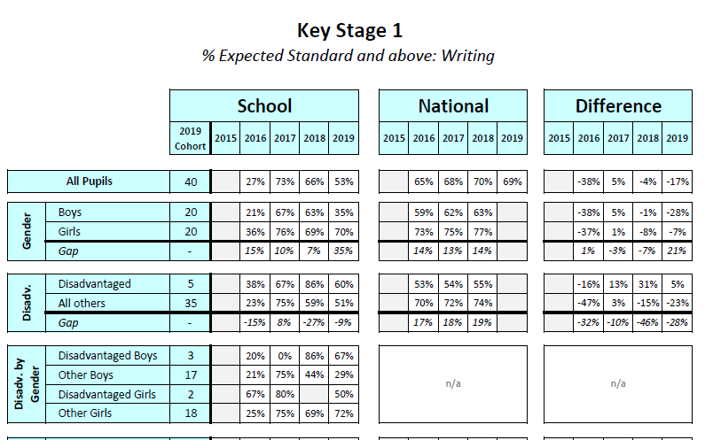

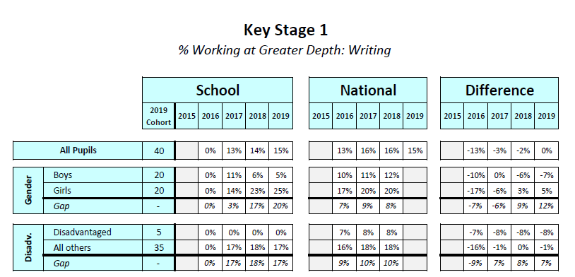

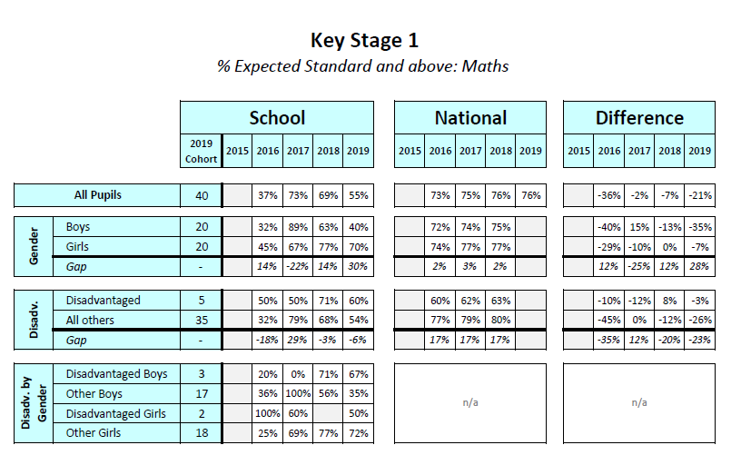

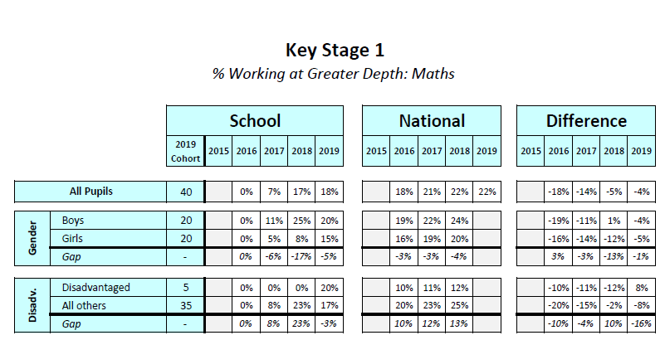

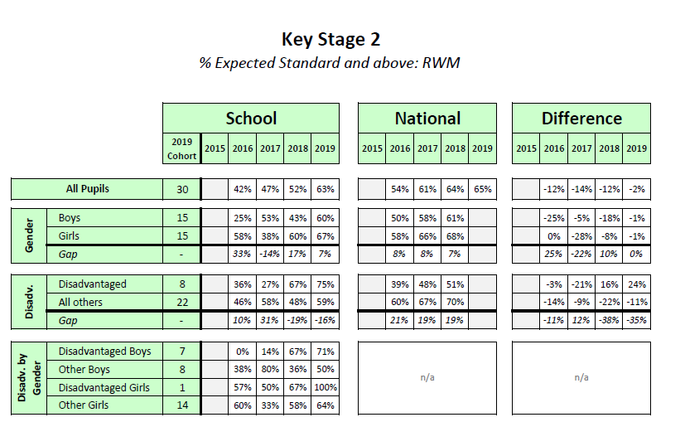

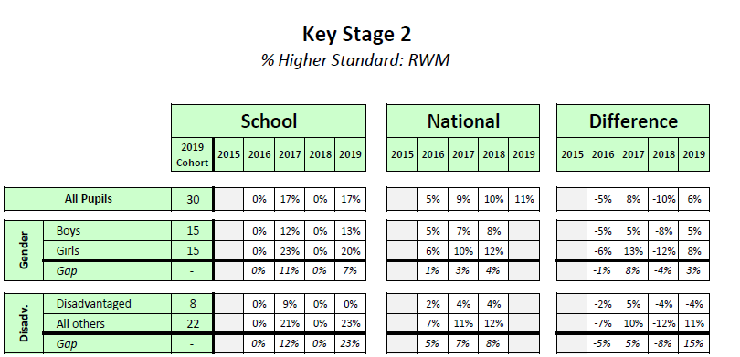

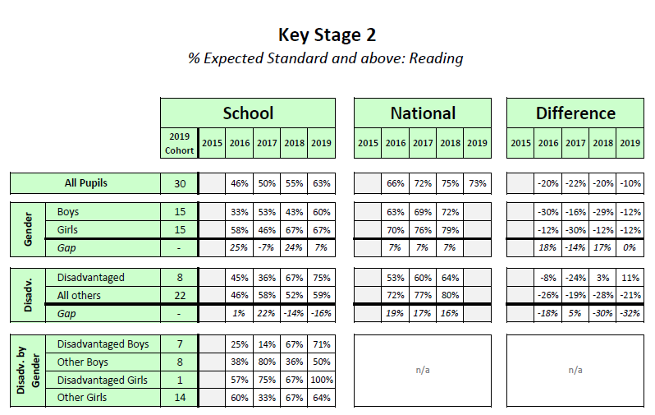

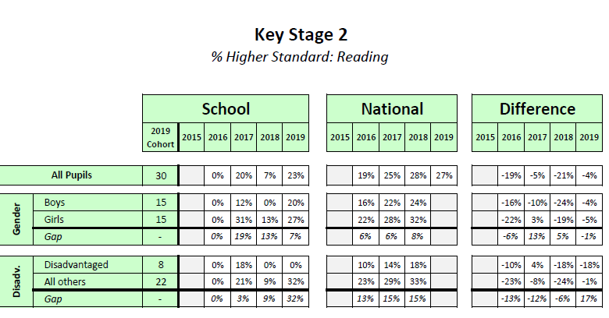

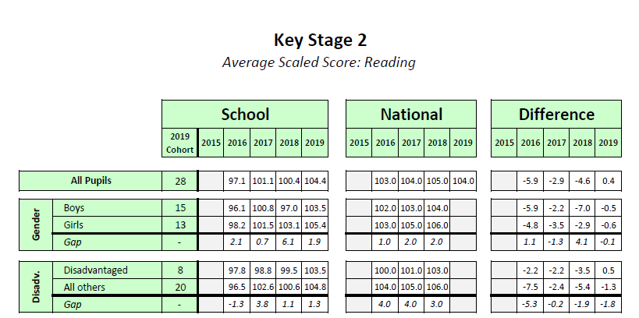

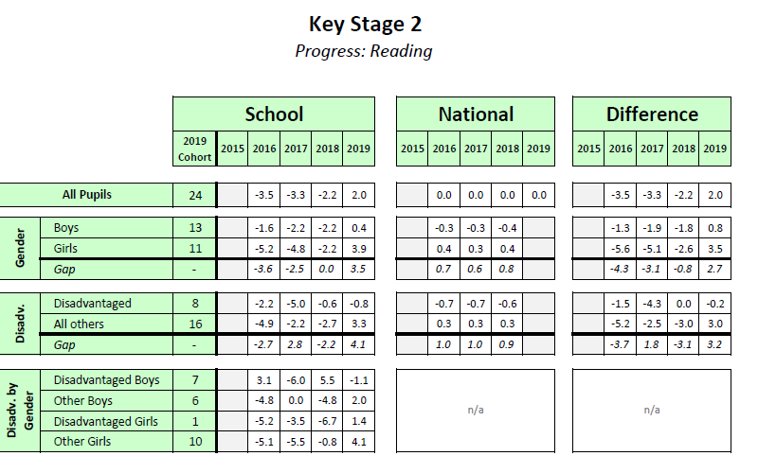

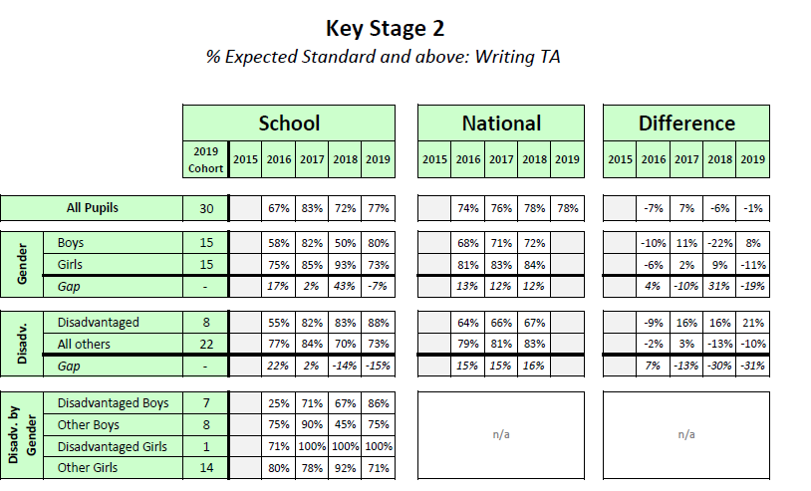

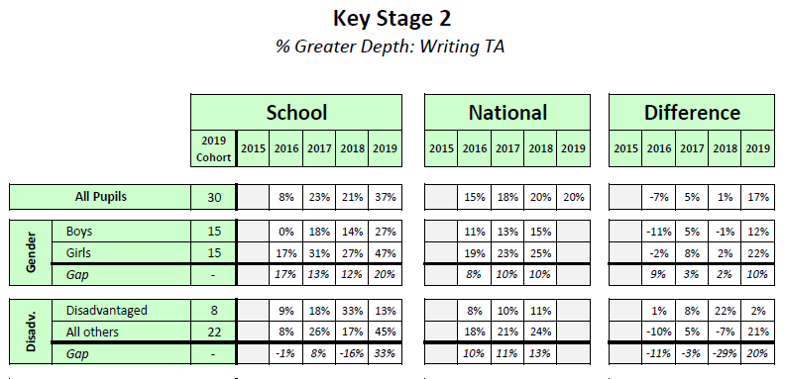

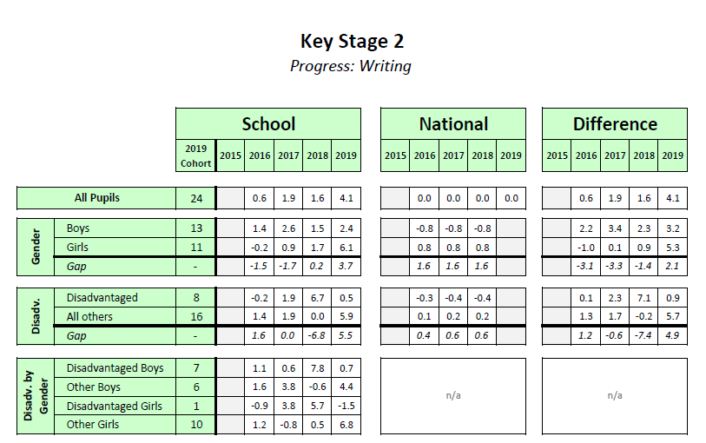

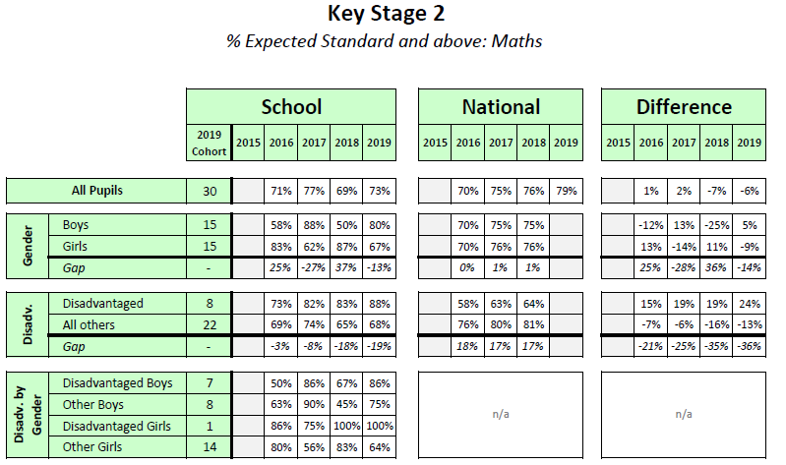

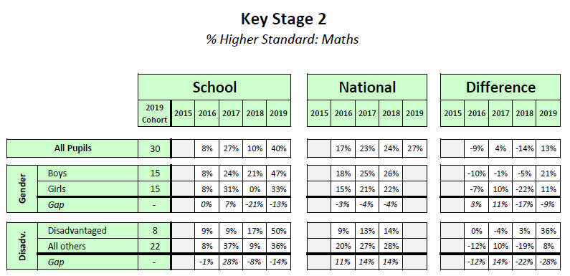

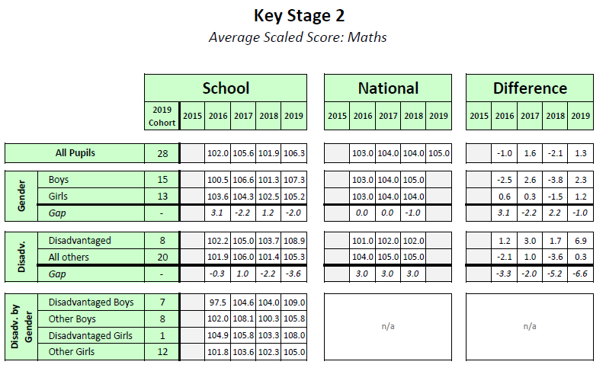

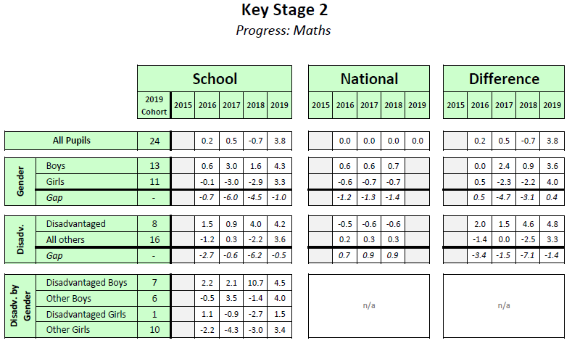

**Year 1 Gap Analysis (Academic Year 2018/2019)**







**Year 2 Analysis (Academic Year 2018/2019)**







**Year 3 Analysis (Academic Year 2018/2019)**







**Year 4 Analysis (Academic Year 2018/2019)**







**Year 5 Analysis (Academic Year 2018/2019)**







**Gap analysis – Difference over time**

**Year 1 Gap Analysis Over Time (Academic Year 2018/2019)**



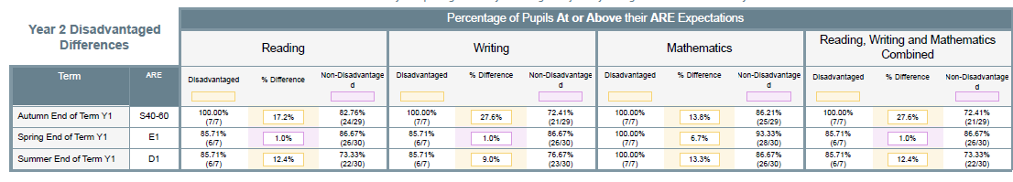

**Year 2 Gap Analysis Over Time (Academic Year 2018/2019)**



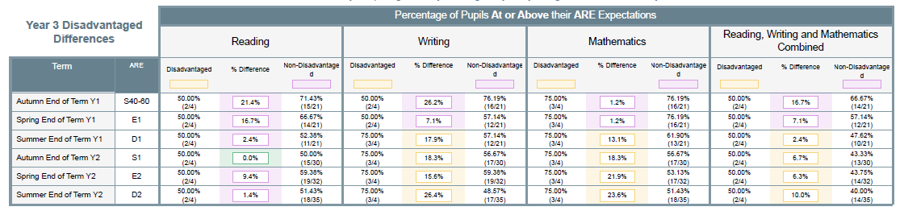

**Year 3 Gap Analysis Over Time (Academic Year 2018/2019)**



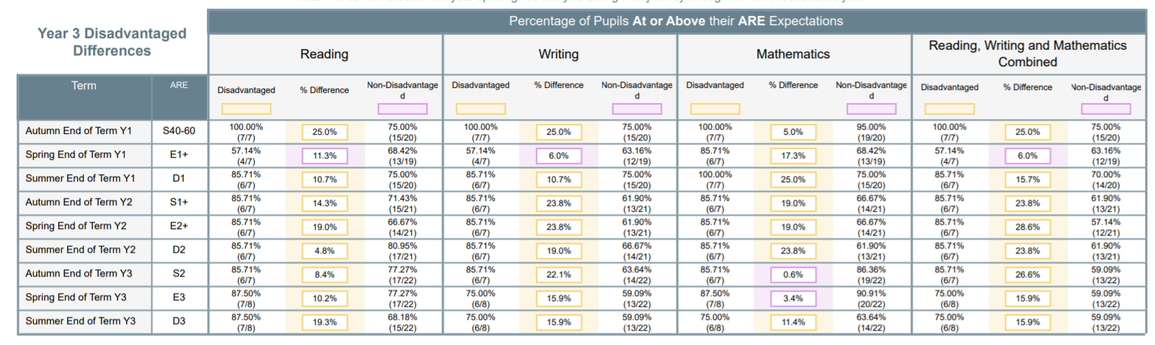

**Year 4 Gap Analysis Over Time (Academic Year 2018/2019)**



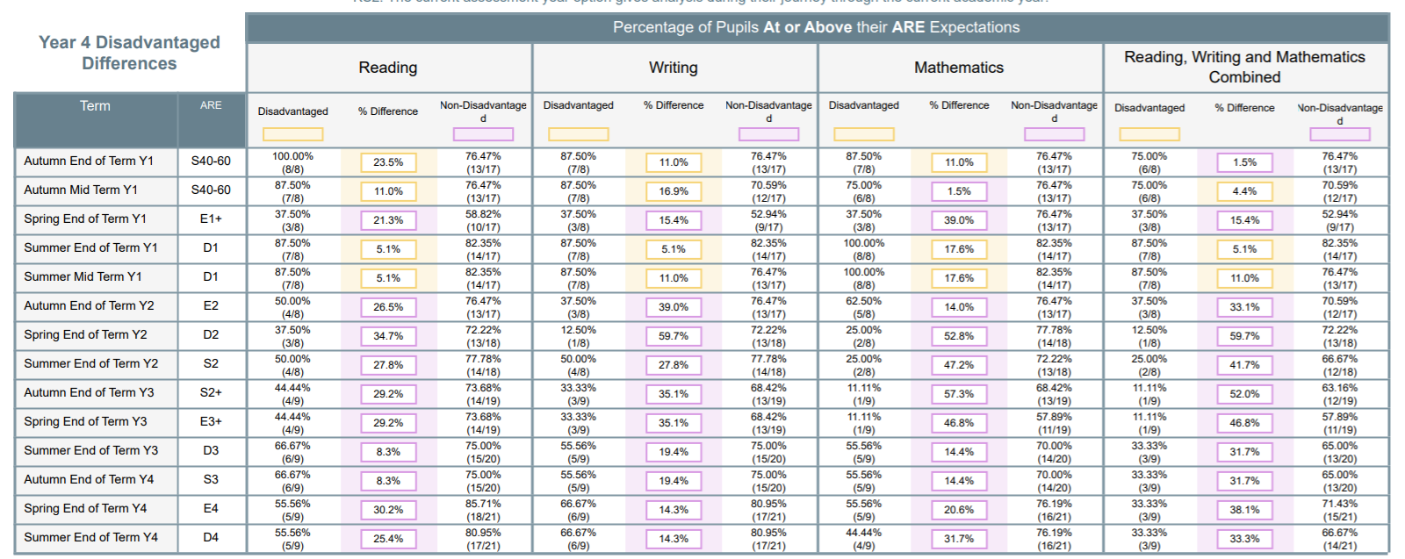

**Year 5 Gap Analysis Over Time (Academic Year 2018/2019)**



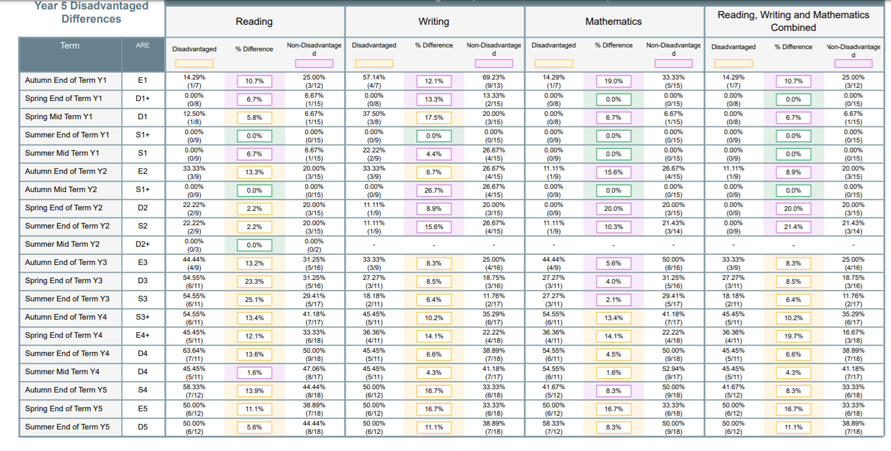

|  |  |  |  |  |
| --- | --- | --- | --- | --- |
| **Methodology** | | | | |
| **Focus** | **Reading comprehension + Greater Developed Vocabulary**  Data shows that disadvantage pupils in Year 6 underperform relative to their peers and nationally. The gap in reading is __% percentage points. The school will focus on this with the current Year 6’s and early readers as well as a whole school agenda. | **Early Reading**  Data shows that our pupils are below the national trend within Reading with disadvantage children being further behind than their peers and the national trend. | **Effective focused intervention and Precision Teaching**  Data shows the disadvantage pupils in Years 3,4,5 and 6 are underperforming compared to national statistics. However the attainment and progress of middle attaining children is a whole school agenda. | **Pastoral Care**  We have a significantly proportion of children at school with Pastoral needs to ensure they feel safe and confident. This is throughout the school (Nursery to Year 6) |
| **Barriers to learning** | Higher percentage of EAL children (80.1%) Low parental engagement Low percentage of parents able to read English.  Children coming into the country with no English.  High percentage of EAL making statutory testing harder for children to access | Higher percentage of EAL children (80.1%) Low parental engagement Low percentage of parents able to read English.  Children coming into the country with no English.  High percentage of EAL making statutory testing harder for children to access | Children coming into the country with no English.  An increase percentage of correct answers within working meaning /finding domains.  Low parental engagement | Vulnerable facts that can disadvantage a child’s development. |
| **Desired outcomes** | Improve pupils’ engagement with and understanding of texts, leading to improved learning across the curriculum and raised attainment in reading.  Increase the number of children attaining ARE expectations within Reading, Writing and Maths. | Improve pupils’ engagement with and understanding of texts, leading to improved learning across the curriculum and raised attainment in reading.  Increase the number of children attaining ARE expectations within Reading, Writing and Maths. | Increase the number of children attaining ARE expectations within Reading, Writing and Maths. | Decreased number of children accessing pastoral care. Increased children in tackling social and emotional situations within school.  Increased percentage of children accessing the lessons. |
| **Success Criteria** | Gap in expected level for reading between disadvantaged pupils in school and other pupils nationally will reduce and there will be a higher % of disadvantage children achieving A  Disadvantage children to make better progress than non-disadvantage children. Disadvantage children attaining ARE inline with national expectations. aRE and greater depth. | Gap in expected level for reading between disadvantaged pupils in school and other pupils nationally will reduce and there will be a higher % of disadvantage children achieving A  Disadvantage children to make better progress than non-disadvantage children. Disadvantage children attaining ARE inline with national expectations. aRE and greater depth. | Disadvantage children to make better progress than non-disadvantage children. Disadvantage children attaining ARE inline with national expectations. | Educational outcomes.  Successful implementation of social and emotional strategies within a range of contexts. |
| **Choose your strategies** | **Reading comprehension strategies, peer tutoring and early years intervention**.  Evidence from the EEF toolkit shows that both these approaches are effective relative to their costs – particularly for upper primary children and lower school for effective intervention. Training will enable all teachers and TAs to use reading comprehension strategies effectively. | **Reading comprehension strategies, peer tutoring and early years intervention**.  Evidence from the EEF toolkit shows that both these approaches are effective relative to their costs – particularly for upper primary children and lower school for effective intervention. Training will enable all teachers and TAs to use reading comprehension strategies effectively. | **Small group tuition**  Small group tuition is working up to five pupils and enables the teacher to focus exclusively on a small number of learners, usually in a different room or a different part of the classroom. This is made to regular and using a range of apparatus and teaching styles. | **Behaviour interventions and Social and Emotional Learning**  Behaviour interventions seek to improve attainment by reducing challenging behaviour, including aggression, violence, bullying, substance abuse and general anti-social activities. Intervention which target social and emotional learning seek to improve attainment by improving the social and emotional dimensions of learning, as opposed to focusing directly on the academic or cognitive elements of learning.  g |
| **Evaluate your strategies** |  |  |  |  |

|  |  |
| --- | --- |
| **Barriers to learning (for pupils eligible for PP)** | |
| **In school barriers** | |
| **A** | Oral Language Skills  (See School Improvement Plan – KIP 2 and 3) |
| **B** | Independent skills |
| **C** | Social and Emotional Wellbeing |
| **External barriers** | |
| **D** | Low attendance rates  (See School Improvement Plan – KIP 4) |
| **E** | Environment/Disadvantage contexts without receipt of PP  (See School Improvement Plan – KIP 4) |
| **F** | Parental Engagement/Language |

|  |  |  |
| --- | --- | --- |
| **Outcomes (Desired outcomes and how they will be measured)** | | **Success criteria** |
| A. | **Development of reading comprehension + Vocabulary** | Greater percentage of children with higher reading and comprehension ages. |
| B. | **Early Reading – Attaining good foundations.** | Termly assessment analysis of Data outcomes  Pupil Progress Meeting |
| C. | **Precision Teaching** | Accelerated pupil progress and diminishing the difference |
| D. | **Pastoral Care** | Children able to access the curriculum and making appropriate progress.  Individual case studies  Pastoral Impact |

|  |  |  |  |  |  |
| --- | --- | --- | --- | --- | --- |
| **Planned expenditure** | | | | | |
| Academic Year: 2019/2020 | | | | | |
| **The fours headings below enable school to demonstrate how we are using the Pupil Premium to improve classroom pedagogy, provide targeted support and support whole school strategies.** | | | | | |
| 1. **Ensure reading is higher profile, that pupils’ reading, and comprehension is more closely monitored, and that school has a focus on reading questioning and comprehension feedback.** | | | | | |
| **Desired outcome** | **Chosen action/approach** | **What is the evidence and rationale for this choice?** | **How will you ensure it is implemented well?** | **Staff lead** | **When will you review implementation?** |
| Improvement in children’s reading age and comprehension age.  Children access a higher range of vocabulary throughout all subjects. | Develop inviting and stimulating reading areas in every classroom which might include photos of pupils and their families reading and include pupils’ book reviews to promote the image of pupils and families as readers;  Include explicit messages that reading is fun and important in every classroom and reading area;  Development of the extra curricular and enrichment curricular activities and within the breakfast club provision.  High level of reading MRE making it explicit to staff what the marking and feedback expectations are in reading activities so that reading and comprehension work are given a higher priority;  Reading records and/or guided reading records and reading files to be scrutinise to monitor the quality and consistency of the reading  Monitor the frequency of home reading with a whole school reward system celebrating whole class achievements.  Governor meetings to have Reading as an agenda item. Reading link governor to be actively involved in school.  Quality CPD sessions for teachers and learning support assistants  Implementation of new reading registers with disadvantage children identified.  Performance Management targets for teachers and learning support assistants linked to key children.  Whole school training to develop higher order reading skills and the development of reading speeds. This linking with the activities created within the Read and Respond and Cracking Comprehensions.  MRE of the taught reading sessions of Cracking Comprehension and Read and Respond.  Further enhancement of ‘Cracking comprehension’ to ensure children secure exam techniques.  Precision teaching reports/activities to further inform teaching and learning activities.  Targeted afterschool booster sessions  (Year 2 and Year 6)  Year 5/6 Pixl Morning sessions  Foundation subjects to include reading skills and book stimulus to promote inference and deduction;  Explore opportunities for pupils to talk at greater length in foundation subjects which may involve a greater focus on explicitly teaching pupils how to work in pairs or groups as speaking partners;  Vocabulary books to be implemented which might become interactive and which can be designed to develop pupils’ knowledge and understanding of different word groups such as prepositions, nouns, conjunctions, adjectives and adverbs;  Subject Leader to be evolved as part of school’s ongoing work on its broad and balanced curriculum so that each subject leader develops a bank of age appropriate technical vocabulary in his or her subject. This can then be shared with colleagues and the vocabulary explicitly taught over the course of an academic year so that pupils develop an appropriate and broad range which supports their learning;  Governors fully informed of all the above so that they can offer support and challenge in their role as critical friends.  Ensuring all lessons, observations and drop ins are focusing on vocabulary development. | EEF Tool kit  SIP  The review process identified that the school has an inviting library. However, it was also evident that school can do a lot more to promote the value of reading and the image of pupils and adults as readers, particularly in classrooms. It was also noticeable that feedback in writing and maths was easier to assess than in reading. This makes it very important that school focuses more closely on reading in its monitoring cycle to ensure that pupils receive accurate feedback on their reading skills and to quickly identify gaps/areas of weakness and use targeted QFT to address these. This is particularly relevant in view of disadvantaged pupils’ reading progress over the course of Key Stage 2 in recent years, in addition to the identification of many disadvantaged pupils’ low start points in their communication and literacy skills.  Senior leaders have rightly identified improving pupils’ vocabulary and further developing the key skills of reading, writing and maths in other areas of the curriculum as key future priorities. School already has some strong practice in promoting key English and maths vocabulary on its working walls but there is the potential to develop the teaching of technical vocabulary across the curriculum, particularly if it is a future expectation of the subject leader role. | MRE  Evaluation check ups  Mid Point Reviews  Half termly reading register impact check | LK, CF, GB | Each term |

|  |  |  |  |  |  |
| --- | --- | --- | --- | --- | --- |
| **B) Effective identification of targeted support within early Reading ensure there is early intervention in pupils’ learning journeys to support disadvantaged pupils in developing their oracy and in reaching age related standards in reading and to involve parents and carers more fully in developing pupils’ communication and reading.** | | | | | |
| **Desired outcome** | **Chosen action/approach** | **What is the evidence and rationale for this choice?** | **How will you ensure it is implemented well?** | **Staff lead** | **When will you review implementation?** |
| All groups to make appropriate progress within every lesson with the focus of diminishing the difference. | Promote positive messages about reading and attendance in in Early Years; This will lead into EYFS Staff directed time being used for additional weekly parent meetings targeting key reading development points.  This will encourage parents and carers to spend time with their children on oracy activities at home such as by producing talk cards and/or story sacks.  Utilise parent groups, and early parental involvement to show parents and carers how to share picture books with young children, to teach parents and their children Nursery rhymes and to model play activities to parents and their children;  Emphasise the importance of parents helping their children to be more independent and to explain the crucial impact of attendance and punctuality on pupils’ learning;  Keep the governors fully informed of all the above so that they can offer support and challenge in their role as critical friends  Areas to always reflect a reading environment with the key reading gems being reinforced throughout the provision and teaching sequences.  Continued implementation of the Read and Respond teaching session. | EEF Tool Kit  Maths HUB Research  Recent research has identified that there is a ‘word gap’ between disadvantaged pupils and other pupils by the time they start Early Years (‘Unlocking Talent, Fulfilling Potential’ December 2017) and that if this gap is not addressed then it can leave a legacy of poor academic performance throughout a child’s education. This makes it particularly important that the school has more impact on disadvantaged pupils and families at the start of pupils’ education so that families become more involved and so that disadvantaged pupils’ gaps begin to be diminished as early as possible. | MRE  Planned monitoring of middle attaining children or disadvantaged | SS, LK, CF | Autumn  Spring  Summer |

|  |  |  |  |  |  |
| --- | --- | --- | --- | --- | --- |
| **Effective focused intervention and Precision Teaching** | | | | | |
| **Desired outcome** | **Chosen action/approach** | **What is the evidence and rationale for this choice?** | **How will you ensure it is implemented well?** | **Staff lead** | **When will you review implementation?** |
| Children’s gap are being closed across the curriculum because of targeted whole class/small group intervention. | PiXL testing to be completed across all year groups. Information to be submitted for analysis identifying key strengths and weaknesses.  Precision report to be created for class identifying whole class strategies to teach and small group interventions.  Pupil Progress focusing on marginal children and the impact of the precision report.  Half termly pupil progress with the whole class to team to ensure the gap is being targeted and narrowed.  Reading staff meeting used to unpick the testing skills of the PiXL paper with a useful analysis that will be used within the planning and the implementation of the Cracking Comprehension Lesson.  Implement the writing screening programme to vulnerable marginals to ensure skills are being targeted. | EEF Tool Kit  National Agenda | MRE  SIP  SEF  Phase Leadership  Lesson Observations | SLT + Middle Leaders |  |

|  |  |  |  |  |  |
| --- | --- | --- | --- | --- | --- |
| 1. **Pastoral Care** | | | | | |
| **Desired outcome** | **Chosen action/approach** | **What is the evidence and rationale for this choice?** | **How will you ensure it is implemented well?** | **Staff lead** | **When will you review implementation?** |
| Increase attendance and decrease PA | First response  Internal EWO – TO support families and children.  Attendance Policy | Government Research | CF – Data Analysis  Admin Office  EWO – Internal  EWO - External | CK, LK | Half Termly |
| Transference of self-regulation of skills to allow better engagement in lessons | Social and Emotional Support Groups to teach children to self-regulate their behaviours | EEF Tool kit | Data Analysis  Behavioural Logs  RAG rated evaluations of the group | AP | Half Termly |
| Family goals achieved | Social and Emotional support for families to self-regulate their behaviours and home life. | SIP  Prior Experience  Catchment area | CF LK FT | FT | Termly |
| Increased adult attendance at parent groups | To plan parent groups to increase their skills to enable them to support their children’s learning at home. | EEF tool kit  SIP | CF LK | FT | Termly |
| Decrease negative behaviours in school and within the playground | Playground leader to run organised social activities and engage vulnerable children  Whole school training on behaviour | EEF Tool kit  Pupil Conversations | Data Analysis - Otrack  CF LK | AP | Termly |
| To widen children’s breadth of experience outside of the classroom. | Children’s universities | EEF Tool kit  Wakefield College | No of children who graduate  Monitoring of passports | CF | Termly |

**Previous Academic Year 18/19**

**Pupil Premium Strategy**



|  |  |  |  |
| --- | --- | --- | --- |
| **Review of expenditure -** | | | |
| **Previous Academic Year: 18/19** | | | |
| 1) | | | |
| **Desired outcome** | **Chosen action/approach** | **Estimated impact: Did you meet the success criteria? Include impact on pupils not eligible for PP, if appropriate** | **Lessons learned**  **(and whether you will continue with this approach)** |
| **Development of reading comprehension** | Whole school training to develop higher order reading skills.  Breadth of high quality books for classrooms and library.  Every staff meeting reflects a reading agenda within school  New reading approach with the implementation of Cracking Comprehension and Read and Respond.  Engagement reading programme of children reading at home. Silver and Gold Book awards  Development of TA’s and the teaching of Library skills  Enhancement of the library to create an exciting space for reading.  Reading activities through TA intervention Breakfast club for targeted children.  Breakfast given to children to prime them for academic learning. All children have access to bagels in the morning and punctuality concerns are invited for a free breakfast club. | See Data Profile at the beginning of the strategy for PP VS Non and PP VS ALL  Headline Reading Outcomes  KS1 – 40% ARE compared 54% Others  0% GD compared to 26% Others  KS2 – 75% ARE compared to 59% Others  0% GD compared to 32% Others  Progress Score  -0.8 Dis compared to 3.3 others |  |
| **Effective focused intervention including Early Years** | Implementation of marking time and ‘Same Day Intervention’ within the maths curriculum.  Guided Writing groups within Literacy with diminishing the gap focus to encourage good/outstanding progress. .  TA and CT staff meetings on the implementation of active marking and effective intervention. | EYFS – 50% Dis ARE Compared to 71% Others  25% GD compared 29% Others  Maths  KS1 – 60% ARE compared to 54% Others  20% GD compared to 17% Others  Maths  KS2 – 88% ARE compared to 68% Others  50% GD compared to 36% Others  Progress – 4.2 to All others 3.6 |  |
| **Pastoral Care** | First response and second response attendance actions from the attendance policy  Social and Emotional Support Groups to teach children to self-regulate their behaviours  Social and Emotional support for families to self-regulate their behaviours and home life  Parent groups to increase their skills to enable them to support their children’ learning at home.  Breakfast club for targeted children. All children welcomed for free to breakfast club but heavily encouraged for the disadvantage children.  Breakfast given to children to prime them for academic learning. All children have access to bagels in the morning and punctuality concerns are invited for a free breakfast club. | **Ofsted quote**  You and your staff put pupils’ safety and welfare above all other considerations. Staff who are new to the school receive thorough induction training and all staff are given regular training in safeguarding. The safeguarding policy and procedures are fit for purpose and understood by all staff. As a result, staff are vigilant and know what to do should they have any concerns. They understand their need to report any suspicions to you or your deputy safeguarding lead and know who to talk to should they have any concerns about the conduct of adults. Leaders respond well to the changing risks faced by pupils. For example, the building work on site has been carefully risk assessed and pupils talk about the assembly you arranged to explain to them the dangers associated with entering work sites.    Your safeguarding team communicates with each other well and this allows you to provide good support for vulnerable pupils. You have detailed knowledge about the needs of your pupils and work well with external agencies to ensure that they remain safe. The actions you take are swift and robust and you ensure that the care you provide for pupils is extended to families. The learning mentor provides effective support for families and a wide range of approaches are used to develop strong, supportive relationships with the community.    Leaders ensure that pupils are provided with a good quality of education on how to keep themselves safe, including when they are online. Pupils can talk maturely about the different ways that they can keep themselves safe and know what to do should they have any concerns. The curriculum provides opportunities for pupils to learn about road safety and cycle training allows them to develop the skills they need when cycling on roads.  25/50 children from the Pupil premium group attends breakfast club  All children have access to free bagels in their classroom every morning**.**  Attendance – All – 95.50% (Dis 96.59%)  PA – All – 9.84 (Dis 4.9) |  |

|  |
| --- |
| **Additional detail** |
| Attendance Report  Behavioural minutes Report |