**Pupil Premium Strategy  
Parent Friendly Version 2017 – 2018**



Pupil Premium is additional funding provided to schools for supporting children who are at a greater risk of underachievement.

**Academic Year 2016/2017**

Total number of pupils eligible for Pupil Premium: 55   
Allocation 2016/2017: £73,800

The impact of Pupil Premium at Pinders Primary School 2016 – 2017 was:

|  |  |  |  |
| --- | --- | --- | --- |
| **EYFS** | | | |
|  | **Pupil Premium** | **Non-Pupil Premium** | **Difference** |
| **Good level of Development** | 0% (1 child) | 66% | -66% |

|  |  |  |  |
| --- | --- | --- | --- |
| **Phonics Screening Test (Year 1)** | | | |
|  | **Pupil Premium** | **Non-Pupil Premium** | **Difference** |
| **Pass** | 80% | 68% | +12% |

|  |  |  |  |
| --- | --- | --- | --- |
| **Attainment at KS1 (Age Related Expectations)** | | | |
|  | **Pupil Premium** | **Non-Pupil Premium** | **Difference** |
| **Reading** | 40% | 80% | -20% |
| **Writing** | 60% | 72% | -12% |
| **Mathematics** | 80% | 80% | = |

|  |  |  |  |
| --- | --- | --- | --- |
| **Attainment at KS2 (Age Related Expectations)** | | | |
|  | **Pupil Premium** | **Non-Pupil Premium** | **Difference** |
| **Reading** | 30% | 57% | -27% |
| **Writing** | 90% | 81% | +9% |
| **SPaG** | 90% | 81% | +9% |
| **Mathematics** | 70% | 76% | -6% |

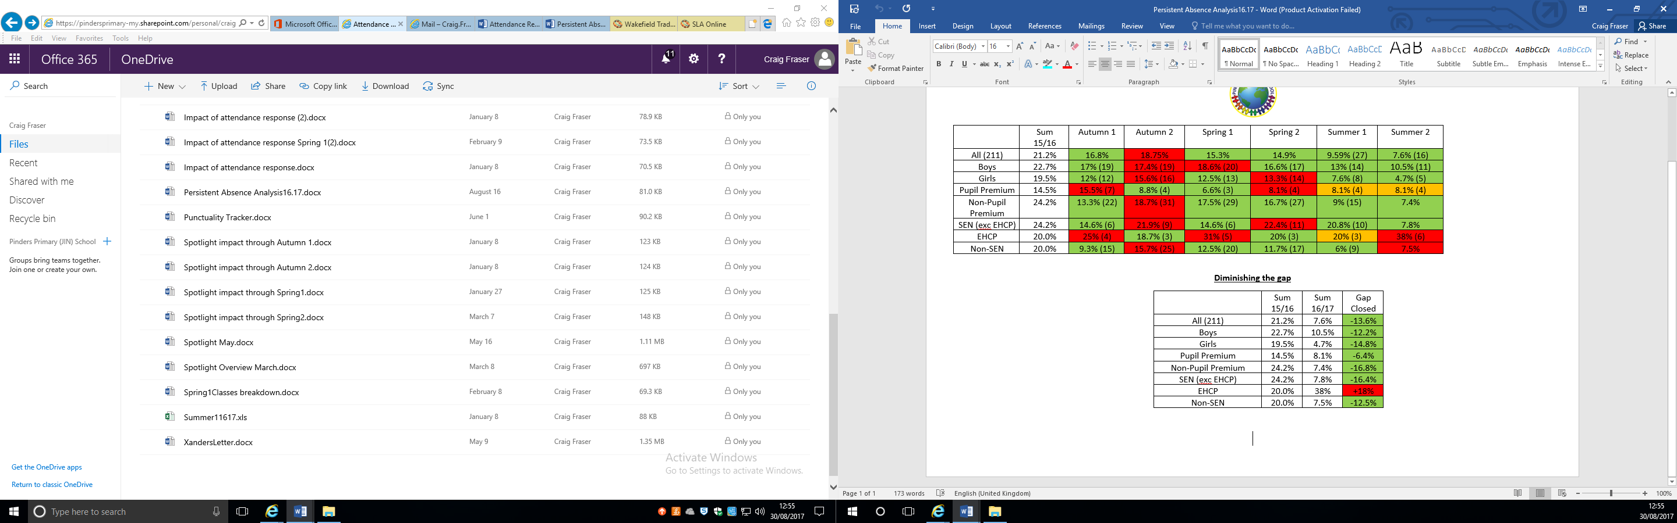**Attendance**

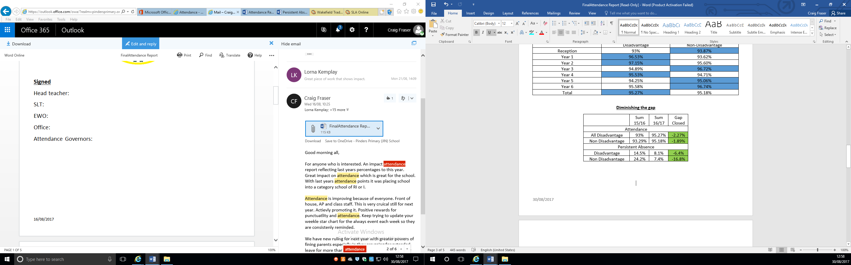

**Pupil Premium Strategy Statement 2017/2018.**

**Total Pupil Premium Budget £55,450**

**Number of Pupils Eligible for Pupil Premium – 42**

|  |  |  |
| --- | --- | --- |
| **Planned Expenditure** | | |
| **Barrier to learning** | **Provision Offered** | **Desired Outcome** |
| **Focus Booster Groups**  **(Years 2 and 6)** | Pupils in Year 2 and 6 to receive focus intervention within Maths, Reading and Writing after school by 4 teachers. | A greater number of children of pupils at or above age related expectations. Increased confidence and self-esteem |
| **Maths resources** | Pupils to use high quality resources to support their learning. | A greater number of children of pupils at or above age related expectations. Increased confidence and self-esteem |
| **Cracking Comprehension—KS1 and KS2** | Pupils in Year 1-6 to be taught comprehension skills through high quality comprehension lessons and resources | A greater number of children at or above age related expectations. Increased confidence and ability to answer higher order reading skills. |
| **Increase writing outcomes** | Author workshops to develop creative writing. | Increased ARE in writing |
| **Learning Support Assistants through Same Day Intervention** | Pupils throughout the year through phonic intervention. Same day invention in maths. Maths Hub Intervention programme. | A greater number of children at or above age related expectations. Increased confidence and self-esteem |
| **Outdoor Environment** | To have rich and engaging activities through break and lunch periods. | Developed emotional, social and physical education |
| **Broaden children’s experiences** | Children’s universities | Raise aspiration, motivation and engagement. Give a purpose and breadth to their learning.. Engage parents educational activities with their children. |
| **Subsidised Enrichment Activities** | After school clubs | Raise aspirations and pupils engagement. Teach life skills. |
| **Raise Aspirations** | Primary Futures | Raise aspirations and pupils engagement. Teach life skills Give a purpose/meaning to learning. |
| **Learning mentor—Emotional and Behavioural Support** | To support pupil’s well being, social and emotional behaviours. | Pupils happier at school and at home, more able to access learning. Learning mentor supports at lunchtime with social skills and interaction. |
| **Behavioural Awards** | Rewards for Team points and Diddi Dots + Whole school behavioural training. | Children making positive choices. Behaviour is good throughout school. |
| **Attendance Initiatives.** | Promote attendance at school with termly rewards and events | Improved attendance which results in less missed learning and better outcomes. |
| **Family Support Work** | Works with families to provide pastoral care and education groups, signposting families. | Pupils happier at school and at home, more able to access learning. |