**Book List – Science**

**KS1**

**Cycle A**

**Explorers**

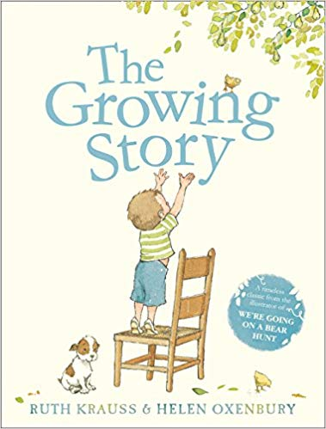 **The Growing Story – Ruth Krauss & Helen Oxenbury**

Why this book was chosen:

The topic is Explorers, pupils will be learning about Humans in Science.

**Paddington’s Travels**

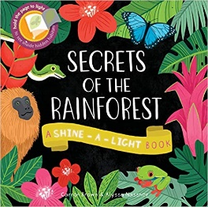 **Secrets of the Rainforest – Carron Brown & Alyssa Nassner**

Why this book was chosen:

The topic is Paddington’s Travels, pupils will be learning about Animals and their Habitats (including the Rainforest) in Science.

**London’s Burning**

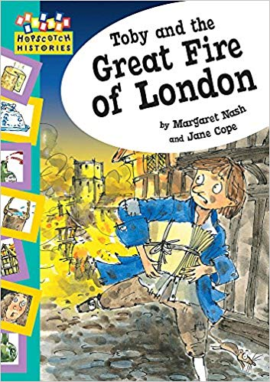

**Toby and the Great Fire of London - Margaret Nash and Jane Cope**

Why this book was chosen:

The topic is London’s Burning, pupils will be learning about Materials in Science.

**Book List – Science**

**KS1**

**Cycle B**

**Traditional Tales**

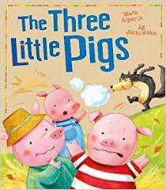

**The Three Little Pigs – Mara Alperin**

Why this book was chosen:

The topic is Traditional Tales, pupils will be learning about Materials in Science.

**Wonderful World**

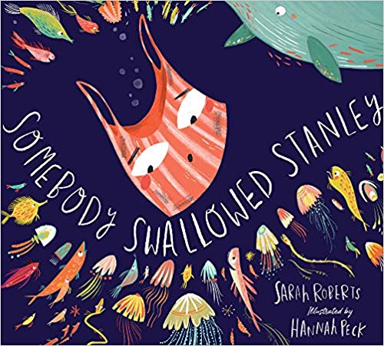 **Somebody Swallowed Stanley – Sarah Roberts & Hannah Peck**

Why this book was chosen:

The topic is Wonderful World, pupils will be learning about Animals and their groups in Science.

**How does your Garden Grow?**

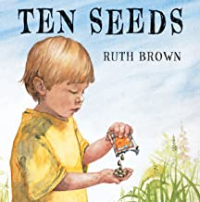 **Ten Seeds – Ruth Brown**

Why this book was chosen:

The topic is How does your Garden Grow? , pupils will be learning about Plants in Science.

**Book List – Science**

**LKS2**

**Cycle A**

**Stone Age to Iron Age - Rocks**

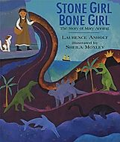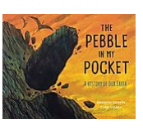

**The pebble in my pocket - Meredith Hooper & Chris Coady**

**Stone Girl Bone Girl - Laurence Anholt and Sheila Moxley**

Why this book was chosen:

The topic is Stone Age to Iron Age , pupils will be learning about Rocks in Science.

**Stone Age to Iron Age – Animals**

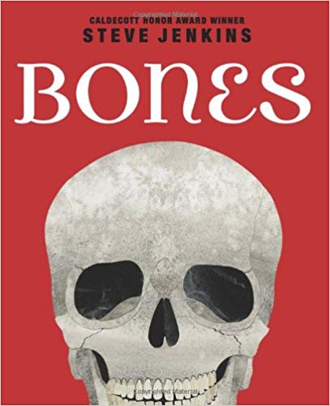

**Bones – Steve Jenkins**

Why this book was chosen:

The topic is Stone Age to Iron Age , pupils will be learning about Animals in Science.

.**Greeks**

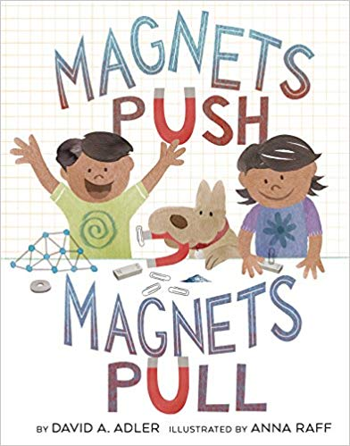[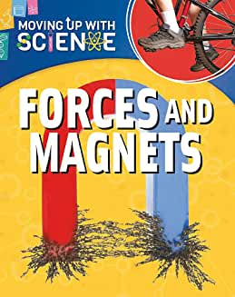](https://www.amazon.co.uk/Forces-Magnets-Moving-up-Science/dp/1445135256/ref=sr_1_8?keywords=magnets&qid=1574428724&s=books&sr=1-8)

**Forces and Magnets (Moving up with Science) – Peter Riley**

**Magnets Push, Magnets Pull - David A Adler**

**and Anna Raf**

Why this book was chosen:

The topic is Greeks , pupils will be learning about Forces & Magnets in Science.

[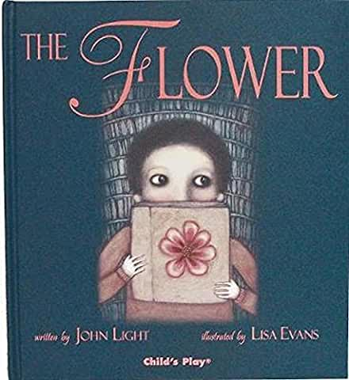](https://www.amazon.co.uk/Flower-Childs-Play-Library/dp/184643016X/ref=sr_1_1?crid=1FUX9GE82SP8&keywords=the+flower+john+light&qid=1574435029&sprefix=the+flower+john,aps,327&sr=8-1)**Local Area – Animals**

**The Flower - John Light**

Why this book was chosen:

The topic is The Local Area, pupils will be learning about Plants in Science.

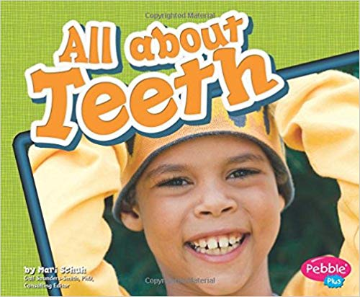**Local Area – Digestive System, Teeth , Food**

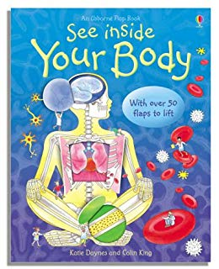

**All About Teeth – Mari C. Shuh**

**See Inside Your Body – Katie Daynes**

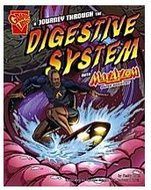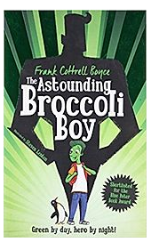

**A Journey Through the Digestive System –Emily Sohn**

**The astounding broccoli Boy – Frank Cottrell Boyce**

Why this book was chosen:

The topic is The Local Area , pupils will be learning about Humans in Science.

**Book List – Science**

**LKS2**

**Cycle B**

**Romans – States of Matter**

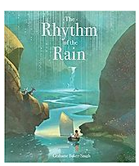 **The Rhythm of the Rain - Grahame Baker-Smith**

Why this book was chosen:

The topic is Romans , pupils will be learning about States of Matter in Science.

**Window on the World – Animals**

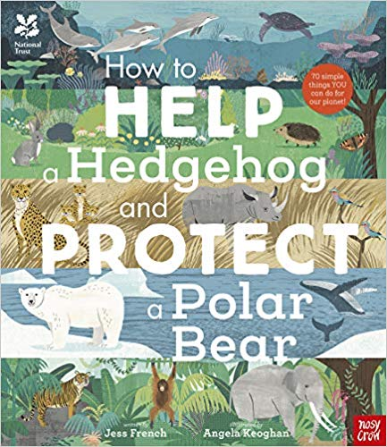

**How to Help a Hedgehog and protect a polar bear - Jess French and Angela Keoghan**

Why this book was chosen:

The topic is Window on the World , pupils will be learning about Animals in Science.

**Anglo- Saxons**

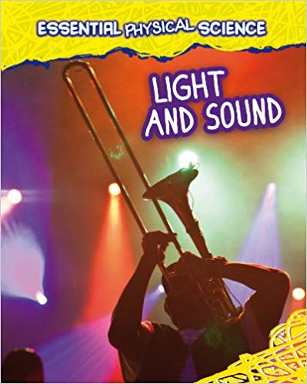 **Light & Sound – Louise Spilsbury and Richard Spilsbury**

Why this book was chosen:

The topic is Anglo Saxons? , pupils will be learning about Sound & Light in Science.

**Book List – Science**

**UKS2**

**Cycle A**

**Poppies Peace and Power – Electricity**

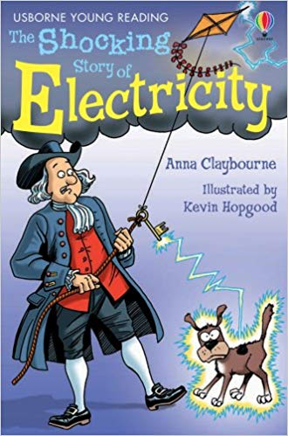

**The shocking story of electricity - Anna Claybourne**

Why this book was chosen:

The topic is Poppies, Peace & Power, pupils will be learning about Electricity in Science.

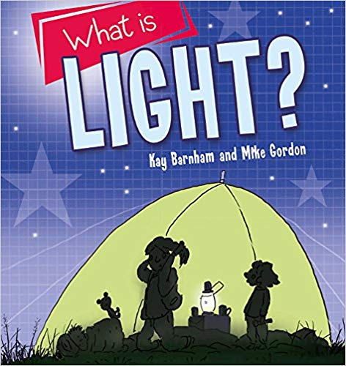**Poppies Peace and Power – Light**

**What is Light? - Kay Barnham and Mike Gordon**

Why this book was chosen:

The topic is Poppies, Peace & Power, pupils will be learning about Light in Science.

.**Natural Disasters – Materials**

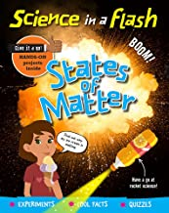**States of Matter – George Amsom-Bradshaw**

Why this book was chosen:

The topic is Natural Disasters, pupils will be learning about Materials in Science.

**Space**

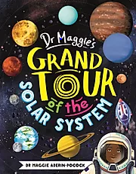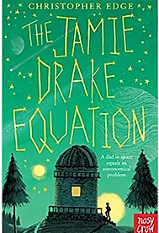

**The Jamie Drake Equation – Christopher Edge**

**Dr Maggie’s Grand Tour of the Solar System – Dr Maggie Alderin - Pocock**

Why this book was chosen:

The topic is Space, pupils will be learning about Earth & Space in Science.

**Book List – Science**

**UKS2**

**Cycle B**

**Vikings – Humans and Animals**

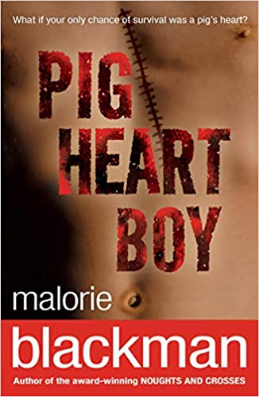

**Pig Heart Boy – Malorie Blackman**

Why this book was chosen:

The topic is Vikings , pupils will be learning about Humans in Science.

**Egyptians – Micro Organisms**

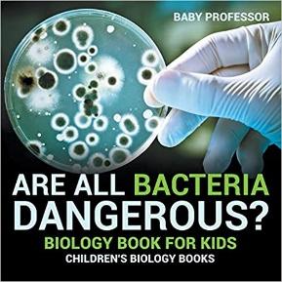Are all bacteria dangerous Baby Professor

Why this book was chosen:

The topic is Egyptians , pupils will be learning about Micro-Organisms in Science.

**Rainforest**

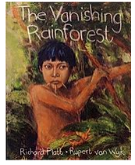

**The Vanishing Rainforest - Richard Platt & Rupert van Wyk**

Why this book was chosen:

The topic is The Rainforest , pupils will be learning about Evolution in Science.

**Book List – Science**

**UKS2**

**Cycle B**

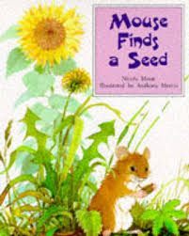

**Mouse Finds a Seed – Nicola Moon and Anthony Morris**

The topic is How does your Garden Grow? , pupils will be learning about Plants in Science.