

**Safeguarding Policy**

**Child Friendly Version**

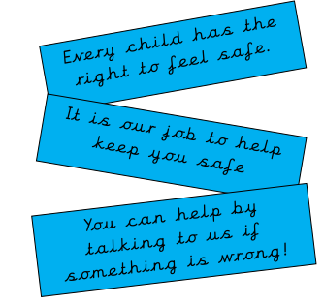

**What is this?**

Your school has a Safeguarding Policy for staff, families and governors. This ‘child friendly’ policy is designed for young people and this should be read as a guide to the main policy.

**What is it for?**

To help you decide what could be a ‘problem’ and where you can get help and support.

Safeguarding and Child Protection mean the same thing and they mean that we look after children and keep them safe.

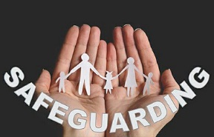**What is Safeguarding?**

• All the adults around you think that your health, safety and welfare are very important

• At our school, we respect all children and adults, and help to protect their rights and keep them safe.

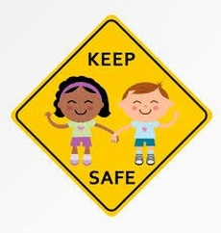**How does Pinders Primary School work to keep you safe?**

• We provide a safe environment for you to learn

• Staff at our school know how to keep you and your friends safe, at home as well as school

• It is important for you to know where to get help if you are worried or unhappy about something.

• We teach you how to keep you, and others, safe. And to recognise risks in different situations. Our lessons include, healthy eating, e-safety, road safety and assemblies

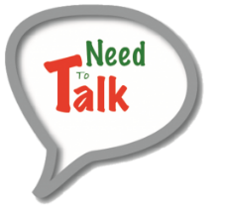**Need to Talk?**

* Mrs Kemplay is our Safeguarding Lead and her main role is to keep our children safe.
* Mrs Bedford, Mrs Rowlands, Mrs Bowen & Mrs Peaker are also part of the Safeguarding team.
* You can speak to any adult in school, they will always listen to you. •
* You can place a note in a Worry Box in class & an adult will arrange to meet with you.

**What happens next?**

• Sometimes adults may need to speak to one of the safeguarding team.

• Sometimes they may need to contact other people who support children and families

**Is someone bullying you?**

Bullying is usually defined as behaviour that is

• Repeated-for example it happens every day

• Intended to hurt someone either physically punching kicking hitting, or emotionally-name calling or saying unkind things that may make you feel upset or sad.

**You must tell someone at school so we can help you!!!**

Is someone saying unusual or unkind things to you? Has someone said something to you or have you heard some-thing that you do not like or upsets you? **You must tell someone at school so we can help you!!!**

Is someone touching you? Has someone touched you on a part of your body like your bottom, chest or anywhere else you do not like? **You must tell someone at school so we can help you!!!**

**Is someone hitting, punching or smacking you?**

Has someone hit, punched or smacked you or hurt you in anyway? You must tell someone at school so we can help you!!! If in doubt, talk to someone.

There are many staff at school for you to talk to and they will help support you. Examples of people you can tell are:

• Your Teacher   
• Your Head teacher   
• Your Learning Mentors   
• Your Learning Support Assistant   
• Your Dinner Supervisor…Or any other adult in school

**What are the next steps?**

Sometimes a member of staff at your school will need to check things with your Head teacher and then if they can deal with the issue themselves, they will.

There are times though when they may need to contact some other agencies for support. These may be Children’s Social Care (Social Workers) or Police. There are lots of other agencies who support children and their families as well. Your Head teacher or a safeguarding officer will talk to you and explain all of this and you can always go and ask them questions if you are unsure about anything.

The four main areas of Child Protection concerns are:

1. **Physical Abuse** – hitting, smacking, shaking, throwing, burning or biting.

2. **Sexual Abuse** – be aware this doesn’t always mean actually touching a child. It could be someone making you watch things to do with sex or encouraging you to act in an inappropriate way.

3. **Neglect** – this means things like not providing meals or warmth or clothing. Or perhaps not taking you to the Doctors when you need to go. There may be lots of different reasons why a child is neglected and it is really important that we know so we can help.

4. **Emotional Abuse** – This means when someone upsets you or makes you feel bad. If someone in your family says horrible things to you and makes you feel sad and worthless. These are just a few examples for you and if you think you may have a problem that is similar to one of these then talk to an adult in school.

**You can also contact:**

• Child Line are also there to listen to your worries too.

You can call them on:

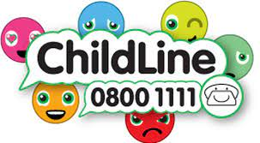

Here is a reminder of our pantasaurus PANTS rule and child line number.

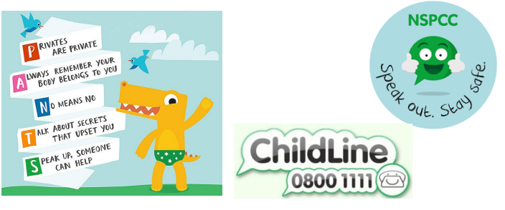

You can also use Young Minds Crisis Messenger and text ‘YM’ to 85258

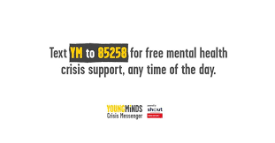

If you need support online you can report this to CEOP

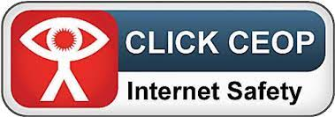

If you or your family are in immediate danger you need to call 999