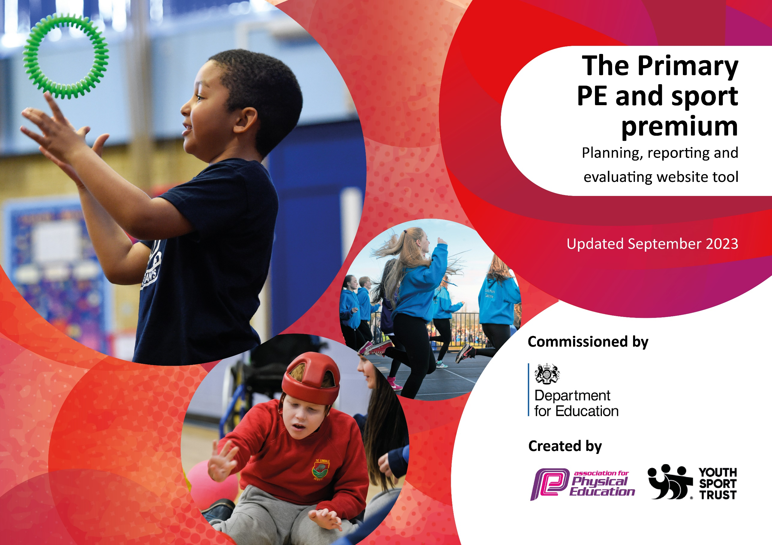

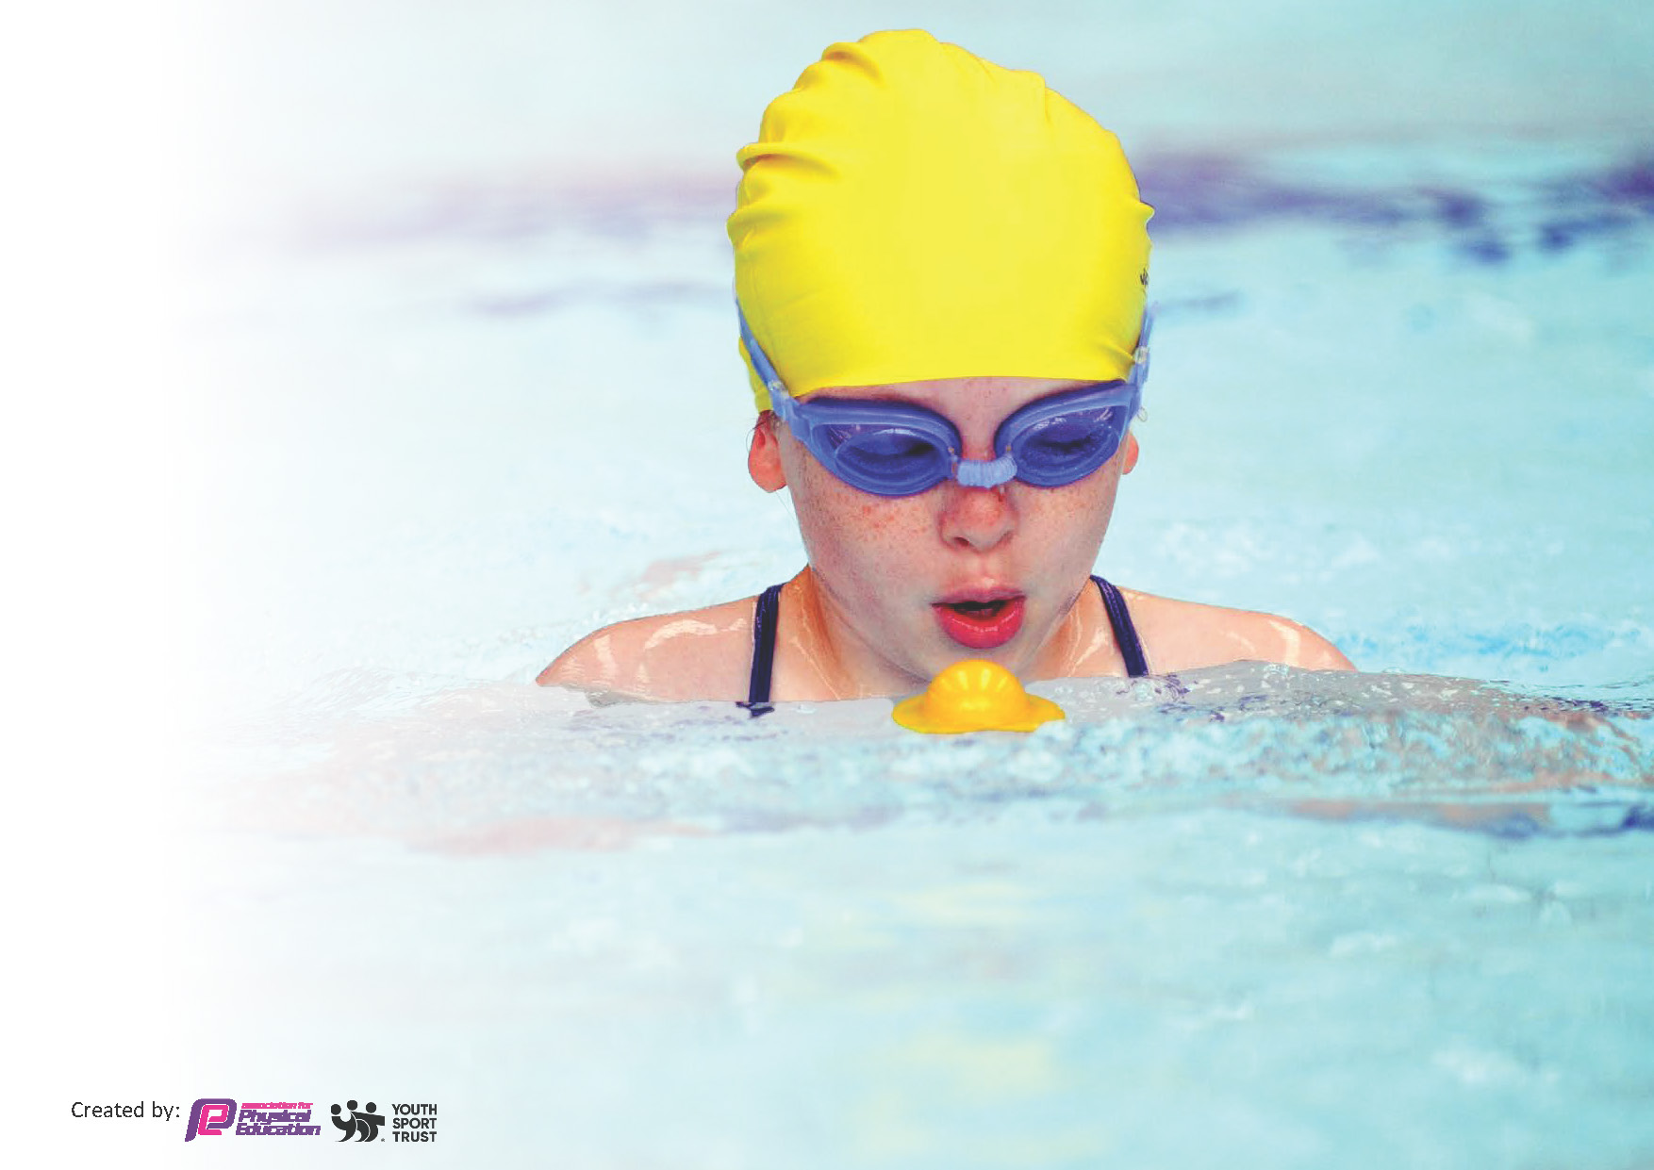
This template can be used for multiple purposes:
by:
- It enables schools to effectively plan their use of the Primary PE and sport premium
- It helps schools to meet the requirements (as set out in guidance) to publish information on their Primary PE and sport premium
- It will be an effective document to support Ofsted inspections enabling schools to evidence progress in Physical Education (PE) and evidence swimming attainment, which forms part of the PE National Curriculum. We would recommend schools consider
the Intent, Implementation and Impact of any spend, as examined within the Education Inspection Framework.

It is important that your grant is used effectively and based on school need.

Schools must use the funding to make additional and sustainable
improvements to the quality of the PE, School Sport and Physical Activity (PESSPA)
they offer. This means that you should use the Primary PE and sport premium to:

- Build capacity and capability within the school to ensure that improvements made now will benefit pupils joining the school in future years
- Develop or add to the PESSPA activities that your school already offers.

The Primary PE and sport premium should not be used to fund capital spend projects; the school’s core budget should fund these. Further detail on capital expenditure can be found in the updated Primary PE and sport premium guidance.

The Primary PE and sport premium guidance, outlines 5 key priorities that funding should be used towards. It is not

necessary that spending has to meet all the key priorities, you should select the priorities that you aim to use any funding towards.

Although completing this template is not a requirement for schools, schools are required to publish details of how they spend this funding. Schools must also outline what the impact this funding has had on pupils’ PE and sport participation and attainment and how any spending will be sustainable in the future. All funding must be spent by 31st July 2025.

The Department for Education has worked closely with the Association for Physical Education (afPE) and the Youth Sport Trust (YST) to develop this template and encourages schools to use it. This template is an effective way of meeting the reporting requirements of the Primary PE and sport premium.
Review of last year’s spend and key achievements (2023/2024)

We recommend you start by reflecting on the impact of current provision and reviewing your previous spend.

Activity/Action | Impact | Comments
Forest School provision  Outdoor environment resources  Subject Leader CPD  Additional achievements:  Clubs –  Hockey  Pro football  Forest Schools  Residential trip to Nell Bank for Year 6 outdoor adventure activities  Subsidised places | All children have received forest schools. Pupils Voice is positive and children’ confidence improved. Children understand fire safety, how to build a den. Team sports and cooperation. From nursery to Year 6 at age appropriate levels.  Provision has been coordinated for football, cricket and basketball. Pupil engagement is high in these predominantly boys. Pupil Voice is that they would like less football next year and more cricket and hockey.  Equipment has been refurbished and will need doing again for September as very well used.  Training attended, impact from this has been with regards to outdoor adventure unit of work and improving provision for the next cycle. Revising swimming.  Networking for clubs and interschools sports for next year.  Get set Education has been successfully delivered. The cycles have been reviewed for next year.  The teaching is consistent and of a higher standard  Clubs well attended and positive feedback from parental engagement group and pupil voice | Continue with Forest Schools as this is an experience that out inner City school pupils do not experience otherwise. A lot of the pupils do not have garden spaces and culturally they are not exposed to different weather conditions. All of these are character building, develop essential life skills, collaborative learning and resilience. They also reinforce the school values including Respect.  Outdoor space will continue to be developed listening to pupil voice. The PE lunchtime lead has been extended to continue to coordinate next year.  To attend the training again next year.  To monitor the provision of education through following the scheme for our second cycle. Monitoring teaching standards o ensure they are good.  Get Set for PE to continue.  Clubs will continue next year. Septembers have been advertised already.  Tag Rugby has been arranged for three classes with the Wakefield Trinity this is to enhance the rugby provision from get set for PE.  Look to booking Ackworth again next year  Residential booked for September. There will be subsidized places offered again. This is an experience the children will not otherwise access.

Key priorities and Planning

Action – what are you planning to do | Who does this action impact? | Key indicator to meet | Impacts and how sustainability will be achieved? | Cost linked to the action
Provision for all children to access Forest Schools to build confidence and knowledge in regards to the outdoor curriculum.  To continue to develop our outside provision and delivery of activities at break and lunchtimes  Maintaining and developing the outdoor environment to ensure it remains stimulating and gives additional opportunities for physical exercise and team work.  To continue to provide a major contribution to the strategic leadership of school improvement, by ensuring effective subject leadership of PE, within the context of the wider school curriculum.  Additional afterschool clubs subsidised to provide a wide range of sporting opportunities  Residential trip for outdoor activities Kingswood. Subsidised places  Internal PE events to be planned in for the ends of units. Parents may be invited to watch  Sports Day to continue to have a competitive element.  Wakefield Trinity to teach Tag rugby Year 3, ¾ and 4 ( 90 Children) for a 6 week block | Forest School company employed for a full day each week for 38 weeks  Sports Leader in place to coordinate the outdoor activities. £3,802  Equipment –  West Yorkshire PE conference  External provider sourced to run the additional clubs  Identified families supported with trip costs to enable underprivileged pupils to go.  Staff CPD for teaching rugby  Specialist sports teaching for the pupils. | Key indicator 2 -The engagement of all pupils in regular physical activity – the Chief Medical Officer guidelines recommend that all children and young people aged 5 to 18 engage in at least 60 minutes of physical activity per day, of which 30 minutes should be in school.  Key indicator 4: Broader experience of a range of sports and activities offered to all pupils.  Key Indicator 3 Increased confidence, knowledge and skills of all staff in teaching PE and sport.  Key indicator 4: Broader experience of a range of sports and activities offered to all pupils  Key indicator 4: Broader experience of a range of sports and activities offered to all pupils.  Key Indicator 5  Increased participation in competitive sport.  Key Indicator 3 Increased confidence, knowledge and skills of all staff in teaching PE and sport.  Key indicator 2 -The engagement of all pupils in regular physical activity – the Chief Medical Officer guidelines recommend that all children and young people aged 5 to 18 engage in at least 60 minutes of physical activity per day, of which 30 minutes should be in school. | More pupils meeting their daily physical activity goal, more pupils encouraged to take part in PE and Sport Activities.  More pupils experiencing a range of sports. Other lunchtime supervisors to be trained up to run sports.  Knowledge of subject leader is current and this can be cascaded down to all staff who are teaching PE.  In future years to include costing within CPD budget.  Clubs to be supported by a parent donation to enable the clubs to continue.  Look for competitive providers to make the trip as affordable as possible.  Staff CPD enable improved teaching of Rugby next year. | Forest School Coach  £7220  Sports Leader  £6523 (includes swimming time)  Equipment  £2,000  £200  Football £1710 (less £1200 income)  Club costs£4560 (less £2,773 income)  £450  TOTAL £18690

Key achievements 2024-2025
This template will be completed at the end of the academic year and will showcase the key achievements schools have made with their Primary PE and sport premium spending.

Activity/Action | Impact | Comments

Swimming Data
Meeting National Curriculum requirements for swimming and water safety.
Priority should always be given to ensuring that pupils can perform safe self-rescue even if they do not fully meet the first two requirements of the National Curriculum programme of study

Question | Stats: | Further context  Relative to local challenges
What percentage of your current Year 6 cohort can swim competently, confidently and proficiently over a distance of at least 25 metres? | 26% | Number of lessons have been increased as our starting points each year are so low.
What percentage of your current Year 6 cohort can use a range of strokes effectively [for example, front crawl, backstroke, and breaststroke]? | 40% | Good progress was made. Additional swimming has been put into the curriculum for the next cohort coming through

What percentage of your current Year 6 cohort are able to perform safe self-rescue in different water-based situations? | 26% | None of the cohort were able to swim when they started in Year 5.
If your schools swimming data is below national expectation, you can choose to use the Primary PE and sport premium to provide additional top-up sessions for those pupils that did not meet National Curriculum  requirements after the completion of core lessons. Have you done this? | No | Extra swimming is being out in at Year 4 so that they will then have an top up for those not meeting the national expectation in Year 5
Have you provided CPD to improve the knowledge and confidence of staff to be able to teach swimming and water safety? | Yes | We have employed a swimming teacher as a LSA and he takes a group at swimming.

Signed off by:

Head Teacher: | Lorna Kemplay
Subject Leader or the individual responsible for the Primary PE and sport premium: | Katie Hargreaves
Governor: | Stuart Heptinstall
Date: | 11/09/2024

