**Book List – Design & Technology**

**UKS2**

**Cycle A**

**(Poppies Peace and Power – Electricity) – Christmas tree decorations**

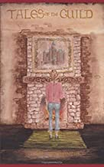

**Tales of the Guild – T Mackenzie**

**Natural Disasters – Shelters**

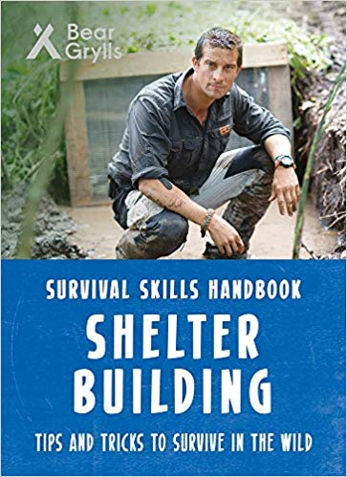

**Survival Skills Handbook: Shelter Building - Bear Grylls**

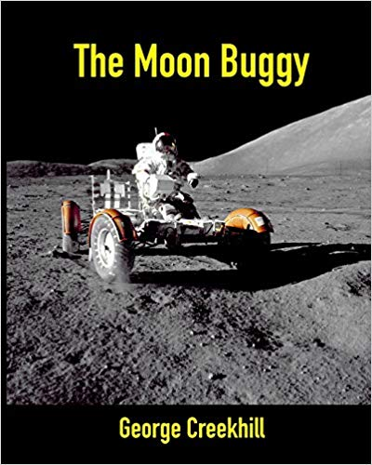**Space – Moon Buggy**

**The Moon Buggy – George Creekhill**

**Book List – Design & Technology**

**UKS2**

**Cycle B**

**(Vikings) – Christmas Decorations**

**Egyptians – Bread**

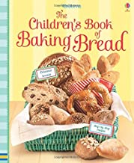

**The Children’s Book of Baking Bread – Abigail Wheatley**

**Rainforest – Gears, Pulleys & Mechanisms**

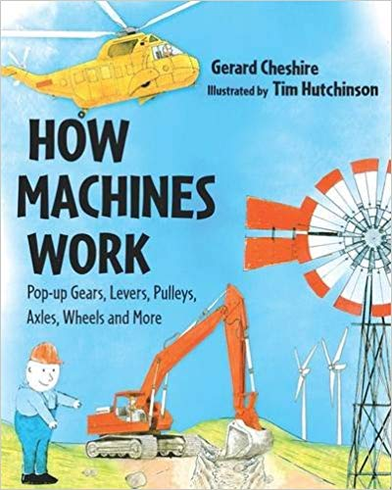

**How Machines Work – Gerard Cheshire**