[](https://www.google.co.uk/url?sa=i&rct=j&q=&esrc=s&source=images&cd=&ved=2ahUKEwijzvWTx-rlAhVGUxoKHYlFB9YQjRx6BAgBEAQ&url=https%3A%2F%2Ftwitter.com%2Fpindersprimary&psig=AOvVaw3lnCr7ADz0zX1LpKWIcUE_&ust=1573850233724143)

**Pinders Primary School Spelling Policy.**

**April 2020**

At Pinders Primary School, we believe that good spelling is a skill, which is essential in allowing children to communicate their understanding effectively. Children must develop and utilise a range of effective spelling strategies in order to develop into competent and confident writers. At Pinders Primary School, we equip children with an independent confidence in spelling through the use of a range of strategies.

Within the National Curriculum (2014), it is stated that children should be able to spell quickly and accurately through knowing the relationship between sounds and letters (phonics) and understanding the morphology (word structure) and orthography (spelling structure) of words.

**Whole School objectives:**

1. Develop and teach the children to use a range of effective spelling strategies.

2. Encourage children to have an interest in words and their meanings.

3. Children to use a growing range of creative and ambitious vocabulary.

4. Promote a positive and confident attitude towards spelling.

6. Teach children to check and correct spellings using strategies.

7. Provide equal opportunities for all pupils to achieve and be guided towards becoming a more effective speller.

**Teaching and Learning**

Spelling is taught as part of a planned programme following the requirements of the 2014 National Curriculum. In addition, handwriting lessons and writing sessions offer many opportunities for spelling discussions and the revisiting and practising of strategies that have been taught previously.

**EYFS**

Children will be taught phonics daily. They will begin to learn the high frequency words. Children will be streamed from Nursery and Reception in Autumn Term according to the Phonics Phase they are working towards.

**Key Stage 1**

Phonics is streamed based on phonics assessments which will be carried out half termly. Children are put into groups according to the phase they are working on. Within the phonics sessions children will be taught to revisit their last session, to be introduced to new sounds/rules and they will do an application activity based on the objective. In Year 1, most children should know all the high frequency words. The expectation is that most pupils will complete phase 5 phonics before the end of Year 1.

In Year 2, children will move on to the No Nonsense spelling scheme. Spelling sessions must take place on five occasions across two weeks. Lessons follow revise, teach, practise and apply approach outlined below.

Pupils assessed at working below age-related expectation will receive targeted phonics teaching.

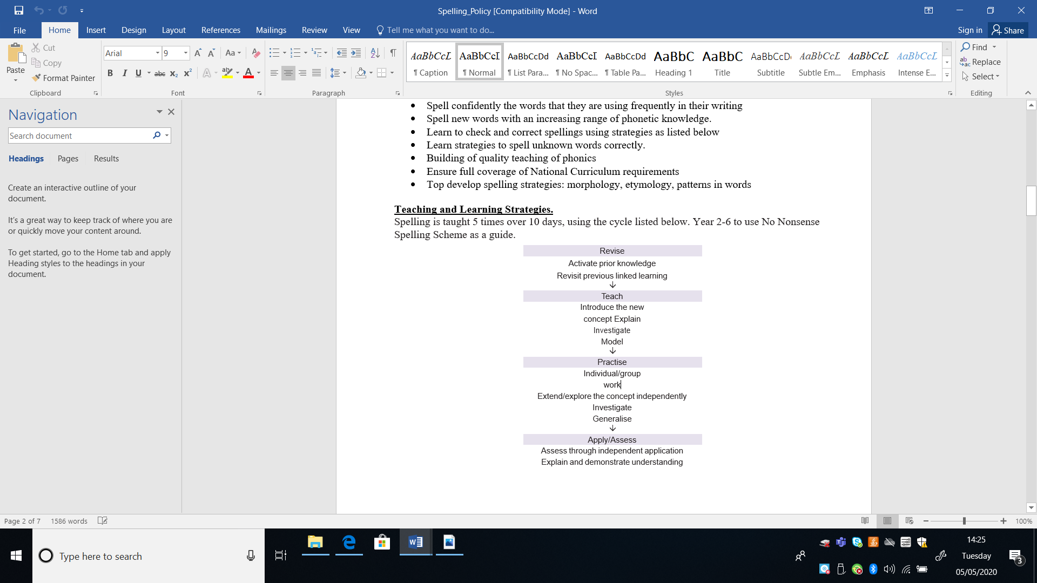

**Key Stage 2**

An investigative approach is taken to the teaching of spelling in Key Stage 2, in line with the spelling objectives in the 2014 English curriculum. Where appropriate, these are supported by *No Nonsense Spelling (Babcock)*. Spelling sessions take place two to three times per week -using the cycle listed above- to ensure children have the opportunity to practice and embed new spellings. This will include the learning of the statutory word lists in the 2014 English curriculum. In addition to this, spelling homework is given each week. Where necessary, some pupils will consolidate the phonic knowledge and skills from KS1.

**No Nonsense Spelling Scheme:**

What is the No Nonsense Spelling Programme?

The No Nonsense Spelling Programme was devised to offer teachers a comprehensive yet accessible progression in the teaching of spelling. Guidance, rather than prescription, is provided on how to teach the strategies, knowledge and skills pupils need to learn.

The focus of the programme is on the teaching of spelling, which embraces knowledge of spelling conventions patterns and rules; but integral to the teaching is the opportunity to promote the learning of spellings, including statutory words, common exceptions and personal spellings.

The programme delivers a manageable tool for meeting the requirements of the 2014 National Curriculum. It has a clear progression through blocks of teaching units across the year and comprehensively explains how to teach spelling effectively.

**Homework**

Children have weekly spellings to learn and spelling tests are timetabled within each class and communicated to children and parents. Spellings are differentiated and include words from each year’s statutory spelling list.

Key Stage 1 spellings are based on the phonic sounds the children have learned from the previous week. This is to consolidate learning from the previous phonic lessons and to check they are applying their phonic knowledge.

Key Stage 2 spellings are to include words from the statutory spelling lists and spelling patterns set out in the No Nonsense Spelling Programme.

**Inclusion**

We teach spelling to all children, whatever their ability. It is part of our school curriculum policy to provide a broad and balanced education to all children. Equality of opportunity is always observed with positive attitudes to spelling being irrespective of disability, gender, race, ethnic origin, culture, language or religion.

**Monitoring and Evaluation**

It is the role of the writing subject leader to monitor the teaching and learning of handwriting throughout the school. This is done through regular work sampling, analysis of assessment pieces and lesson observations. Feedback from this monitoring is used to inform staff of necessary developments in order to raise standards. Monitoring is supported by the Head-teacher and SLT.

**Monitoring and Review**

This policy will be monitored by the Writing Leader and SLT on a three year basis.

Policy agreed: