**  
Writing Policy**

**April 2021**

Writing is integral to everyday life, it fosters an ability to explain and refine ideas, preserving ideas and memories. At Pinders Primary School, we aim to deliver an exciting curriculum that enables children to develop an engaged attitude towards writing that will remain with them. It is our intent at Pinders Primary School to ensure that writing enables pupils to communicate with others, building on experiences, encouraging thinking and allows communication skills to grow.

At Pinders Primary, we aim to encourage children to:

* Have a positive attitude towards writing.
* Use their reading to inform their writing and be magpies, loving language and borrowing words and phrases from each other and other authors.
* Write legibly and independently.
* Use writing across the curriculum in a variety of genres.
* Understand and apply their knowledge of phonics and spelling.
* Write in a range of genres (including fiction, non-fiction and poetry).
* To love writing and see themselves as authors.

**Writing in EYFS**

Children learn to write in the Early Years Foundation Stage through a combination of adult-directed activities and child-initiated play. Learning to write is a gradual process throughout the early years. Children begin their writing journey through physical development and focus on fine motor control skills. Children have access to a wide range of early mark making and preparatory materials both in our indoor and outdoor learning environments. Within their own play explorations, children are encouraged to explore writing, linking their own ideas. Children's emergent writing is supported by our holistic environment, which encourages the development of links between concrete exploration and literacy.

Positive attitudes to writing are fostered in EYFS with a developing awareness of how ongoing exploration links to cognitive and writing readiness. In order to enable children to progress within their writing, the EYFS environment enables pupils to respond to their individual interests allowing learning to be built over time.

Children in Reception take part in daily focussed phonics sessions, where children receive guided practice in the application of phonics. Handwriting through formation of letters is also taught as part of this approach. In addition to their own explorations in early writing, children take part in daily shared writing experiences, which feeds forward to independent writing.

**KS1 and 2 Sequence of learning**

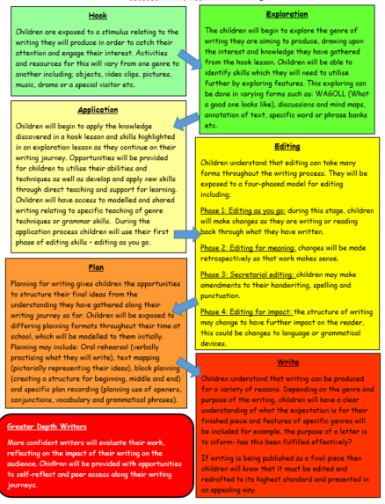

*Hook– stimulus in the form of arts/drama/film/music/photos.

* Exploration- WAGOLL (what a good one looks like) and example text of the focussed genre.

*Application- collection of knowledge, grammar and vocabulary to include in writing.

*Editing- four phases of editing, can be applied through each stage of writing approach.

*Planning- structure of published writing

*Draft – modelled/shared/guided writing opportunity

*Final writing – Published writing.

*Greater Depth Writers- evaluation of impact of writing.

This sequence of learning is followed by all classes. Some steps of the sequence may be developed further, some steps may not be included based on the genre of writing that is being taught and carried out by the class. The aim of this sequence of learning to lead to a piece of writing is to provide children with a high quality example and to give them the skills to produce something of the same quality with a particular emphasis on grammar and vocabulary. A range of genres is taught throughout the year so children are experiencing all writing.

**Planning:**

From Year 1 to Year 6, teachers use the planning overview for the related phase to inform their planning. Every class, use quality texts or parts of texts to stimulate the children and allow for planning of creative teaching and writing experiences. These experiences give children the opportunity to apply what they have learnt and progress in their writing. We teach pupils to plan, proof read, redraft and present their work appropriately taking pride in what they have achieved. We are constantly exposing children to new vocabulary and encouraging them to use it in their writing. We explicitly teach spelling patterns and rules from the National Curriculum and expect children to use these regularly in their writing as set out in the spelling policy.

Teaching of writing is carried out using a sequence of learning. This sequence of learning is centred on a stimulating text that engages the children and is linked to the topic they are studying. Emphasis is also placed on exposing the children, at every opportunity, to higher level vocabulary. Drafting and editing is key to this process of writing to provide children with the opportunity to improve their writing.

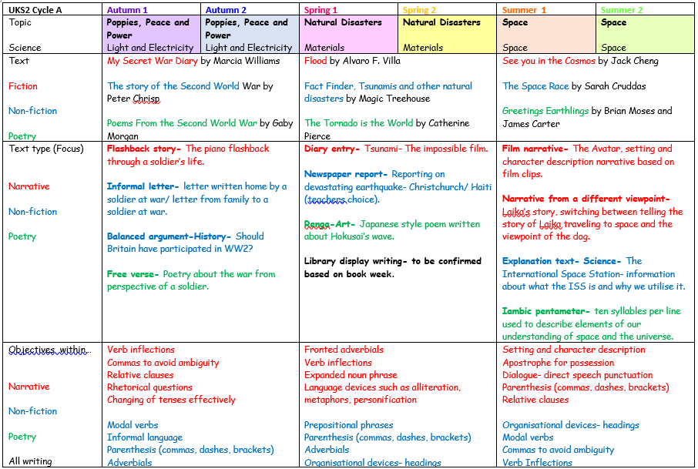

*Planning overviews are individual to phases and separated into termly topics.

*Stimulus texts link to the relevant topics and cover a breadth of genres.

*Text type focuses ensure that pupils are covering a range of narrative, non-fiction and poetry writing throughout their time at school.

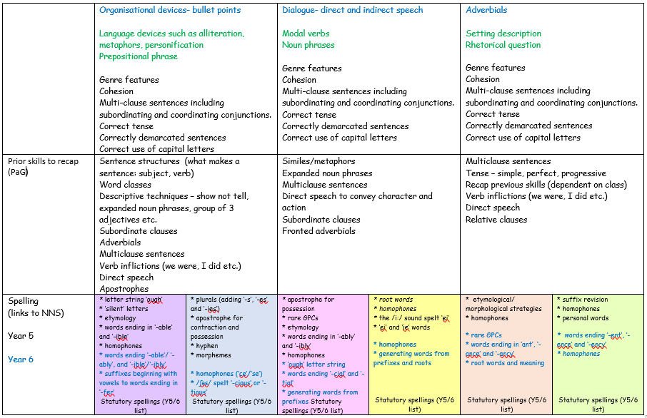

*Age related grammar objectives are included within the sequence of teaching ensuring that pupils are exposed to appropriate devices.

* Prior skills are outlined in order to allow former learning to be revisited and embedded.

*Spelling links are emphasised to provide teachers with a guide to deepen spelling patterns through writing teaching.

**Vulnerable Groups (including SEN and Pupil Premium)**

All children have full access to the development of writing skills, work is differentiated in terms of support within sessions and lesson outcomes. Any intensive support takes place as the teacher sees fit in the form of extra intervention. Children should not be removed from quality first teaching with their class teacher for interventions, this should be at an additional time if needed. Children emotional support will first and foremost be given nurture to ensure they are learning ready. Staff use impact and intervention grids to show progress of any interventions.

**Cross Curricular Writing**

The pupils at Pinders Primary access a range of writing opportunities across the curriculum and staff have high expectations that children will present all writing in the same way as within English lessons. Children are encouraged to write a range of genres across subjects covering historical and geographical accounts, fact files and instructions in art and D.T and written investigations in science.

**Celebrating writing**

Celebrating writing is so important to children across the school. It’s a chance for children to see what ‘good writing’ looks like and to celebrate the work they have completed.

* Every term, a ‘Star writer’ is chosen to be displayed in the corridor for each year group.
* In each class, the teacher displays ‘good writing’ on their ‘star writer’ board.
* Teachers also have the opportunity to select children for the, ‘Star of the Week’ assembly, if they have produced work which is of a continued high standard or in making progress steps in their learning.

**Assessment of writing**

Assessment is an integral part of teaching and learning and is a continuous process. At Pinders Primary School, we are continually assessing our pupils’ allowing us to ensure that the work pupils are provided with is challenging and will further their progress. Assessment enables staff to identify children who need further additional/targeted support in their learning, the marginal children are then specifically targeted for interventions and therapies relating to their specific needs.

Formative assessment

This assessment happens daily when teaching and facilitating the learning of the children. This assessment informs planning, adaptations to planning and informs teachers of progress within lessons. Book marking, dialogue with the children for immediate impact, observations, feedback during the learning process and self and peer assessment are all effective forms of formative assessment used throughout the school.

Summative assessment

Summative assessment is carried out termly as a formal assessment process of pupils’ writing. It is used to review the progress of the children since the previous term and inform staff of their current ability in relation to key objectives and targets. Assessment grids are used as an assessment tool to aid the assessment of writing across the school. This process informs teachers’ of the next steps for children in the following term.

**Feedback to pupils**

Feedback to pupils is an essential aspect of our teaching of writing. This feedback is achieved through discussion with the pupils within lessons, marking of work, intervention work with pupils and self-assessment.

Effective marking:

* Aims to help pupils learn and comments are intended to be constructive, positive and forward looking.
* Is often undertaken while a task is being carried out. This takes the form of a discussion between the teacher and child and is appropriate to age and ability.
* Is used sensitively and with discretion so that pupils assimilate a limited number of corrections at one time, varying with age and ability.
* Informs discussion with pupils in relation to a particular focus for that child.
* Aims to improve the child’s work and increase their confidence with the task they are focusing on.

**Moderation**

Writing moderation is used to validate and support class teachers’ judgements once assessments have been made. In school moderation takes place across years groups, key stages and the whole school. Staff sample two children’s work per year group looking at writing evidence across all curriculum areas including a mixture of supported and independent writing. The writing evidence is reviewed by a number of teachers ranging across year groups and phases. Assessment of children working towards the standard, at the standard and at greater depth is carried out.

**Homework**

Homework to support the English Curriculum is set on a regular basis. Children in KS1 and KS2 are provided with spellings to learn weekly based on spelling patterns from the No Nonsense Spelling programme which link to the National Curriculum. Written homework consists of a variation of punctuation, grammar, and writing.

**Monitoring and Evaluation**

It is the role of the writing subject leader to monitor the teaching and learning of handwriting throughout the school. This is done through regular work sampling, analysis of assessment pieces and lesson observations. Feedback from this monitoring is used to inform staff of necessary developments in order to raise standards. Monitoring is supported by the Head-teacher and SLT.

**Monitoring and Review**

This policy will be monitored by the Writing Leader and SLT on a three year basis.