Autumn Term
KS1 | 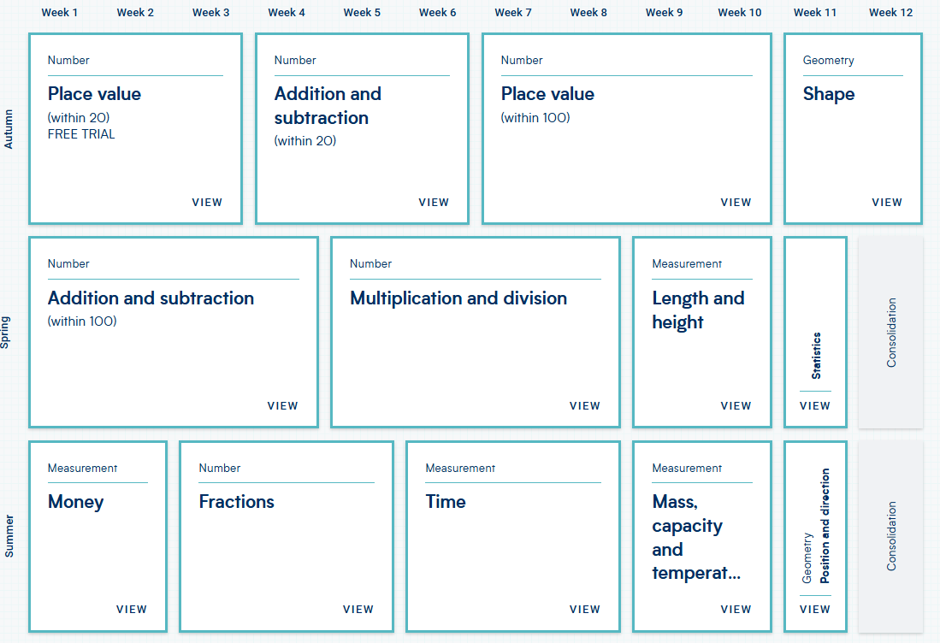
LKS2 | 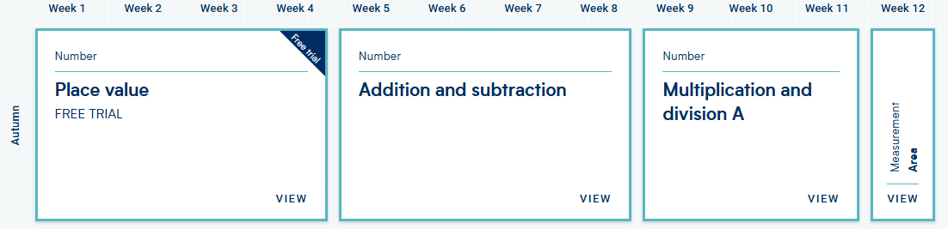
UKS2 | 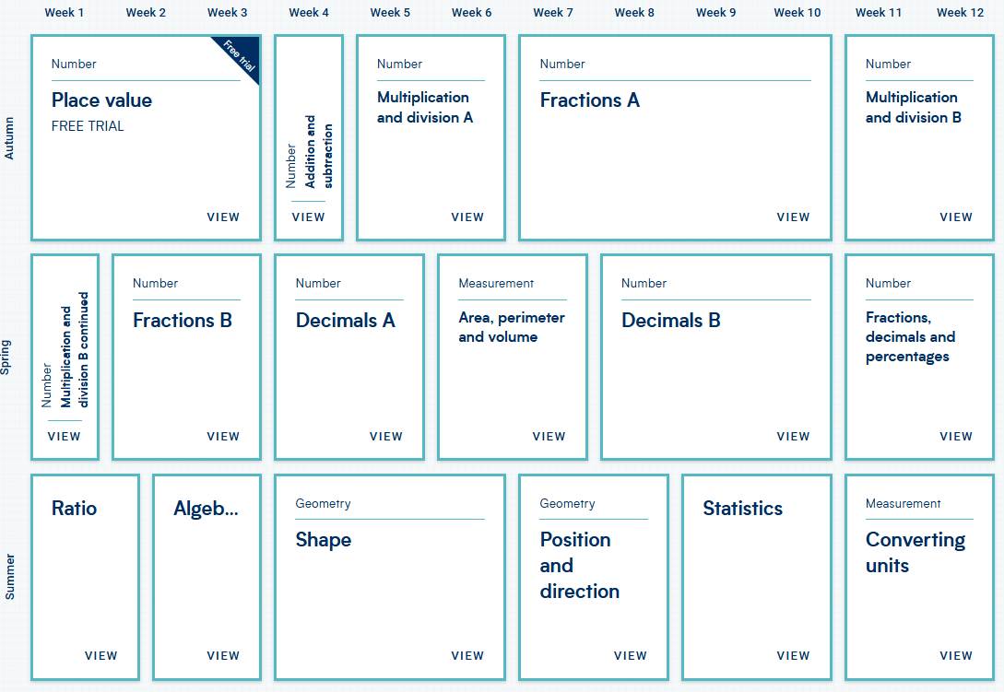

Spring Term
KS1
LKS2 | 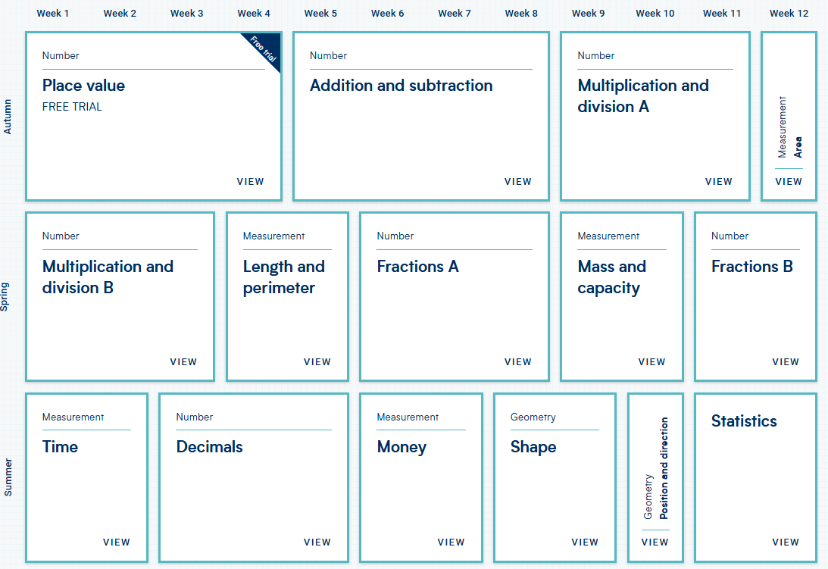
UKS2

Summer Term
KS1
LKS2
UKS2

