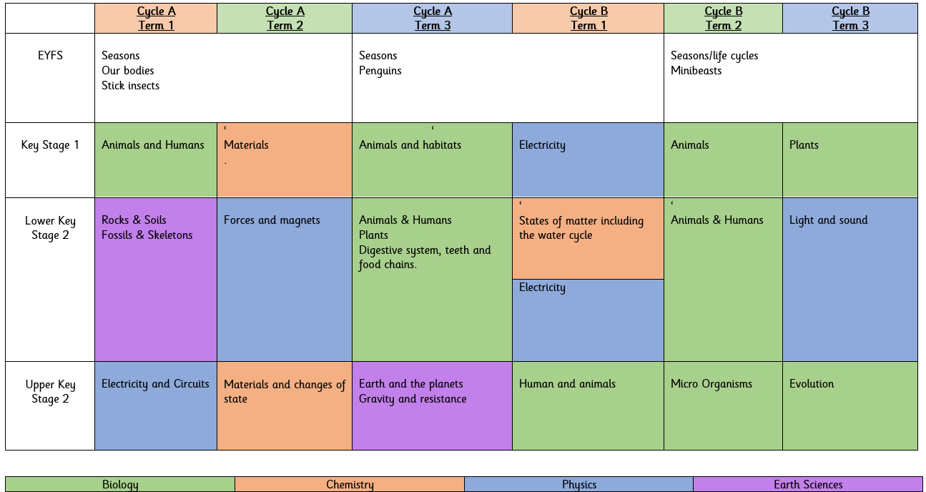

Our science curriculum provides pupils with an understanding of both substantive and disciplinary knowledge.

Substantive knowledge - is the subject knowledge and explicit vocabulary used to learn about the content

Disciplinary knowledge - this considers how scientific knowledge originates and is revised. It is through disciplinary knowledge that children gradually become more expert by thinking like a scientist.

Substantive Knowledge: Concepts, models, laws and theories
Biology
• Living things and their environment (Animals, humans, plants, habitats)
• Reproduction, inheritance and evolution (Evolution, inheritance, life processes, life cycles)

Chemistry
• States of matter (Solids, liquids, gases)
• Materials (properties and changes including reversible/irreversible changes,)

Physics
• Energy (Light, sound, electricity)
• Forces (Friction, air resistance, gravity, magnets)

Earth Science
• Earth and space (Seasons, day and night, solar system and beyond)
• Rocks and fossils

Science in EYFS
All areas of learning and development at the Foundation Stage are inter-connected. Through engaging in science activities, children not only learn about the world around them but develop disciplinary skills in all areas.

Characteristics of Effective Learning
The ways in which a child engages with other people and their environment - playing and exploring, active learning, and creating and thinking critically – underpin learning and development across all areas and support the child to remain an effective and motivated learner.
‘Understanding the World’
- This is a specific area of the Early Years Curriculum that includes essential skills and knowledge about the world and provides firm foundations on which children can build their scientific understanding. Early Years children will be actively involved in play and exploration and be encouraged to be creative. They will be supported to think critically and ask questions, which will help them to make sense of their world through well-planned play opportunities.
ELGs:
- Explore the natural world around them, making observations and drawing pictures of animals and plants.
- Know some similarities and differences between the natural world around them and contrasting environments, drawing on their experiences and what has been read in class.
- Understand some important processes and changes in the natural world around them, including the seasons and changing states of matter
- Manage their own basic hygiene and personal needs, including dressing, going to the toilet and understanding the importance of healthy food choices.
- Listen attentively and respond to what they hear with relevant questions, comments and actions when being read to and during whole class discussions and small group interactions.
- Make comments about what they have heard and ask questions to clarify their understanding.

End points:

By the end of EYFS, children can identify similarities and differences between themselves and others, places, objects, materials and living things. They can make simple observations of animals and plants. They recognise that technology is used for particular purposes in different environments and can select technology appropriately. They can explore how to make things move.

By the end of KS1, the basic fundamentals of the biology strand have been established. Pupils explore animals, humans and changes within environments and begin to develop simple scientific vocabulary linked to this. Children use different types of scientific enquiry to answer a range of questions. Children are encouraged to ask questions, discuss their findings and present the ideas in a variety of ways.

By the end of KS2, pupils have a deep understanding of a range of scientific ideas. Children are able to link scientific ideas to the world around them and, through research, understand how scientific ideas are developed over time. Children use secondary sources of information and practical enquiry to draw conclusions and find things out.
1. Pupils have an understanding of the key domains of knowledge and can use key concepts to make links between the domains
2. Pupils can ask questions and make observations about the world around them using scientific knowledge
3. Pupils can analyse data and articulate evidenced conclusions
4. Pupils are able to follow and design scientific enquiries
5. Pupils have an understanding of some of the major issues facing our planet and an appreciation of the importance of science to wider society

Scientific Enquiry Skills:

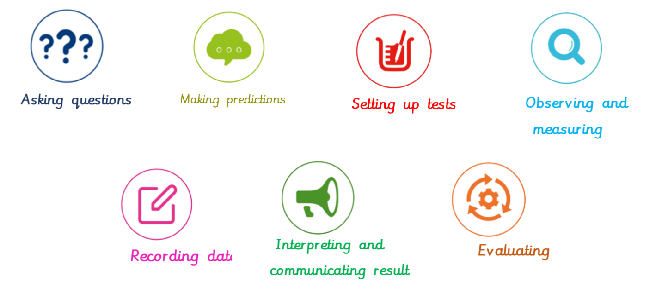
Disciplinary Knowledge
EYFS | Year 1 | Year 2
•ask simple questions about the world around them  • ask teachers or adults within school about things they observe  • make observations about things they see around them  • conduct guided investigations with supervision  • make choices when performing simple identifying and classifying  • make some comparison between objects or living things  • make some predictions about living things based on prior knowledge  • make suggestions about how things work based on their own observations  • use basic observations to help answer questions with help from the teacher  • explore the natural world around me, making observations and drawing pictures of plants and animals.  • identify some similarities and differences between the natural world around me and contrasting environments, drawing on their experiences and what has been read in class | • ask simple questions and recognise that they can be answered in different ways  • (fair tests, comparative tests, observation over time, research, pattern seeking)  • observe closely, using simple equipment (hand lenses, egg timers) • perform simple tests to investigate the answer to a given question  • perform simple identifying and classifying, grouping task using basic observations  • use observations and ideas to suggest answers to questions, using simple sentences to describe the answer  • gather and record data to help in answering questions, using given tables or data formats  • ask simple questions and recognise that they can be answered in different ways (fair tests, comparative tests, observation over time, research, pattern seeking)  • research the answers to questions using books, tablets or computers  • observe closely, using simple equipment (hand lenses, egg timers, rulers, stopwatches etc)  • perform simple tests to investigate the answer to a given question  • begin to design their own tests to investigate the answer to a given question  • perform simple identifying and classifying, grouping using basic observations  • begin to group using prior knowledge  • use observations and ideas to suggest answers to questions, using simple sentences to describe the answer to a question  • give basic conclusions with simple reasoning  • gather and record data to help in answering questions, using given tables or data formats drawing own tables, deciding how to record | • ask simple questions and recognise that they can be answered in different ways  • (fair tests, comparative tests, observation over time, research, pattern seeking)  • observe closely, using simple equipment (hand lenses, egg timers) • perform simple tests to investigate the answer to a given question  • perform simple identifying and classifying, grouping task using basic observations  • use observations and ideas to suggest answers to questions, using simple sentences to describe the answer  • gather and record data to help in answering questions, using given tables or data formats  • ask simple questions and recognise that they can be answered in different ways (fair tests, comparative tests, observation over time, research, pattern seeking)  • research the answers to questions using books, tablets or computers  • observe closely, using simple equipment (hand lenses, egg timers, rulers, stopwatches etc)  • perform simple tests to investigate the answer to a given question  • begin to design their own tests to investigate the answer to a given question  • perform simple identifying and classifying, grouping using basic observations  • begin to group using prior knowledge  • use observations and ideas to suggest answers to questions, using simple sentences to describe the answer to a question  • give basic conclusions with simple reasoning  • gather and record data to help in answering questions, using given tables or data formats drawing own tables, deciding how to record

Disciplinary Knowledge
Year 3 | Year 4 | Year 5 | Year 6
• ask relevant questions and use different types of scientific enquiries to answer them (fair tests, comparative tests, observation over time, research, pattern seeking)  • begin to select their own methods to find the answer to a scientific question  • set up simple practical enquiries, comparative and fair tests  • begin to design their own tests and manage variables  • make systematic and careful observations and, where appropriate, take accurate measurements using standard units, using a range of equipment, including thermometers, rulers, stopwatches, measuring cylinders and jugs.  • gather record, classify and present data in a variety of ways to help in answering questions  • begin to use simple keys for classification • record findings using simple scientific language, drawings, labelled diagrams, keys, bar charts, and tables  • report on findings from enquiries, including oral and written explanations, displays or presentations of results and conclusions  • explain findings from investigations to rest of class  • use results to draw simple conclusions, make predictions for new values, suggest improvements and raise further questions  • draw clear conclusions from findings and make predictions based on this, suggest improvements to the investigation  • identify differences, similarities or changes related to simple scientific ideas and processes  • use straightforward scientific evidence to answer questions or to support their finding | •ask relevant questions and use different types of scientific enquiries to answer them (fair tests, comparative tests, observation over time, research, pattern seeking)  • select their own methods to find the answer to a scientific question • begin to combine research with their own investigations to confirm conclusions.  • set up simple practical enquiries, comparative and fair tests  • design their own tests & identify and manage variables.  • make systematic and careful observations and, where appropriate, take accurate measurements using standard units, using a range of equipment, including thermometers, rulers, stopwatches, measuring cylinders/jugs and data loggers.  • begin to make decisions about what equipment is appropriate for investigations  • gather, record, classify and present data in a variety of ways to help in answering questions  • identify criteria for classification and use and create simple keys  • record findings using simple scientific language, drawings, labelled diagrams, keys, bar charts, and tables  • report on findings from enquiries, including oral and written explanations, displays or presentations of results and conclusions  • explain findings from investigations to rest of class  • be able to comment on the findings of other investigations compared to their own and how they support or contradict.  • use results to draw simple conclusions, make predictions for new values, suggest improvements and raise further questions  • draw conclusions and support with clear evidence, suggest improvements, raise further questions and possible next investigations  • identify differences, similarities or changes related to simple scientific ideas and processes  • use straightforward scientific evidence to answer questions or to support their findings | •plan different types of scientific enquiries to answer questions, including recognising and controlling variables where necessary (fair tests, comparative tests, observation over time, research, pattern seeking)  • select and plan the most appropriate type of scientific enquiry to use to answer scientific questions; recognise when and how to set up comparative and fair tests and explain which variables need to be controlled and why.  • take measurements, using a range of scientific equipment, with increasing accuracy and precision, taking repeat readings when appropriate  • make their own decisions about what observations to make, repeat readings and learn about reliability • record data and results of increasing complexity using scientific diagrams and labels, classification keys, tables, scatter graphs, bar and line graphs (in line with Year 5 maths curriculum learning)  • use test results to make predictions to set up further comparative and fair tests  • make predictions and complete further investigation  • report and presenting findings from enquiries, including conclusions, causal relationships and explanations of and degree of trust in results, in oral and written forms such as displays and other presentations, including giving an explanation of trust in results, with reasons  • identify scientific evidence that has been used to support or refute ideas or arguments, including identifying which evidence they have produced supports or refutes ideas or arguments | •plan different types of scientific enquiries to answer questions, including recognising and controlling variables where necessary (fair tests, comparative tests, observation over time, research, pattern seeking)  • select and plan the most appropriate type of scientific enquiry to use to answer scientific questions; recognise when and how to set up comparative and fair tests and explain which variables need to be controlled and why.  • plan and execute appropriate investigations based on a given or student-led question  • take measurements, using a range of scientific equipment, with increasing accuracy and precision, taking repeat readings when appropriate  • make their own decisions about what observations to make, repeat readings & learn about reliability, developing an increased level of precision and accuracy  • record data and results of increasing complexity using scientific diagrams and labels, classification keys, tables, scatter graphs, bar and line graphs (in line with Year 6 maths curriculum learning)  • use test results to make predictions to set up further comparative and fair tests  • make predictions and complete further investigation – combine with research  • report and presenting findings from enquiries, including conclusions, causal relationships and explanations of and degree of trust in results, in oral and written forms such as displays and other presentations, including giving an explanation of trust in results, with reasons  • identify causal relationships in investigations  • identify scientific evidence that has been used to support or refute ideas or arguments, including identifying which evidence they have produced supports or refutes ideas or arguments  • begin to research evidence to support or refute ideas/arguments & begin to separate opinion from fact

Substantive Knowledge

EYFS | KS1  Cycle A | KS1  Cycle B
Autumn -  Seasons  Our Bodies  Stick Insects  Spring -  Seasons  Penguins  Summer -  Seasons  Lifecycles  Minibeasts | Animals & Humans  Know the importance of air, water, food & hygiene for humans.  Know names of different body parts.  Materials  Naming, sorting and basic properties of materials  Waterproof and absorbent.  Animals & Habitats  Know groups of animals  Know how animals/ plants are adapted to their habitats | Electricity  Know that common appliances that run on electricity  Know how to construct a simple series electrical circuit  Know basic parts of a circuit  Identify whether or not a Know how a lamp will light in a simple series circuit.  Animals  Know omnivores, herbivories & carnivores,  Know different animal different structures, simple food chain & grouping.  Plants  Know what plants need to grow.  Know basic structure of plants.  Know names of basic plants

Substantive Knowledge

LKS2  Cycle A | LKS2  Cycle B | UKS2  Cycle A | UKS2  Cycle B
Rocks & Soils (inc fossils)  Know the three main types of rocks and their properties.  Know how fossils are formed.  Know how soil is formed.  Skeletons  Know what a skeleton is and that is provides shape of the body and protects vital organs.  Know that muscles enable animals to move  Forces & Magnets  Know what friction is and that resistance is a form of friction.  Know the properties of magnets and how these can be used.  Animals & Humans  Plants  Know the functions of different parts of the plant.  Know what plants need to grow and how this varies from plant to plant.  Know how plants reproduce  Digestive System,  Teeth & Food Chains  Know that there are different types of teeth and what they do.  Know and interpret a variety of food chains.  Know the proprotions of food groups. | States of Matter  Know that matter changes when heated or cooled  Know the states - Solids, liquids and gases  Electricity  Know that the switch breaks the circuit when open  Know that the switch conducts electricity  Know which material will conduct electricity and which will not.  Know that insulators do not conduct electricity.  Humans & Animals  Know the groupings of living things including invertebrate and vertebrate  Know how environment affects animals  Light & Sound  Know that light is a form of energy.  Know that light travels very fast.  Know that light travels in straight lines  Know that we can’t see around corners because light can’t travel around corners.  Know that a shadow is when light is blocked  Know that shadows have the same shape as the objects that cast them | Light  Know the parts of the eye  Know how light travels  Know how light is reflected  Electricity & Circuits  Know and understand circuit components and their symbols.  Understand that the number of Volts equals increased energy  Materials & Change of State  Know some material dissolve  Fair testing  Irreversible and reversible  Earth & Space  Know the movement of the earth and other planets  Know the Earth’s rotation and how day and night occur.  Gravity & Resistance  Know that air resistance is a force that is working against gravity.  Know that whichever force is greater the item will move in that direction | Humans & Animals  Know that the Circulatory system is the body’s transport system  Know the purpose of the digestive system  Know the life cycle of a human  Micro - Organisms  Know that micro-organisms may be beneficial or harmful.  Know that the word micro means not visible with the naked eye  Know that microorganisms are living things you cannot see without a microscope. These include Fungi, bacteria, viruses and algae.  Evolution  Know that living things have changed over time  Know that living things have adapted to their habitats  Know that offspring normally look like their parents.

