

History Curriculum

Contents

- Curriculum Policy
- Curriculum Overview
- Progression Strands
- EYFS Knowledge Plans
- KS1 Knowledge Plans
- LKS2 Knowledge Plans
- UKS2 Knowledge Plans
- Additional information

Curriculum Policy

Intent Statement
To develop children's experiences and understanding, inspiring and igniting their curiosity about the wider world in the past, present and future. As pupils progress, they should be able to think critically, gain knowledge of significant people and events in the past and apply historical skills throughout their learning.

This intent is to be delivered through a carefully structured topic based curriculum, which has a clear sequence of learning. This has been mapped out over a two year rolling program.
Long Term Overview
Skills + Vocabulary

Knowledge + Vocabulary
Sequence of Learning

3-D Curriculum
At Pinders, we have worked with the Senior Leadership team and subject leader to create a unique curriculum that suits the needs of Pinders’ learners.
Horizontal links (HL) are planned within the termly topic for all subject areas. This strengthens the learnt knowledge and the development of their schema.
Vertical Link (VL) are planned to show where there is clear prior knowledge that is being built upon within individual subject areas.
Diagonal Links (DL) are made where key vocabulary and concepts across different areas of the curriculum are pulled together to strengthen the complexity of pupil’s schema.

Knowledge
The knowledge to be taught for each unit has been identified and set out to ensure consistency of teaching and to allow for the pupils to build upon prior learning, revisiting and refreshing taught knowledge at each stage. By making these links throughout all areas of the curriculum children’s knowledge is being built upon and the learning is deepened.
Skills
Pinders Primary has worked closely with the Wakefield Trust to ensure progression of skills from nursery to Year 6. These skills are clearly set out for each thread of History learning and are to be taught alongside and through the delivery of the knowledge.
Vocabulary
We provide a vocabulary rich environment at Pinders. Key vocabulary is planned and taught; this vocabulary is directly linked to the knowledge and skills being taught. This ensures our children get a robust and challenging diet of vocabulary that contains tier 2 and tier 3 vocabulary.
The knowledge and vocabulary for each unit of history work is placed within a knowledge organiser. This organiser is a tool for the children to use to support them with learning and embedding knowledge and vocabulary into their long term memory. The organisers are also shared with parents to support home learning.
Assessment and Recording
Assessment is primarily carried out formatively whilst observing during lessons and carrying out pupil conversations. Throughout the children’s learning journey they will take part in knowledge quizzes to test how much knowledge is being retained. Assessment of pupil’s progress and outcomes is completed against exemplified pieces of work for each year group and thread of learning.
The history leader will keep evidence of pupils work electronically and exemplifications are shared on the school website.
Early Years- Understanding the World
Understanding the world involves guiding children to make sense of their physical world and their community. The frequency and range of children’s personal experiences increases their knowledge and sense of the world around them – from visiting museums to meeting important members of society. In addition, listening to a broad selection of stories, non-fiction, rhymes and poems will foster their understanding of our culturally and ecologically diverse world. As well as building important knowledge, this extends their familiarity with words that support understanding across domains.
Monitoring and Review
The monitoring of the standards of children’s work and the quality of teaching in history is the responsibility of the history subject leader. The work of the subject leader also involves supporting colleagues in the teaching of History, being informed about current developments in the subject, and providing a strategic lead and direction for the subject in the school. The History leader has specially allocated management time, which is used to review evidence of teaching and learning across the school.
The policy is a working document and therefore is open to change and restructuring as and when the need arises. It will be reviewed as part of the whole school review programme.
Governors will work alongside the subject leader to ensure the policy is being followed to successfully deliver the planned outcomes. Planning is monitored every half term to ensure coverage and rigour. There is a named governor who has responsibility for the subject.
Extra-Curricular opportunities
These opportunities will be planned accordingly within the year groups. They will be aimed to support and enrich the historical topics planned.

Curriculum Overview

 | Cycle A  Term 1 | Cycle A  Term 2 | Cycle A  Term 3 | Cycle B  Term 1 | Cycle B  Term 2 | Cycle B  Term 3
EYFS | Throughout their time in EYFS, the children begin to gain some early historical knowledge and skills through focused topic teaching sessions and accessing high quality provision. The children engage in hands on experiences which promote social and cultural understanding and allow for detailed discussions reflecting the world around them at present and in the past. To develop children’s understanding of chronology we use engaging floor books and a learning journey board where the children can look back at their prior learning and continue to recall and develop their knowledge. We use a range of stimulus to engage children and develop their historical understanding, including a range of fiction and non-fiction texts, IPads, visitors and educational visits. We provide the children with an interactive and hands on learning environment and high quality adult interactions to support and further learning, whilst fostering a love of learning about the past and encourage open questioning. Some of the topics that focus on developing historical understanding and skills include ‘Festivals’ where we learn about how and why they are celebrated and compare them to other festivals we have learnt about, ‘Seasons’ where we talk about natural changes over time and ‘People Who Help Us’ where we explore occupations and roles in society.
Key Stage 1 | Topic: ‘A world of discovery’  Question: Were Captain Cooks explorations a good thing?  Did Neil Armstrong teach us anything from his exploration?  How do we know that these discoveries really happened?  Focus: Neil Armstrong and Captain Cook  Abstract Terms: Civilisation, Monarch  Book:  Neil Armstrong and the moon landings (Izzi Howell)  Captain Cook (Rebecca Levene) | Topic: ‘London’s burning’  Question: Was the fire a blessing?  Focus: Great fire of London  Abstract Terms: Monarch  Book:  Samuel Pepys (Izzi Howell) | Topic: Paddington’s Travels’  Question: Does anybody famous live on our street?  Focus: Barbara Hepworth– Locality  Abstract Terms:  N/A  Book:  Meet Barbara (Laura Carlin) | Topic: Traditional Tales  Question: Are toys better today?  Focus: Toys (living memory)  Abstract Terms: Monarch, peasantry  Book: | Topic: Wonderful World’  Question: Should ruins be kept?  Focus: Sandal Castle  Abstract Terms:  N/A  Book: The Grand Old Duke of York Bernard Lodge | Topic: ‘How does your garden grow’  Question: Why is she so famous?  Focus: Beatrix Potter  Abstract Terms:  N/A  Book: The Tale of Peter Rabbit (Beatrix Potter)
Lower Key Stage 2 | Topic: ‘Stone Age to Iron Age’  Question: Which era influenced modern civilisation the most and why?  Focus: Stone age to Celts  Abstract terms: Civilisation, era, empire, period  Book:  Stone Age Boy by Satoski Kotamura  UG by Ramond Briggs | Topic: Greeks  Question: How do we know so much about the Ancient Greeks who lived over 2000 years ago?  Focus: Ancient Greece/Modern Greece (Geography)  Abstract terms:  Civilisation, monarch, period  Book: Meet the Ancient Greeks by James Davies | Topic: Local Area  Question: Is coal one of England’s treasures?  Focus: Mining  Abstract terms:  Economy  Book: You wouldn’t want to be a Victorian Miner!  Digging a hole to heaven SD Nelson | Topic: Romans  Question: Were the Romans Ruthless?  Focus: Roman Empire  Abstract terms:  Empire, government, monarchy  Book: Roman Invasion by Jim Eldridge | ‘Window on the World’ | Topic: Anglo Saxons  Question: Did Britain regress after the occupation of the Anglo-saxons?  Focus: Harold II V William I (Conqueror) Battle of Hastings 1066  Abstract terms: Civillisation, society  Book:  Beowulf Michel Morpurgo
Upper Key Stage 2 | Topic: Poppies, Peace and Power  Question: Did anybody win the war?  Focus: World War 2 – King George  Abstract terms:  Book: My Secret War Diary by Marcia Williams  The story of the Second World War by Peter Chrisp | Geography focus | Topic: Space  Question: Do we achieve more working as one team?  Focus: Space Race – Yuri Gagrin, Tim Peake  Abstract terms:  Liberty, patriotism, justice  Book:  Hidden figues by Margot Shetterly  The space race by Sarah Cuddas | Topic: Viking  Question: Does being rich make us powerful?  Focus: Alfred the Great, first King of England  Edward the Confessor  Abstract terms:  Monarchy, period  Book: Viking Boy by Tony Bradman | Topic: Egyptians  Question: Is the River Nile a gift? Howard Carter: Discoverer or Tomb Raider?  Focus: Ancient Civilisation and Non European Society (Egypt)  Abstract terms:  Era, Monarch, civilization,  Book:  Tutankhamun by Patricia Cleveland-Peck | Topic: Mayans  Question:  Focus:  Abstract Terms:  Book:

Progression Strands

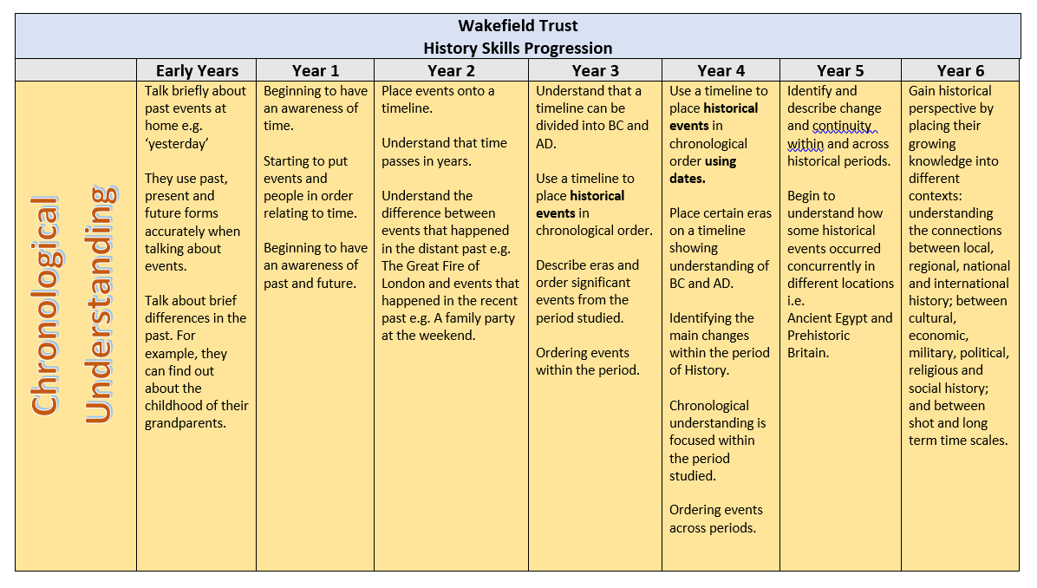
Progression of Skills
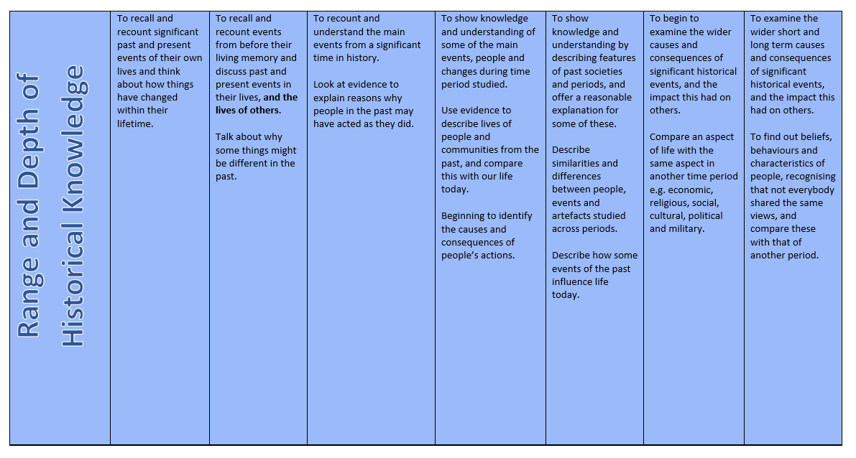
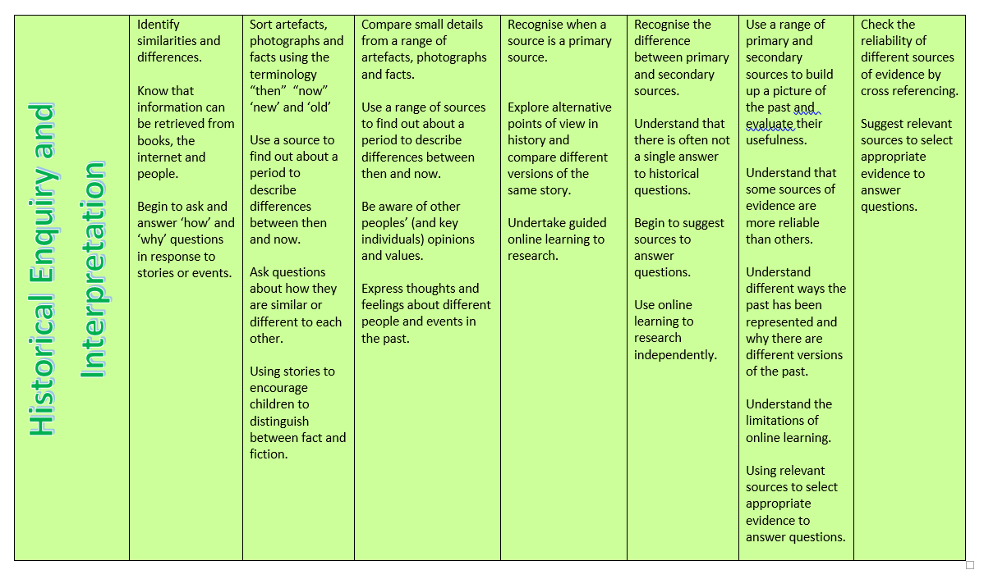
Overview of threads

 | Significant Individuals | Britain’s Past | Significant aspects of the history of the wider world | Abstract Terms | Chronology | Historical Enquiry | Historical Perspective and judgement | Cultural Capital | Sources
EYFS | Artists based on topics of learning  Authors of topic focused books | Christian celebration of Christmas | Diwali – Rama and Sita story.  Eid celebrations, past events in life.  Chinese new year.  Nativity story. | King  Queen  Royal  Prince  Princess  Traditions | Birth to present events, ordering stages of life e.g. baby, child, adult, grandparent. | Can you recall events from these celebrations?  What did you do to celebrate these?  How are these celebrated?  Why is it important to still continue these traditions today?
KS1 | Barbara Hepworth  Pinders Man  Captain Cook  Neil Armstrong  Queen Victoria  Beatrix Potter | Sandal Castle  Barbara Hepworth  Pinders Man  Captain Cook  Neil Armstrong  Victorians  Beatrix Potter | Neil Armstrong  Captain Cook  Beatrix Potter | Civilisation  Monarch  Peasantry  Locality  Era  Colony  Conversation  Chronology  Period  Nobility  Royalty | 12th Century – Sandal Castle  1666 – Great Fire of London  1728 – Captain Cook  1779 – Capital Cook Died  1837 – Queen Victoria reign  1866 – Beatrix Potter was Born  1901 – Queen Victoria died  1902 – Peter Rabbit book published  1903 – Barbara Hepworth  1930 – Neil Armstrong was born  1969 – Landed on the moon  1973 – Death of Barbara Hepworth  2012 – Death of Neil Armstrong | Were Captain Cook’s explorations a good thing?  Did Neil Armstrong teach us anything from his exploration?  Was the fire a blessing?  Why is she so famous?  Does anybody famous live on our street?  Are toys better today?  Should ruins be kept? | Victorian Toys – Modern Toys  Captain Cook – Discovery of land  Neil Armstrong – Space Travel | Sandal Castle  Pinders Man  Hepworth’s House
LKS2 | William the Conquer  Julius Caesar  Augustine  Boudicca  Beowolf  Edward the Confessor | Stone Age  Mining  Romans  Saxons | Julius Caesar (Roman)  Ancient Greeks  Anglo Saxons | Era  Monarch  Civilisation  Period  Climate  Clans,  Tribes,  Trade  Force  Empire  Economy  Conquest  Rule  Values | 8700 – BC – 1700 BCE – Stone Age  776 BCE – 146 BCE – Greek Period  55 BCE – 450 AD – Romans  450 – Anglo Saxons  1870 – 19th Century Mining - Victorian Mining | Which era influenced modern civilisation the most and why?  How do we know so much about the Ancient Greeks who lived over 2000 years ago?  Is coal one of England’s treasures?  Were the Romans ruthless?  Did Britain regress after the occupation of the Anglo-saxons?  Who created a better Britain? | Stone Age – wheel stone tools, farming, trade  Bronze Age-animal drawn vehicles, metal tools, metal plough- developed agriculture, writing  Iron Age- improved weapons  Romans – Improved society  Mining – Is coal precious? | Know about Stonehenge  Mining – National Coal mining museum  Beowulf | Artefacts – Flints  Experience – Mine Shaft, Yorkshire Farming Museum
UKS2 | Howard Carter  King Tutankhamen  Adolf Hitler  King George VI  Winston Churchill  Neville Chamberlain  Time Peake  Yuri Gargarin  Vaughan  Alfred the Great  Eric Bloodaxe  Harold the Second  William the conqueror  Edward the confessor  CAaliph al-Mansur | World War  Viking/Saxon | Haiti  Space Race  Egyptians  Holocaust  Islamic civlization | Period  Monarch  Peasantry  Government  Parliament  Liberty/ to freedom  Consequence  Cause  Liberty  Patroism  Justice  Equality/Diversity  Monarchy  Government  Culture | 8000– 31 BCE – Egyptians  AD781 – 1066 – Viking to Normal Rule  ACE 900 – 1300 – Early Islamic Civilization  1922 – Discovery Of King Tut  1939 – World War 2  1930 – Space Race Starts  1957 - Sputnick  1961 – First Orbital Flight  1969 – Moon Landing  2006 - Haiti | Did anybody win the war?  What consequences are caused by earthquakes?  Do we achieve more working as one team?  Does being rich make us powerful?  Is the river Nile a gift?  Discovery or tomb raider? | Space – Collaborative workings from Space Race to Modern Day  World War – Holocaust – View of Adolf Hitler. Aftermath/effects of the war  Space Race – Equality/Diversity of the hidden figures  Egyptians – Tomb Raider or discovery? | Eden Camp –  Remembrance Memorial  Poppies  Hidden Figures – Black women of the Space Race  School Ethos – Eid, Mosques, Muslim faith in Britain | Source – An witness account, Reporting from the news  Leicester Space Museum - Artefacts  Factual Accounts  Newspaper articles.

EYFS Knowledge Plans

KS1 Knowledge Plans

LKS2 Knowledge Plans

UKS2 Knowledge Plans

Additional Information

Substantive Concepts
 | Topic | Conflict  Does conflict lead to success? | Civilisation  Does the past impact on the way we live in the present? | Beliefs  Do Beliefs influence behaviour?
KS1 Cycle A | Explorers | America landed on the moon first. | Captain Cook discovered new parts of the world which were mapped.  Armstrong helped us understand space travel. | Cooks travels lead to further exploration of earth.
KS1 Cycle A | GFOL | People blamed King Charles II which led to fire brigade. | Homes were built using different materials, fire brigade introduced and reduced overcrowding by building houses further apart.
KS1 Cycle A | Paddington’s Travels
KS1 Cycle B | Victorian Era |  | Big divide between rich and poor.
KS1 Cycle B | Sandal Castle |  | Sandal Castle was rebuilt using stone as it was a stronger material.
KS1 Cycle B | Beatrix Potter |  | Her work was not recognised because she was a woman. | In present day men and women have equal rights in the UK.
LKS2 Cycle A | Stone Age | Iron Age Britain was a very violent time. | Development of tools – sticks and stones to metal swords and ploughs. Invention of the wheel. Farming began in Bronze Age as prior to this they were hunter gatherers. | Stonehenge was used for religious celebrations. Iron Age people worshipped many gods and made sacrifices.
LKS2 Cycle A | Greeks | War with Persia to gain control of the Med Sea.  Conquered by Alexander the Great. Later conquered by the Romans | Greeks created an alphabet similar to the one we use today. There was a system of democracy. Introduction of the Olympics and other sporting events. | Worshipped many different gods and goddesses.
LKS2 Cycle A | Mining |  | Introduction of children’s rights. It became compulsory for children to attend school. | Divide between rich and poor which is not prevalent in the UK today.
LKS2 Cycle B | Romans | Invaded Britain.  Different roles in armies,  Weaponry | Julius Caeser Dictator  Emperor Claudius.  Introduced the calendar  Laws and legal systems  Government- created census  Created roads  Introduced aqueducts led to running water, indoor plumbing and sewage.  Coins- money | Worshipped lots of gods and goddesses. Later we saw early presence of Judaism and Christianity.
LKS2 Cycle B | Saxons | Invaded Britain and conquered the Romans.  Vikings invaded. | Invaders languages led to English language developing. Coins and use of stone to build. Anglo Saxons split into different kingdoms each with their own king. Sometimes these had an overall king. Laws were upheld by Ealdorman and people punished.  Hierarchy Thegns/ Ceorls/ slaves | Anglo Saxons were pagans and believed in many Gods.  They converted to Christianity during their time in Britain.
UKS2 Cycle A | World War 2 | War started in 1914. Battle between “Allies” (Britain, USA, France…) and “Axis” (Germany, Italy, Japan. Adolf Hitler invaded Poland so Britain/France declared war. | Women marched to do Men’s jobs.  Government allowed women to do men’s jobs this led to beginnings of gender equality. 1918 30 women voted in general election. Hitler, along with Nazi party, controlled/manipulated people. Millions of people killed who didn’t fit ‘perfect German’ image. 6 million Jews killed during Holocaust, as Hitler blamed them for losing WW1. Government produced propaganda. Children evacuated from their homes. | Hitler believed he could create the ‘perfect’ race by excluding Jews, Gypsies and those with disabilities.
UKS2 Cycle A | Haiti |  | Many homes were lost due to the earthquake. Houses were rebuilt with modern materials to provide more strength (link to Great Fire of London).
UKS2 Cycle A | Space Race | Race between USA and USSR (Russia) to achieve firsts in spaceflight capabilities. | Black female scientists- segregation white and black that eventually led to integration.  Led to further space exploration and International Space Stations. | More acceptance of other races began and integration between different races at work also commenced.
UKS2 Cycle B | Vikings | Some Vikings came to fight, others came to settle. The Viking raid against the Anglo-Saxons starting a fierce struggle between the two. Anglo-Saxons beat Vikings in 954 AD, where they agreed to live peacefully in Britain. 1066 ended Viking age and Norman rule began. | Families lived together in longhouse.  Used Rune alphabet.  Top of society was a King- Jarls- Karls – thralls (slaves).  Guthrum was King of the Vikings. | Pagans.  Nine different worlds- gods and Goddesses – no need to learn them all
UKS2 Cycle B | Egyptians | Kings, known as Pharaoh’s, tried to conquer new lands. Romans took over Egypt. | Tutankhamen is the most famous Pharaoh. Pharaohs- kings - lineage  Architecture – the pyramids  Archaeology – Howard Carter  Written communication – hieroglyphs/papyrus  Building of pyramids. | Egyptians worshipped many Gods (around 2000) which were represented by animals. They had many different rituals, including mummification.
UKS2 Cycle B | Mayans |  | Halach Uinic as the absolute ruler – lineage.  Developed a number / counting system.  Written communication - made of bark. Maya Script and syllables (own alphabet like the Egyptians) | Mya believed and worshipped a number of different Gods - no need to learn about them all.

