

School Uniform Policy

This policy outlines Pinders Primary School’s expectations regarding the wearing of school uniform by children when attending school, or when participating in a school-organised event outside normal school hours.

September 2026


Background
In developing our uniform policy we have taken full account of the Education (Guidance about Costs of School Uniform) Act 2021 and the Department for Education’s non-statutory guidance on school uniform. Key points of this legislation and guidance are:
- Parents should not have to think about the cost of a school’s uniform when choosing which school to apply for. Therefore, schools need to ensure that their uniforms are affordable.
- In considering cost, schools will need to think about the total cost of school uniform, taking into account all items of uniform or clothing parents will need to provide while the child is at the school.
At Pinders Primary school, we aim to keep the cost of school uniform affordable. We have a simple, inexpensive form of school uniform and PE clothing. Some items of uniform can be bought with the Pinders Primary School logo on, whilst other plain items are easily available, at very competitive prices, at local shops including supermarkets.

- Schools should keep the use of branded items to a minimum.
At Pinders Primary School, there is no requirement for branded items.

- A school’s uniform policy should be published on the school’s website and available for all parents, including prospective parents, and easy for parents to understand.
This requirement is met by this policy, which is available on our website.

- Schools should ensure that their uniform supplier arrangements give highest priority to cost and value for money (including the quality and durability of the garment) for parents.
Securing value for money has been met through the procurement of school uniforms; both quality of material (including durability and wearability) and cost were tested with suppliers during the procurement process.

- Schools should tender their uniform contracts at least every 5 years. Exclusive single supplier contracts should be avoided unless regular tendering competitions are run where more than one supplier can compete for the contract and where best value for parents is secured.

PInders school Business Manager reviews our supplier every five years.

- Schools should ensure that second-hand uniform is available for parents to acquire. Information on second-hand uniform should be clear for parents of current and prospective pupils and published on the school’s website. Pinders Primary School, have a pre loved uniform shop that is open at the beginning and end of each day to support families and enable recycling. This is freely accessible to all our families and all items are of free of charge.

Our Uniform Policy
Within Pinders Primary school we promote an atmosphere which encourages effort, enjoyment and a celebration of the achievements of all our pupils. Our concern for these high standards is also reflected in the pride we take in our school uniform and the feeling of belonging it creates.
School uniform is a way of showing that the children and parents/ carers are READY, RESPECTFUL and SAFE, in line with our whole-school rules. A smart uniform improves discipline, self-esteem and self-respect. Uniform focuses attention upon learning and away from distractions. We ask children to wear their polo-shirts/ shirts tucked into their skirts, shorts or trousers and to take a pride in their personal appearance.
It is our school policy that all children wear school uniform when attending school or when participating in a school organised event outside of normal school hours, except in Nursery where parents may choose if children wear uniform. On occasions, where medical conditions are evidenced to the school, there can and will be reasonable adjustments made.
The uniform is part of our school ethos and in coming to Pinders Primary School, parents agree to support our policy.

Aims and Objectives
Our policy for uniform is based on the belief that school uniform:
- Promotes a sense of pride in the school and it has a positive impact on behaviour and attitudes in school;
- Makes children feel equal to their peers in terms of appearance;
- Supports our commitment to inclusion;
- Develops a sense of community and belonging towards school;
- Ensures that our pupils can be clearly identified with our school when taking part in out of school educational activities and visits;
- Is practical and smart;
- Is not distracting in class (as fashion clothes and hairstyles can be);
- Is regarded as suitable wear for school and considered by most parents as good value for money;
- Is designed with health and safety in mind.

At Pinders Primary School our uniform consists
The school uniform consists of the below, and must not be altered in a way that changes the style of the item.

All Genders
- Navy blue sweatshirt / jumper / cardigan (with school or without school logo)
- White polo shirt or shirt – with collar
- Navy or grey plain tights or socks
- Grey skirt, trousers, pinafore or school shorts
- White and blue checked dress
- Navy Blue book bag (with or without school logo)
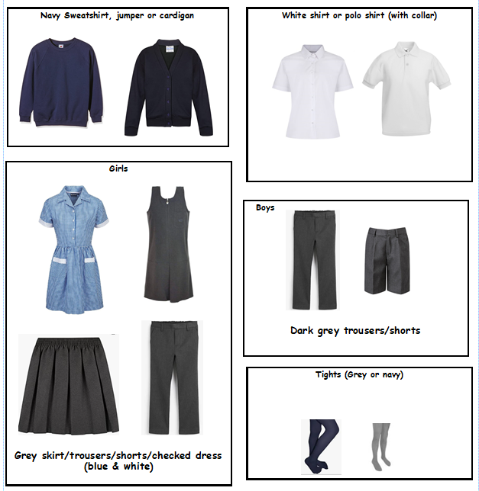

PE Kit
Indoor :
- White t-shirt or polo shirt
- Navy blue shorts
- Navy blue leggings or PE skirt
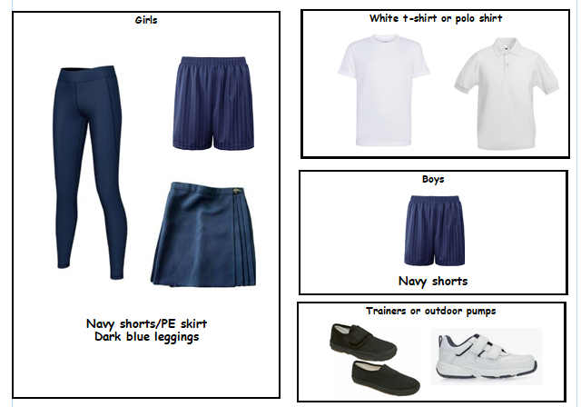
Outdoor:
- White t-shirt
- Blue or black Shorts
- Navy, black or charcoal grey Tracksuit or jogging pants
- Suitable footwear – Trainers
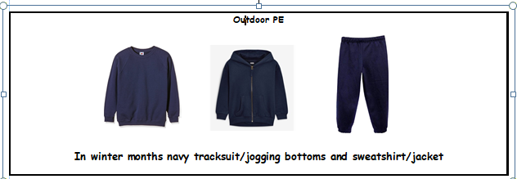

Swimming (as required by the pool that we visit): (Pupils in Year 5 and Year 4)
- Girls must wear a one-piece swimming costume, this may include leg covering
- Boys must wear trunks or ‘short’ swimming shorts (not baggy Bermuda type shorts).

It is also advisable to have:
- Swimming goggles
- Swimming cap
Hijab
1 piece full head coverage hijab tucked neatly into their tops for their own safety. These need to be plain in colour, either black or Navy blue. These can be purchased from the school office.

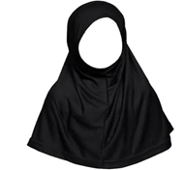
Please reduce the ‘risks’ by ensuring that every garment or piece of clothing (including footwear) is clearly marked with your child’s name.
Uniform for Nursery Children
Uniform for our Nursery children is not compulsory. However, our Nursery children are seen as part of our school community and therefore are welcome to wear the school uniform if they would like to.

Shoe Policy
For health and safety reasons, we do not allow pupils to wear shoes with platform soles, Heelys or high heels. All pupils are required to wear flat, plain black shoes without logos. These should be closed in with no toes visible. If boots are worn these should also be flat and plain black. Sandals and flip-flops are not permitted. Only plain black shoes are allowed to be worn with the uniform.

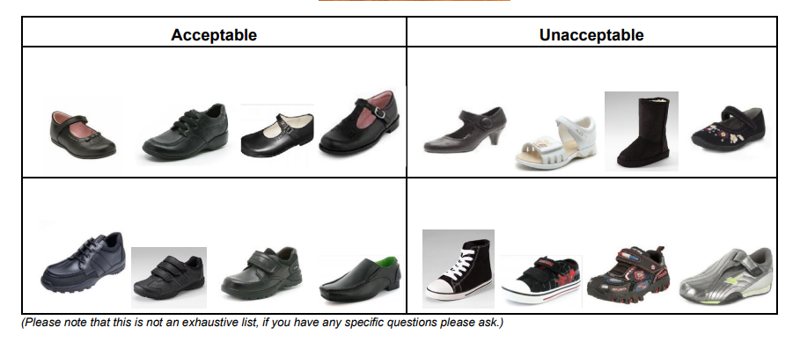

Jewellery
- For Health and Safety reasons, we do not permit children to wear jewellery in school. The exception to this rule is watches. This does not include any watch based technology which can record or take pictures, access the internet or have access to games.
- Medic Alert necklace or bracelets are permitted.
- Pupils with ear pierced must only wear studs.
- For PE and swimming and watches removed to prevent them causing injury.

Make-Up and Nail Polish
- Nail polish and any type of false nails (including clear gels, acrylics, extensions, Shellac etc) are not allowed.
- Make-up is not acceptable under any circumstances.
- Fake tattoos are not appropriate at school and must be removed without trace.

Hair and hair ornaments
- Hairstyles should be reasonable and appropriate for being in a learning environment at school.
- Hair bands, ribbons/bows or ‘scrunchies’ should be plain and simple and not have objects attached to them such as flowers.
- All children, girls and boys, are required to have their hair tied back, if long enough.

Religion and Beliefs:

The school will always be sensitive to the needs of different cultures, races and religions and will act reasonably in accommodating these, without compromising safety or discipline within the school. We believe any concerns in this regard can be addressed through dialogue and understanding.

Flexibility and Non-Discrimination:

Children will not be discriminated against in terms of uniform expectations, based on cost or availability (e.g. boy and a girl should have the same expectations in terms of cost and availability). Children with protected characteristics will not be discriminated against. Individual needs and requirements will be addressed on an individual basis through dialogue, reasonable adjustments and fair decision making, in a discrete and thoughtful way.

We ask that parents requesting adaptations to school uniform arrange an appointment with Mrs Rowlands or Mrs Kemplay so that requirements can be discussed on a personal level.

Purchasing school uniform
Uniform with the school logo; sweatshirts and cardigans are all available from the school office and are sold at cost price (not for profit) from our suppliers.
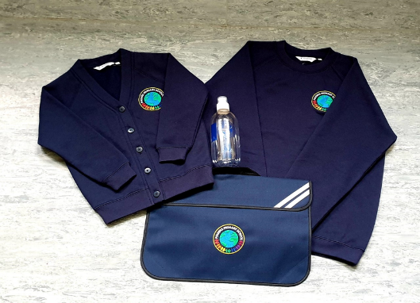
All other items can be bought from a variety of shops and supermarkets at a reasonable price including second hand shops.

Role of the Head teacher and Governing Body
The Head teacher:
- Implement and monitors the policy throughout the school community as part of the duty within maintenance of day-to-day discipline in the school;
- Has overall responsibility for ensuring standards are maintained;
- Is responsible for any disciplinary measures required for failing to follow the uniform rules;
- Issues letters to parents / carers as required.

The Governing Body:
- Should be receptive to any reasonable complaint from parents or carers concerning uniform, by handling it respectfully and considering fully the issues they raise;
- Should aim to work with parents to arrive at a mutually acceptable outcome.

Role of the Staff
Staff should support the Leadership Team in maintaining high standards of uniform dress.
The staff will:
- Make discreet and sympathetic enquiries when children fail to wear school uniform;

Role of the Parents / Carers
The Parents will:
- Support the School Uniform Policy;
- Ensure children come properly dressed and ready for their daily schoolwork every day;
- Ensure all items of clothing are clearly named – this helps lost items be easily identified and returned;
- Parents and carers should raise any complaints about the school uniform by following the school complaints procedure.
- The school welcomes children from all backgrounds and faith communities. If there are serious reasons (e.g. religious objections), why parents want their child to wear clothes that differ from the school uniform, the school will look sympathetically at such requests. If any parent would like to request a modification to the uniform policy they should, in the first instance, contact the Headteacher.
- Similarly, should an item of school uniform prove problematic for a pupil with disabilities, then parents are invited to draw this to the attention of the Headteacher. Reasonable allowances may be made to support pupils with disabilities. The school will not permit requests that are adjudged by the Headteacher to put the health and safety of pupils at risk.

Role of the Children
The Children will:
- Wear the school uniform when attending school, representing the school or when participating in a school organised event outside normal school hours;
- Wear the school uniform with pride;
- Try to keep their uniform clean and tidy;
- Remember to bring/ wear kit on the correct days.

Inclusion
All children have equal access to wearing school uniform regardless of their race, religion, gender, disability or ability. We ensure that the set uniform respects other policies such as race relations, sex discrimination and allows for individual sets of circumstances of all groups and individuals.
Pinders Primary School is committed to creating a positive climate that will enable everyone to work free from racial intimidation and harassment and to achieve their full potential.

Non-compliance with the School and P.E Uniform Policy
If a child breaches the school uniform or P.E uniform policy, the teaching team will discreetly talk to them to find out why they are not in uniform and to remind them of the need to wear one. If a child breaches this again a reminder letter will be sent home to parents reminding them of our uniform policy.

If a child forgets their swimming kit, school will attempt to contact parents/ carers to bring a swimming kit to school immediately.

Collective praise for wearing uniform as well as reminders of the need to do so, will also be given to classes within assemblies.

A member of the school leadership team will make the decision if there is a need to contact parents / carers to bring some suitable uniform to school immediately.

We understand that there may be some exceptional and unavoidable situations where children may have to come to school without a part of their school or P.E uniform (lost or damaged) then we ask parents to contact us on the day to confirm the reason.

Persistent non-compliance
The Head teacher may contact the parent directly to discuss this matter. Continued non-observance of the policy will result in a formal letter.
Pinders Primary School expects all pupils and parents to conform with this policy, but in the event of persistent breaches, we will work closely with the parents / carers to resolve the situation.

Appendix 1
Wakefield Metropolitan District Council Family Services
Pinders Primary J. I and Nursery
Headteacher: Mrs L Kemplay



Date: ………………………………….

Dear Parent,

We noticed that your child ………………………………………in ………………………… Class was not wearing their school uniform in school today.

Please help your child by ensuring they bring…………………………………………………. to school in the future.

I am sure you will appreciate the many advantages of wearing school uniform as listed in our School Uniform Policy both for you and your child in school.

You are very welcome to access our pre-loved uniform shop which is open before and after school, everything is completely free.
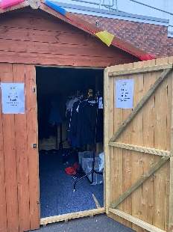
Thank you for your support.
Yours faithfully,

Mrs Lorna Kemplay
Headteacher

Appendix 2
Wakefield Metropolitan District Council Family Services
Pinders Primary J. I and Nursery
Headteacher: Mrs L Kemplay

Date:
Dear Parent,
We noticed that your child ………………………………………in ………………………… Class was not wearing their school uniform in school today.

I am sure you will appreciate the many advantages of wearing school uniform as listed in our School Uniform Policy, which you will find on the website, both for you and your child in school.

We would therefore be very grateful if you could make sure that your child is dressed appropriately every school day.
If there is a way we can support you please do not hesitate to contact the school to make an appointment to discuss the situation.
We would hope to be of help in supporting you and your child in fulfilling our requirements.

Thank you for your support in this matter.

Yours faithfully,

Mrs Lorna Kemplay
Headteacher

